Hardware upgrade error as follows (Connect to target USB)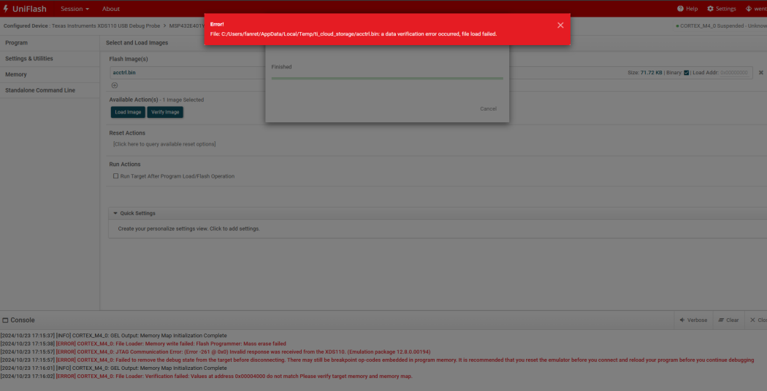
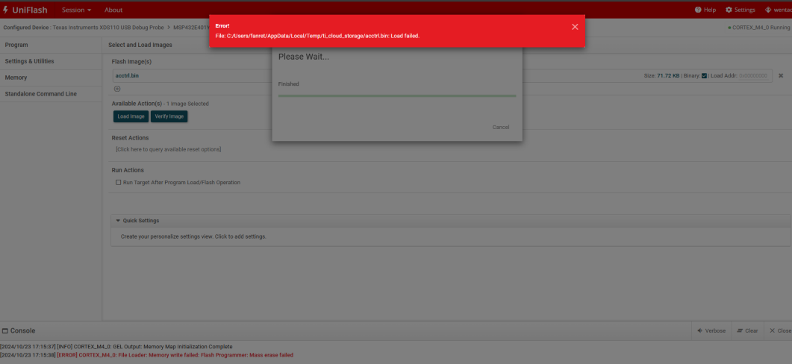
After the ADS-110USB is connected, the LED light on the board is on, the port cannot be identified,and the software shows that the hardware is not connected.