***Assumptions:***

* MibSPI1 is being used for this communication
* MibSPI1 drivers are enables in Driver Enable Tab.

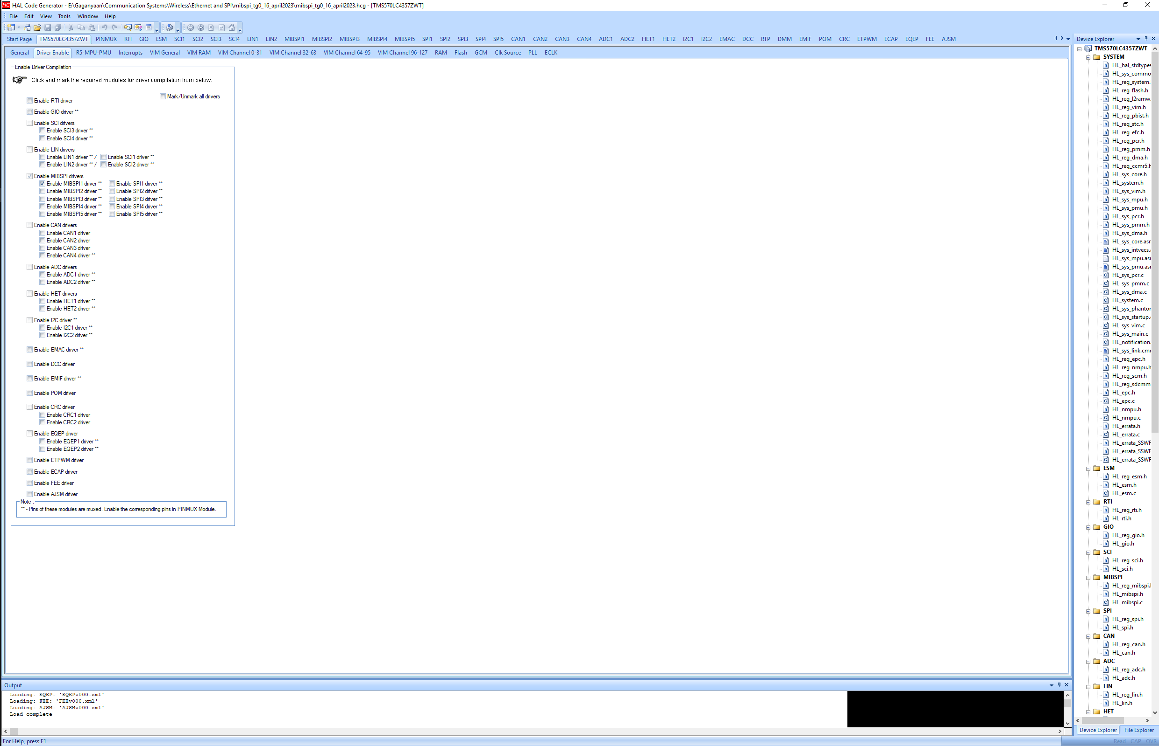

* Corresponding interrupts are enables in the VIM Channel 0 – 31 tab

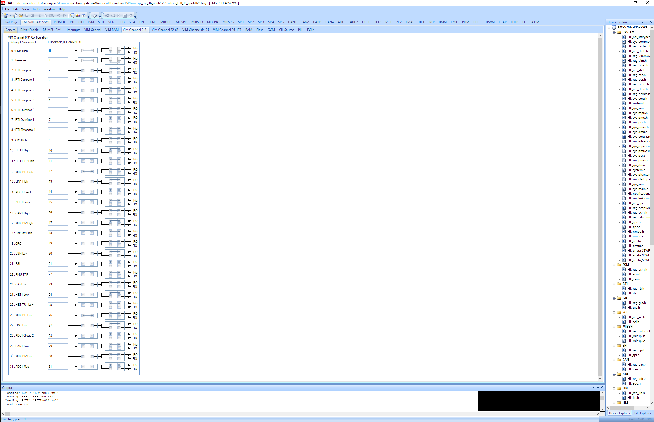

* MibSPI1 is checked in PinMUX tab and all the conflicts have been resolved.

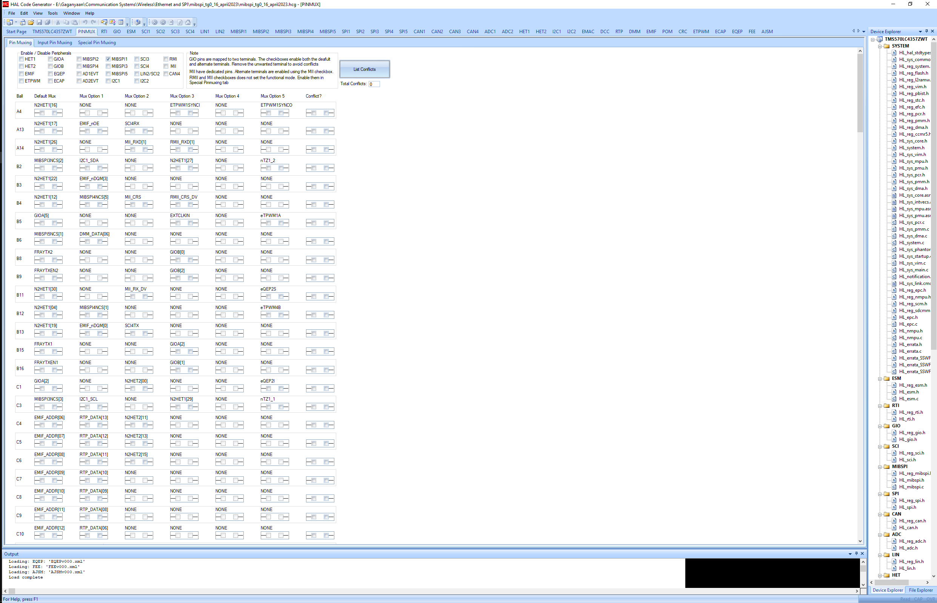

***Master Mode :: 3 pin***

* Master Mode checkbox has been in checked condition in MibSPI1 tab -> MibSPI1 Global subtab.
* Internal Clock checkbox has been in checked condition in MibSPI1 tab -> MibSPI1 Global subtab.

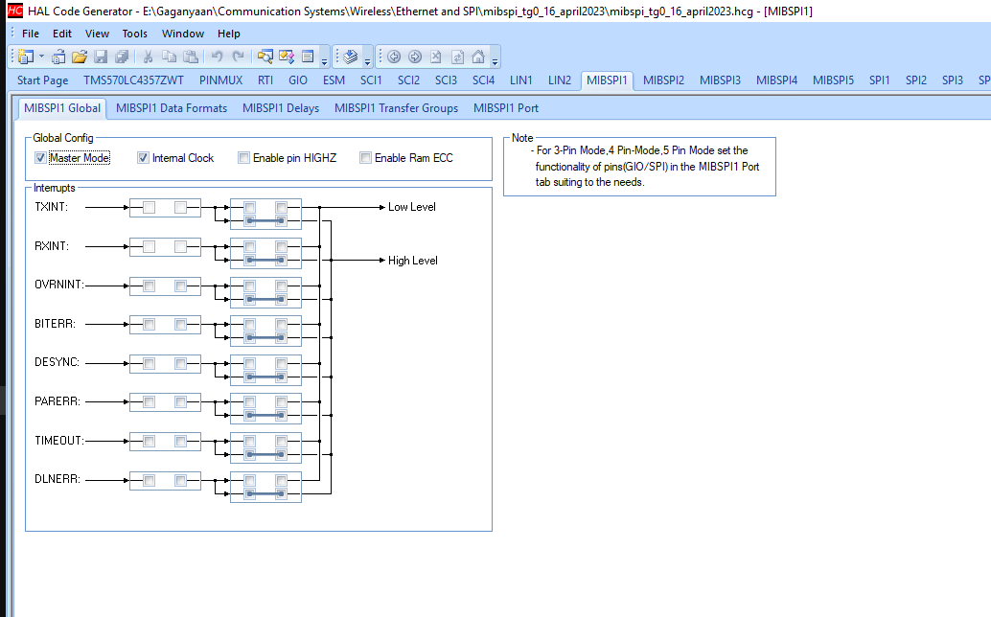

* No changes as of now in MibSPI1 tab -> MibSPI1 Data Formats subtab.

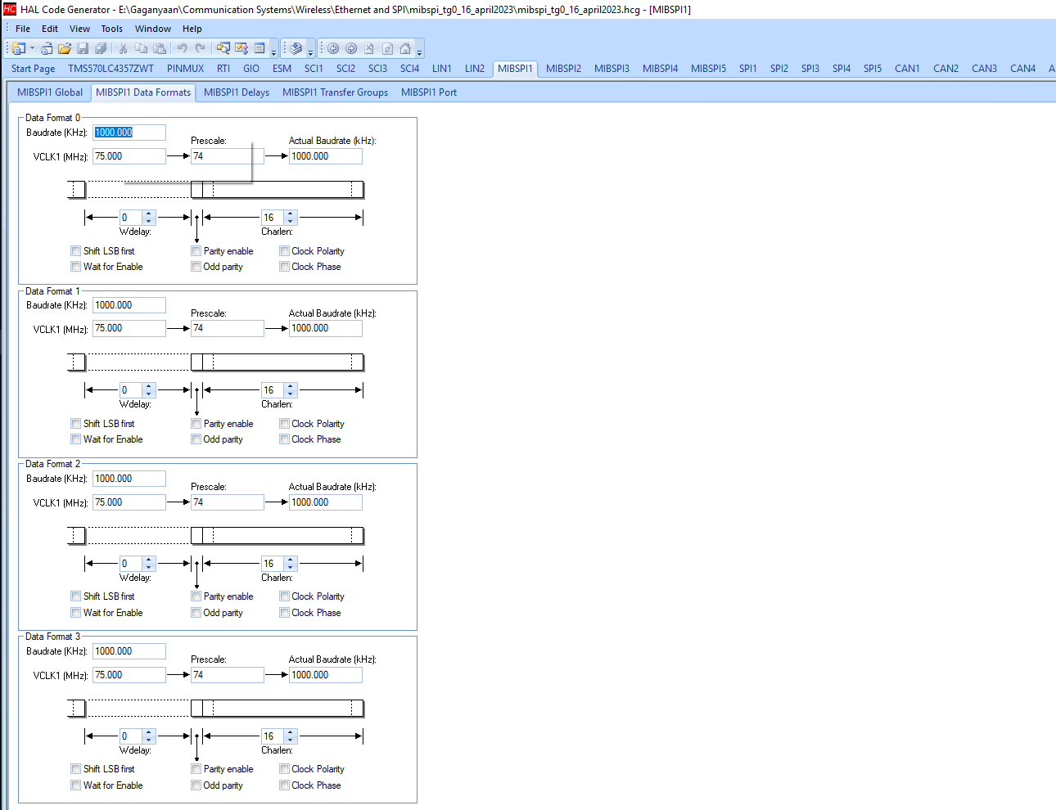

* No changes as of now in MibSPI1 tab -> MibSPI1 Delays subtab.

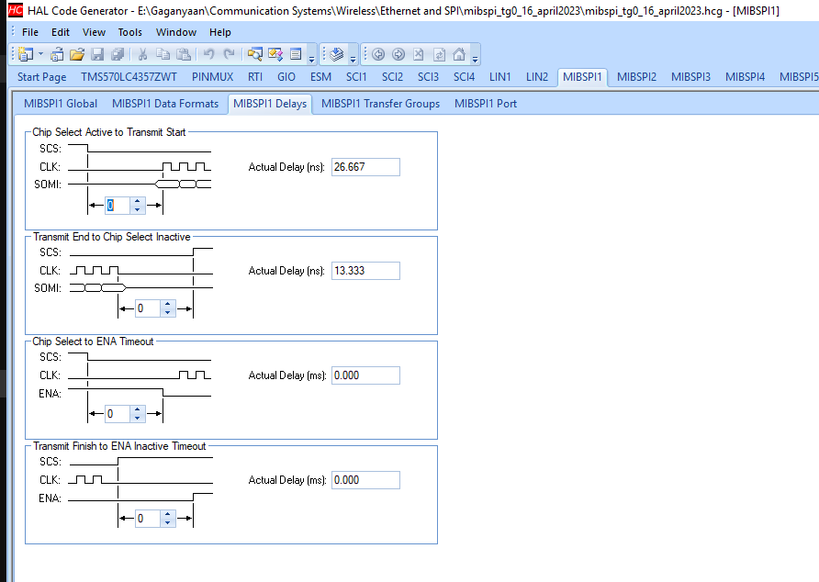

* No major changes as of now in MibSPI1 tab -> MibSPI1 Transfer subtab. You can change the Transfer Group Length as per the requirements.

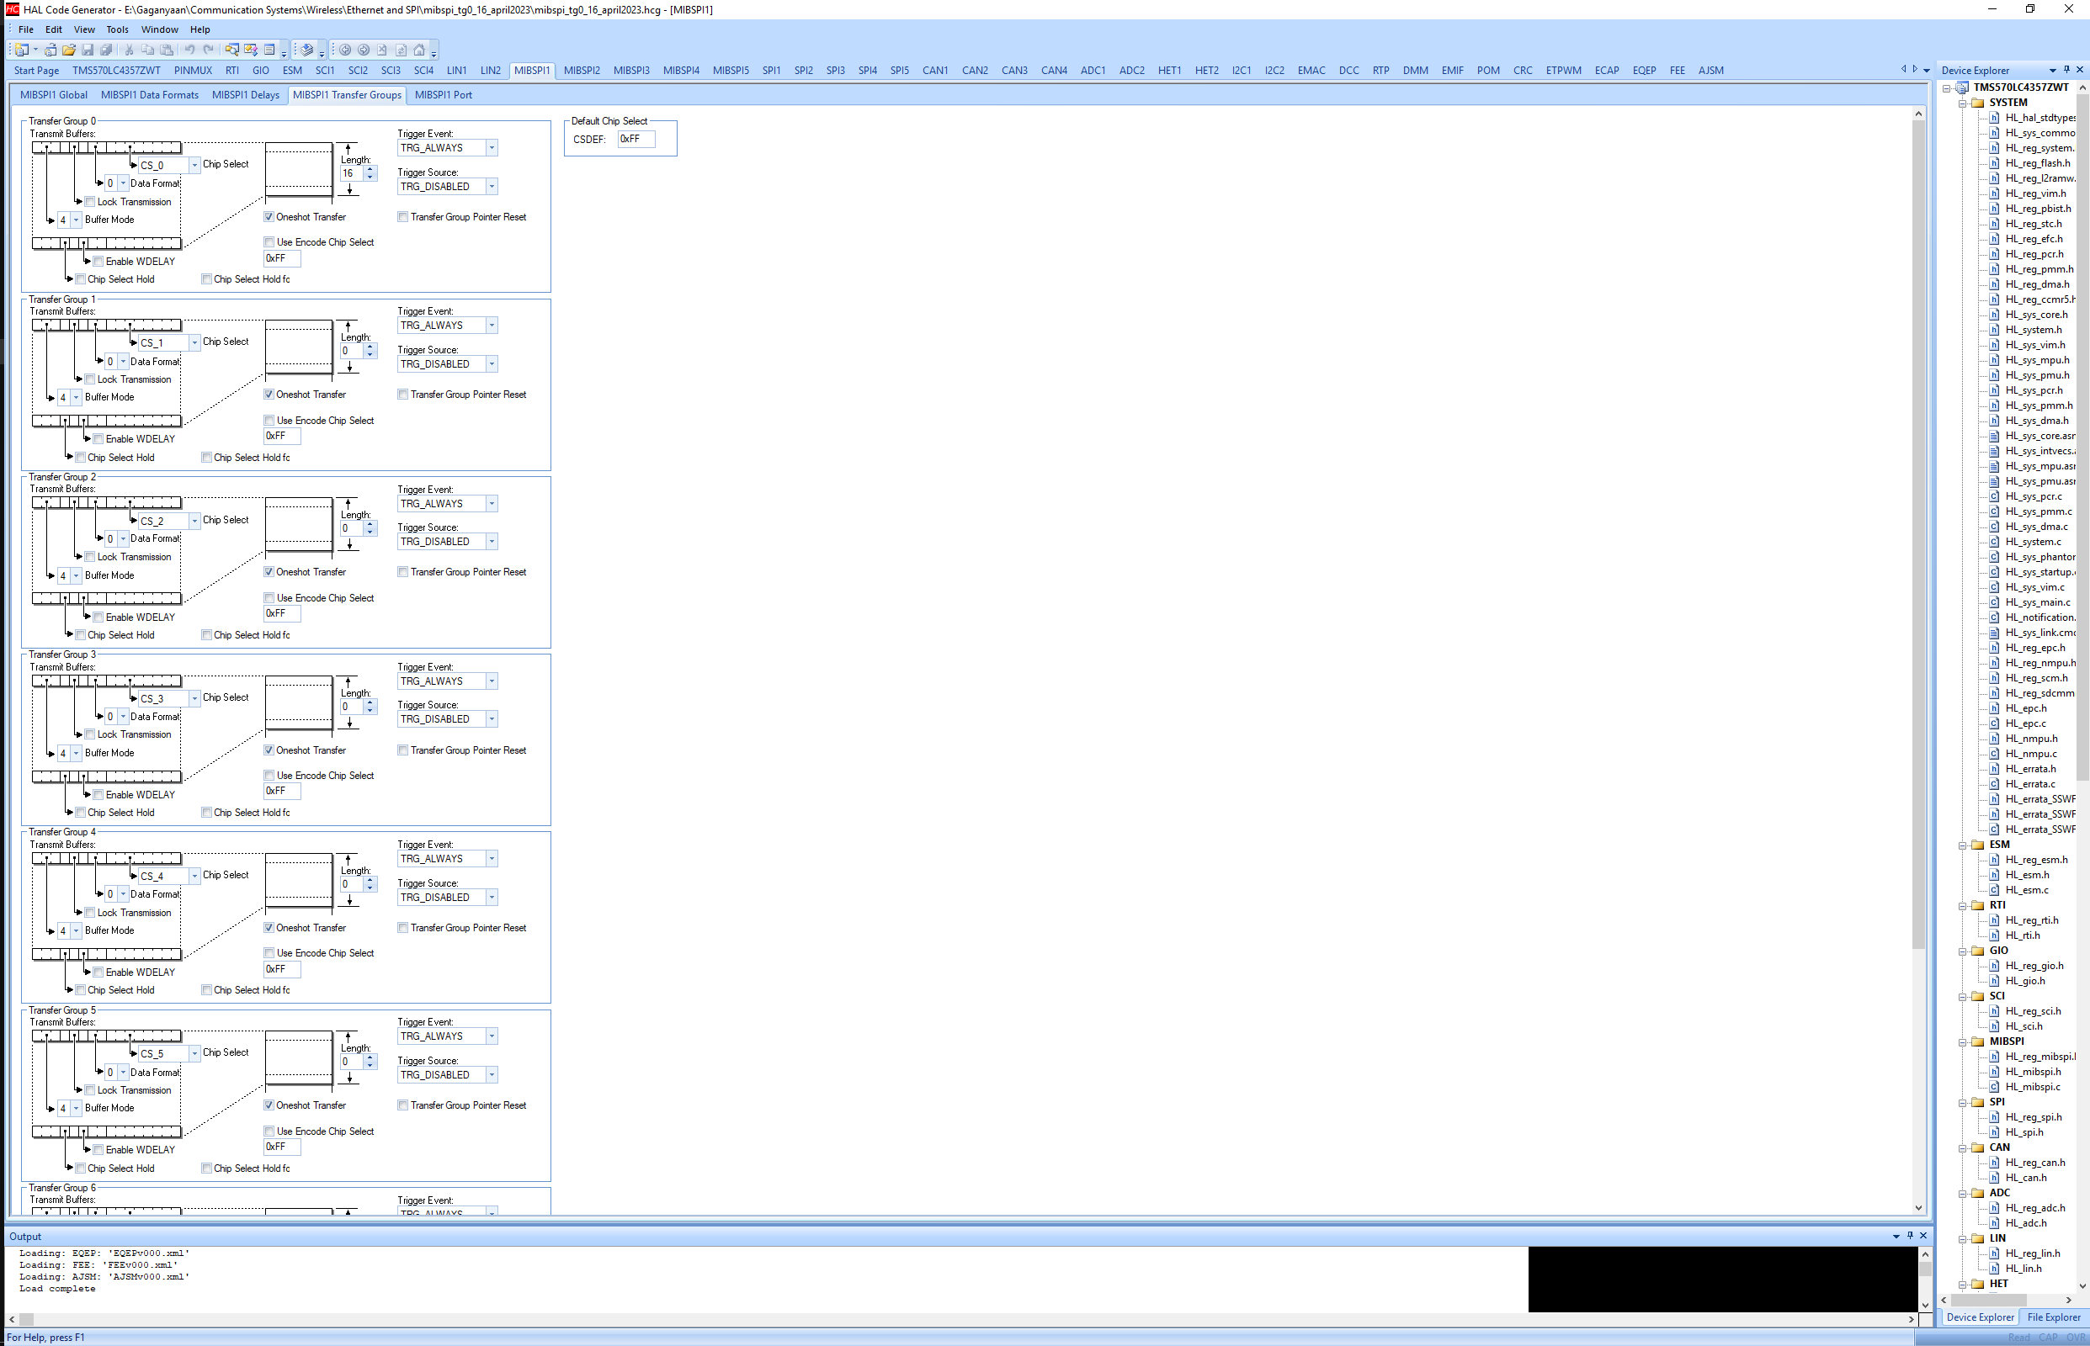

* No major changes as of now in MibSPI1 tab -> MibSPI1 Ports subtab. This port configuration will output data on MOSI, Clock on SCLK pin and will receive inputs on MISO pins. Since checkboxes for CLK and MOSI are checked (this indicated the port will work as output port)

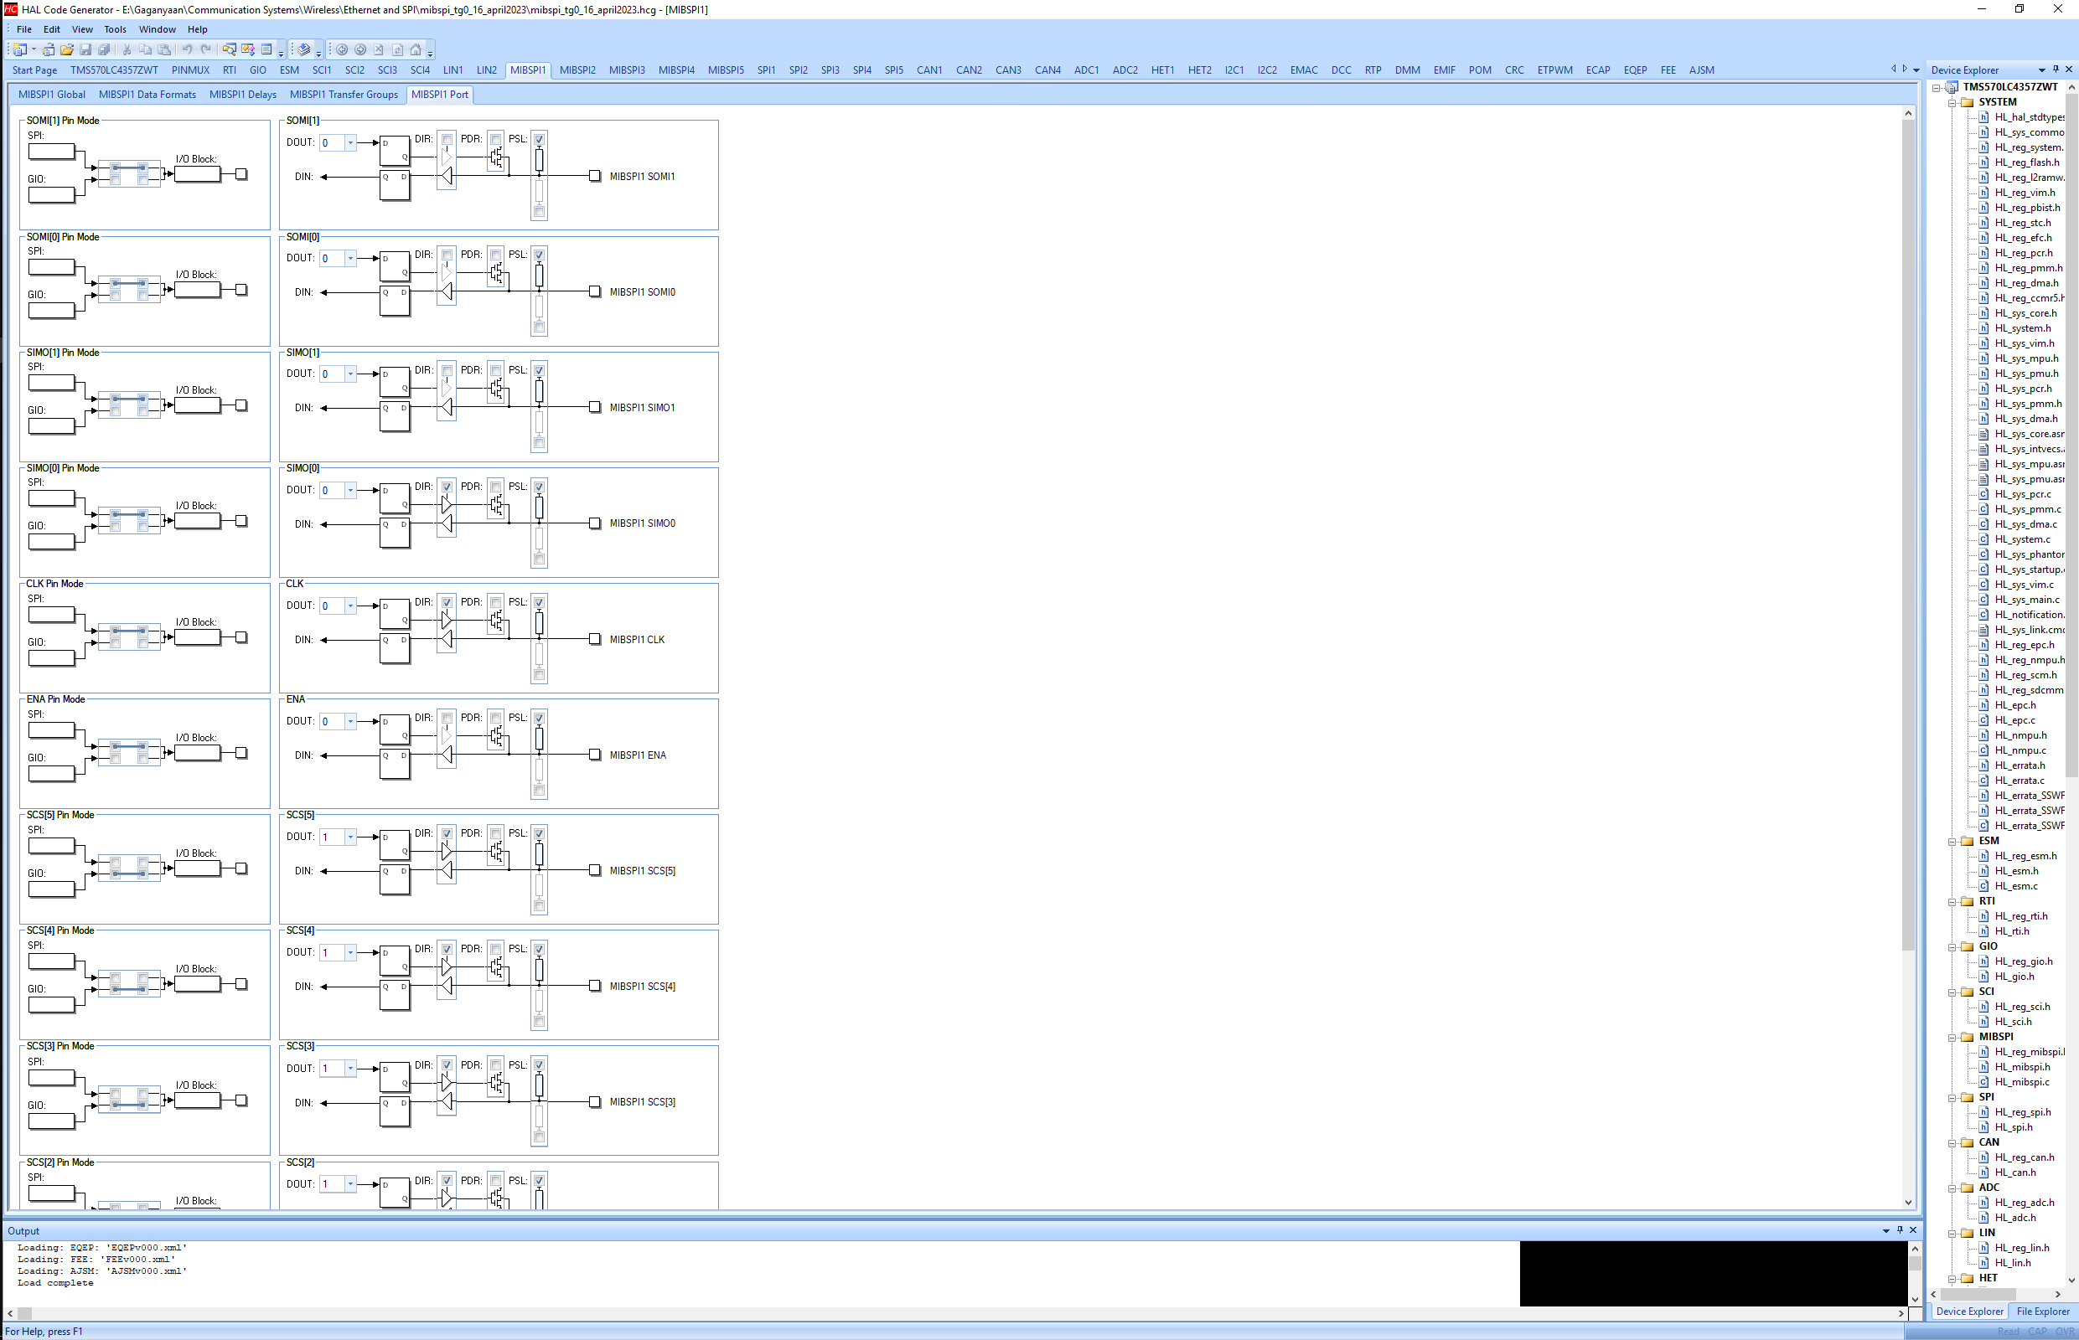

***Queries associated with this configuration:***

1. Is the information provided above (in ***assumptions*** and ***Master Mode :: 3 pin sections***) is correct or any kind of modification is required?
2. If the same needs to be used for 4 pin mode, with ENA being the fourth pin, in my opinion, following additional modifications are required. Please correct the mistakes (if any) or if anything is missed out by me.
   1. In MibSPI1 data formats tab, check the wait for enable checkbox.
   2. Leave ENA pin in MibSPI1 port tab unchecked as it will be an input pin for master.

***Slave Mode :: 3 pin***

* Master Mode checkbox has been in ***un-checked*** condition in MibSPI1 tab -> MibSPI1 Global subtab.
* Internal Clock checkbox has been in ***un-checked*** condition in MibSPI1 tab -> MibSPI1 Global subtab.

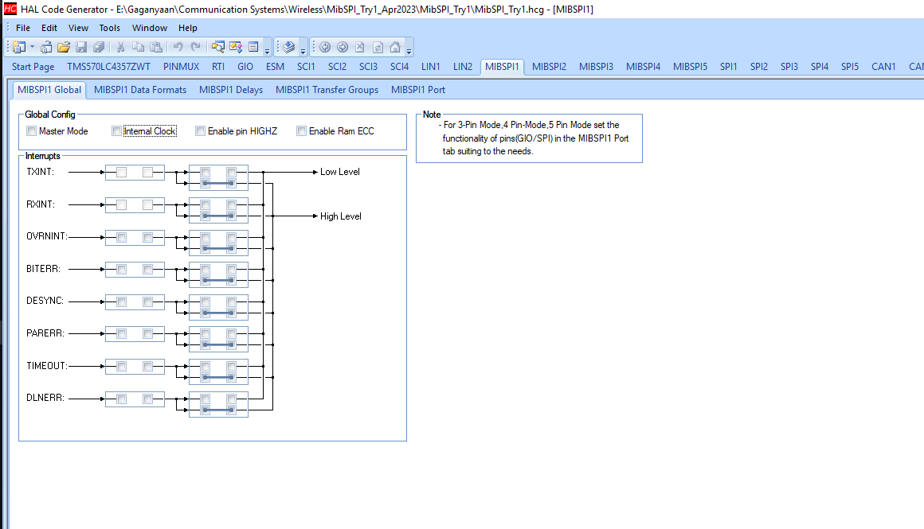

* No changes as of now in MibSPI1 tab -> MibSPI1 Data Formats subtab.



* No changes as of now in MibSPI1 tab -> MibSPI1 Delays subtab.



* No major changes as of now in MibSPI1 tab -> MibSPI1 Transfer subtab. You can change the Transfer Group Length as per the master configuration.



* In MibSPI1 tab -> MibSPI1 Ports subtab, check MISO box to configure it as output port.

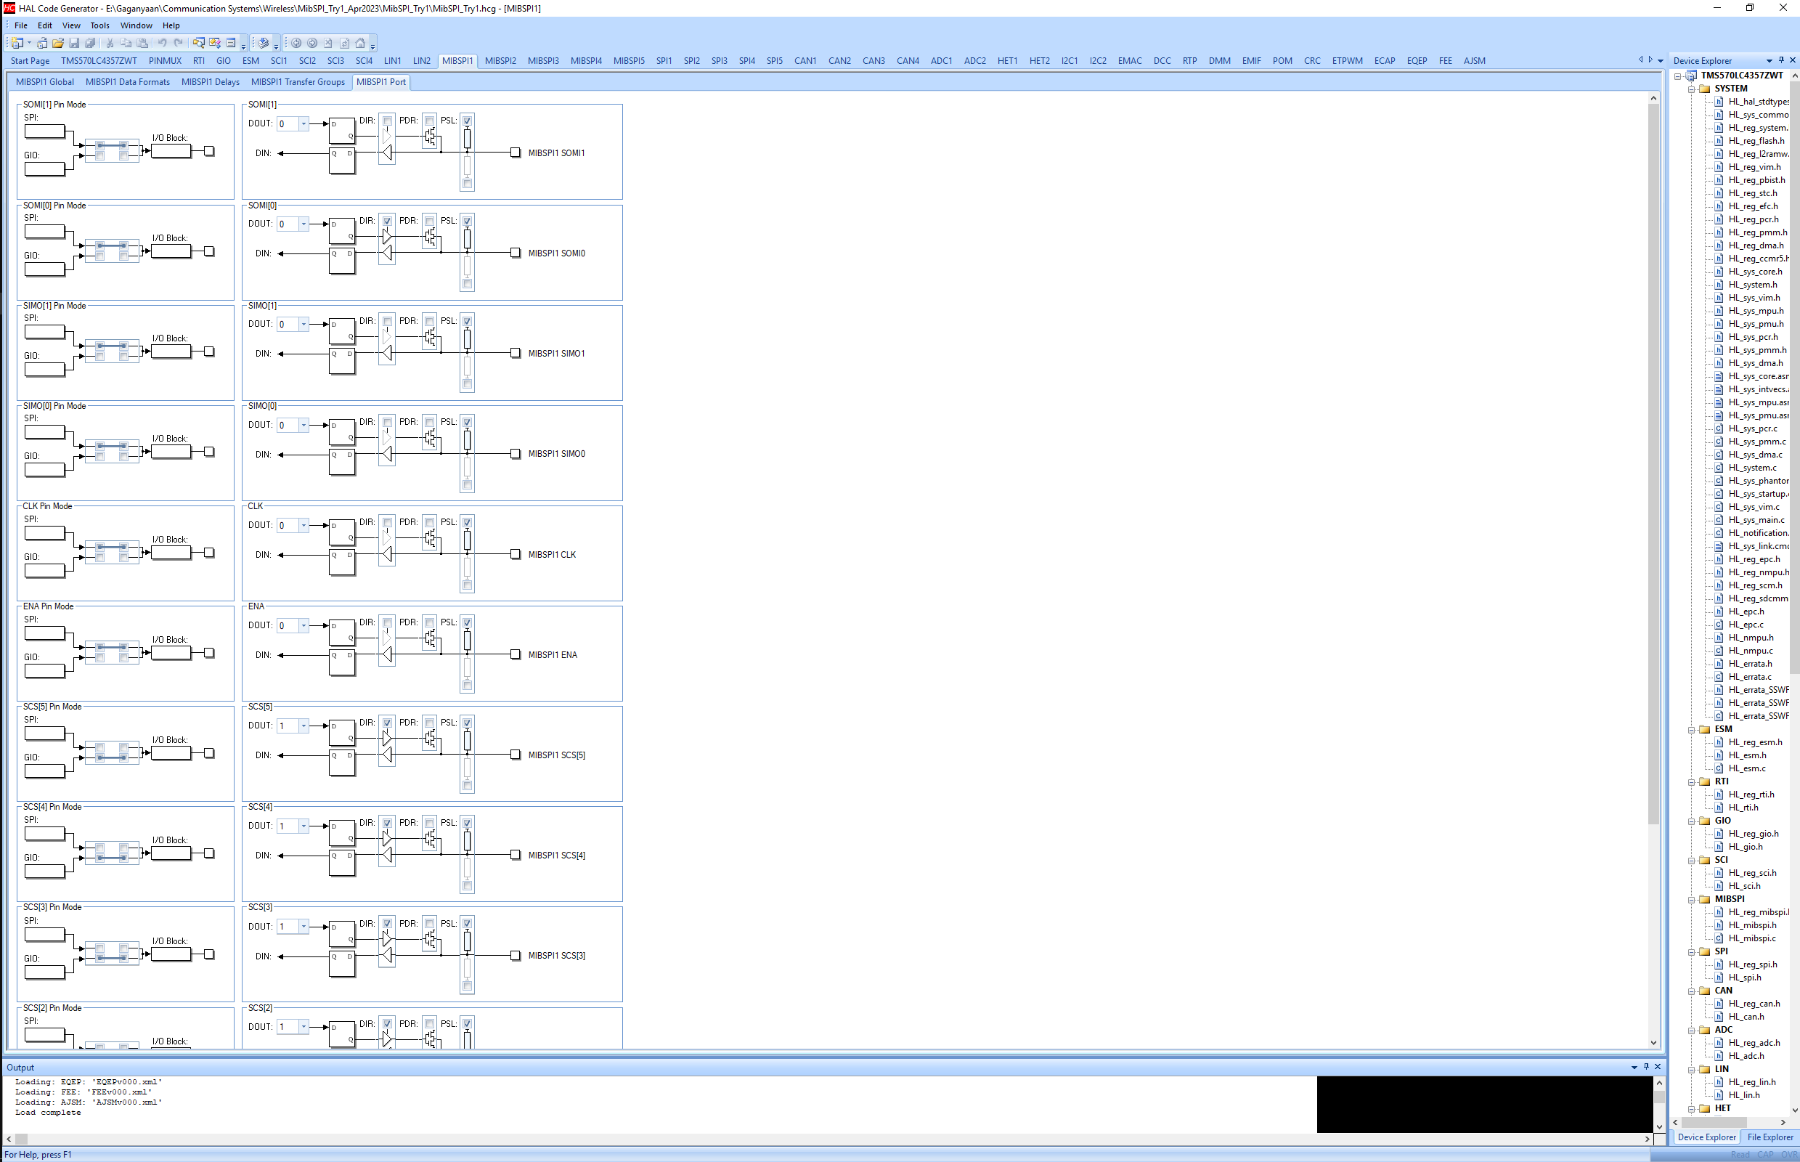

***Queries associated with this configuration:***

1. Is the information provided above (in ***Slave Mode :: 3 pin sections***) is correct or any kind of modification is required?
2. If the same needs to be used for 4 pin mode, with ENA being the fourth pin, in my opinion, following additional modifications are required. Please correct the mistakes (if any) or if anything is missed out by me.
   1. In MibSPI1 data formats tab, check the wait for enable checkbox.
   2. Check the ENA pin in MibSPI1 port tab as it will be an output pin from slave.
3. Is there any document / presentation or any such material available that links information provided in Technical Reference Manual with HALCoGen UI?