Syscnfg file:
In TI Board driver:
Ethernet : DP83869
PHYAddress: In my Schematic
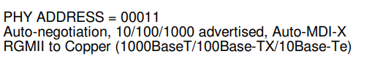

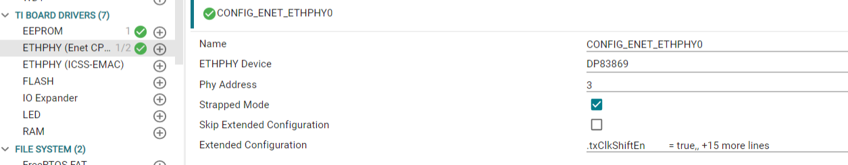
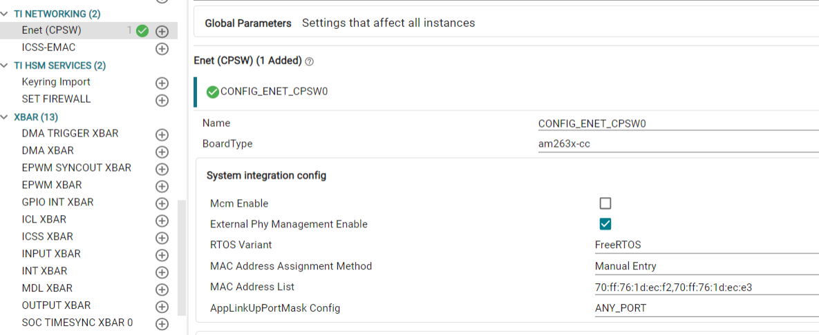
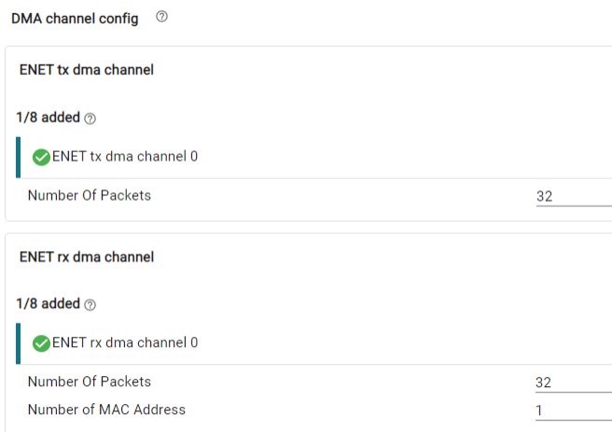
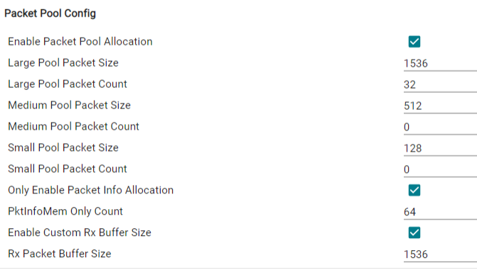
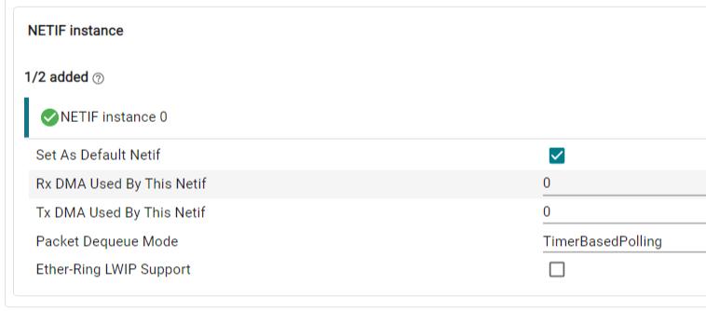
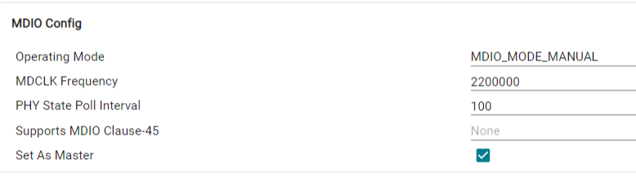
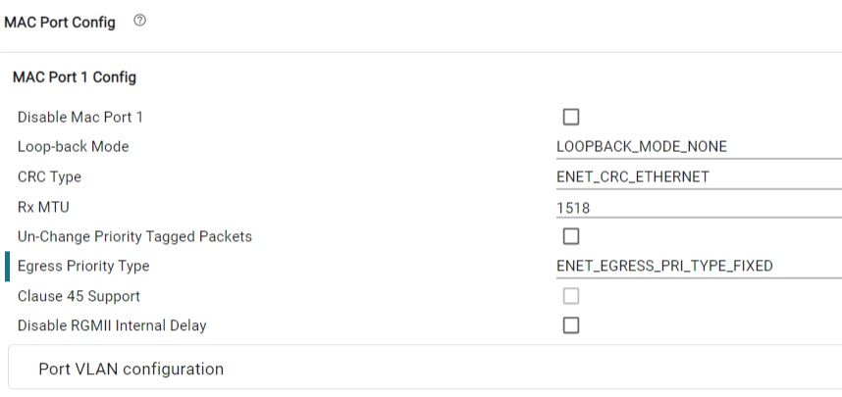
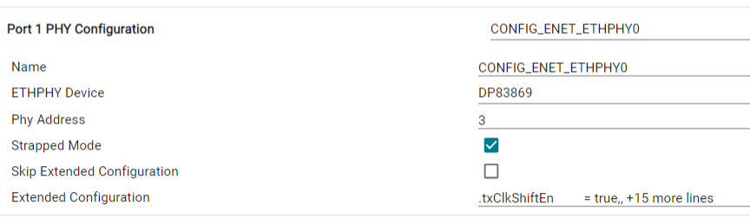
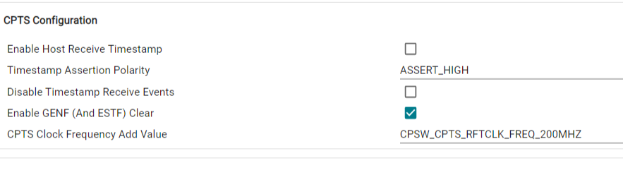

Based on the configurations implemented, the ping is not working. I have attached the UART log and ping output for reference. Kindly review and let me know if any software or SysConfig changes are required.

