Power up ramp looks good for TM4C1294’s LDO.

CH1: P3V3

CH2: P1V2 of TM4C internal LDO

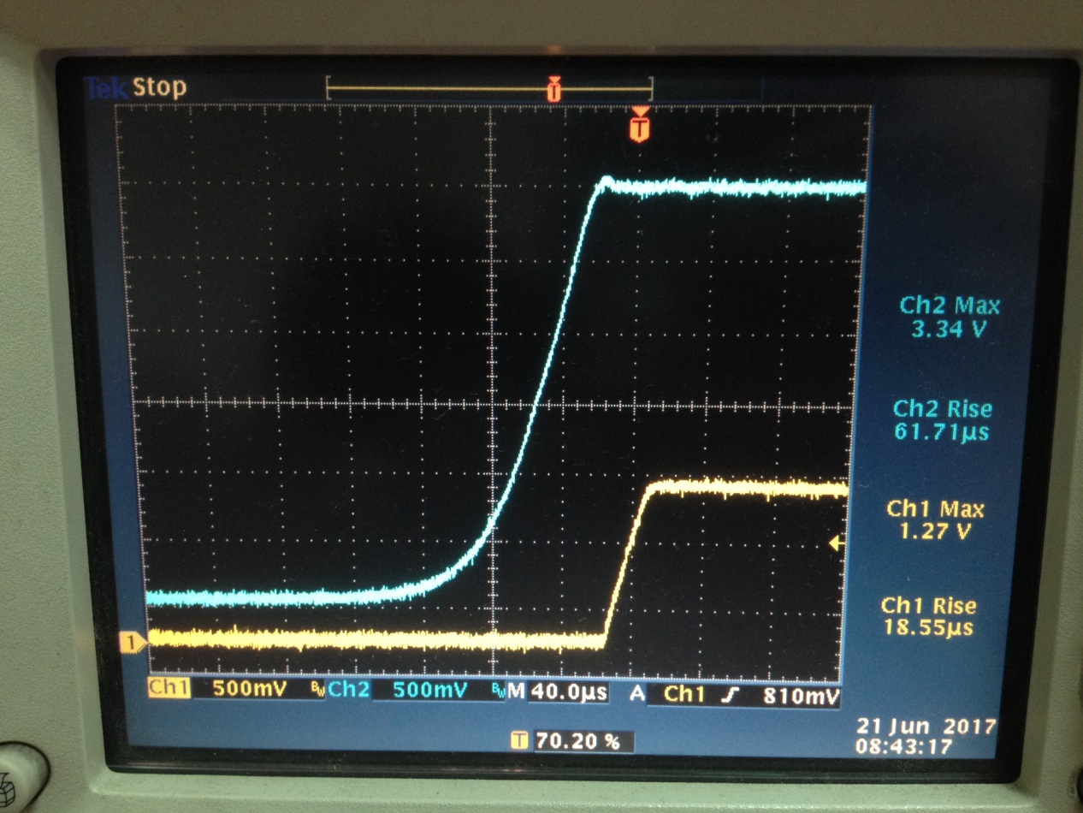

Power up ramp looks bad for TM4C1294’s LDO.

