EXAMPLE SCOPE PLOTS SHOWN BELOW

Yellow = M0PWM2
Blue = M0PWM3 (i.e Complement of M0PWM2)
Green = M0PWM4
Red = M0PWM6

a) Correct phase relation. Green lagging by about 120 degrees and Red lagging by about 60 degrees

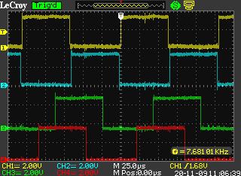

b) Wrong phase relation. Green lagging by about 120 degrees
but Red lagging by about 210 degrees (180+30).
