FIRST TIME IT RUNS:
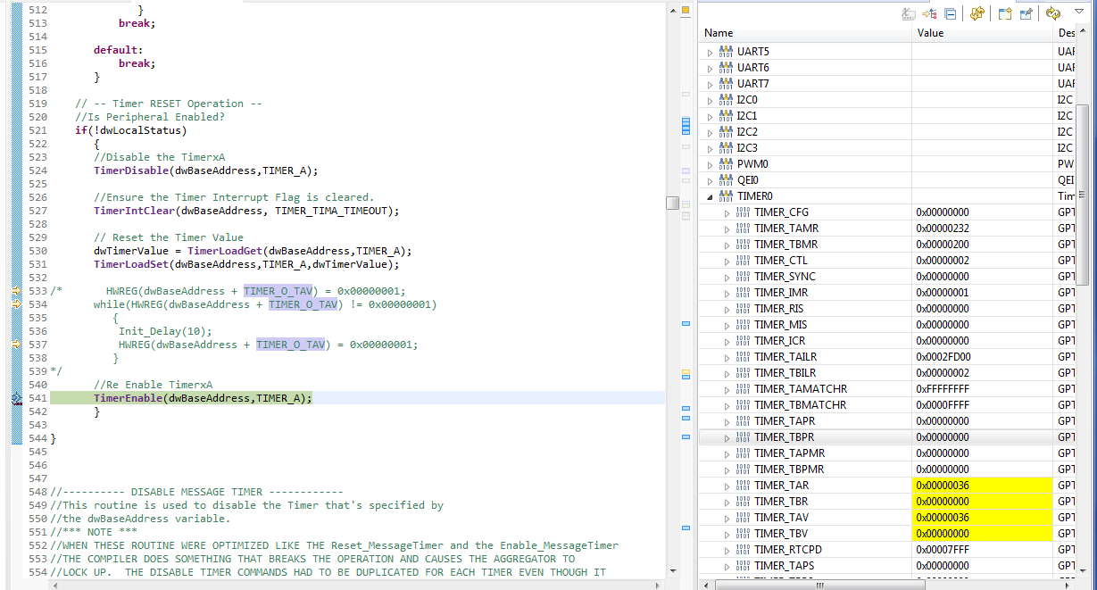

SECOND TIME IT RUNS:
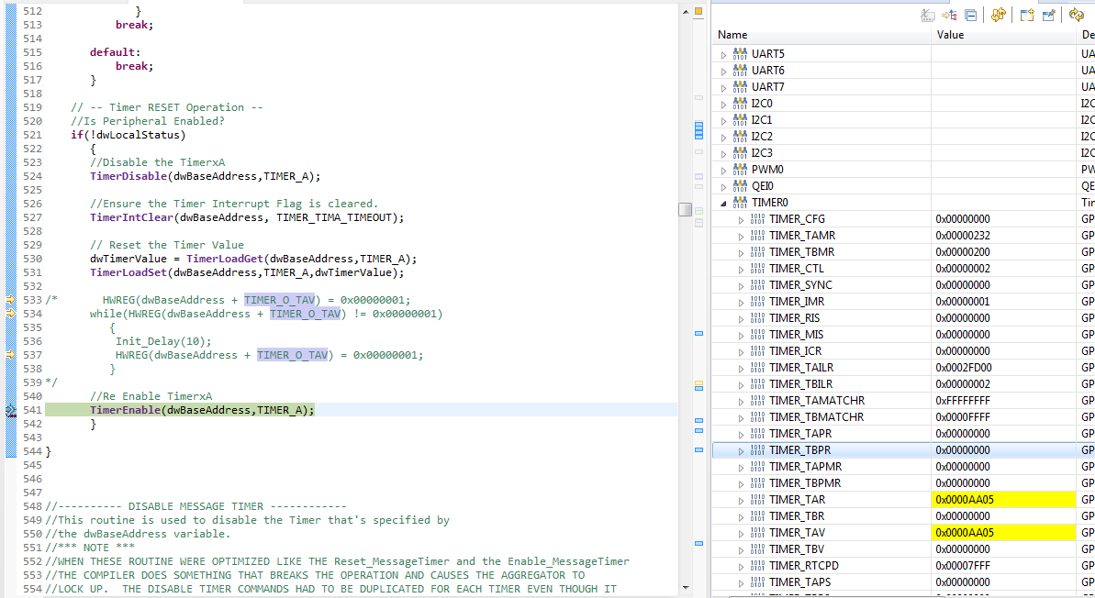

THIRD TIME IT RUNS:
