USB debugging status
2024年11月29日
13:24

I would like to first share my debugging status with you. If further information is needed for testing, I will sign an NDA later.
First of all, our company is working on USB series products based on the AM2434 chip. The overall architecture includes the Windows application layer, the Windows driver layer, and the Cadence USB device layer

Overall implementation effect: Data sent from the Windows side to the AM2434 reaches the TinyUSB receive complete callback function, where the received data (a total of 512 bytes) is processed, and continuous transmission is supported.

Debugging phenomenon: When I continuously send data from the Windows USB side to the AM2434, the TinyUSB receive complete callback function is only triggered once, and subsequent data does not enter the receive complete callback function.

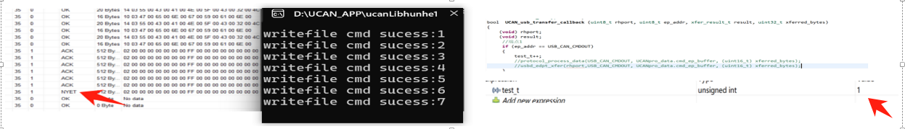

With my hypothesis that 'the DMA buffer might not be cleared, or the endpoint interrupt is not cleared, etc.', in the receive complete callback function, I submitted another transfer to the USB controller. I believed that the transfer function might clear the DMA buffer when submitting the transfer. I continued to send data continuously from the Windows USB side to the AM2434. This time, the number of data transfers was higher than before, but in the end, I found that the USB status was still NYET, and the number of prints on the Windows side was still 6 more than .

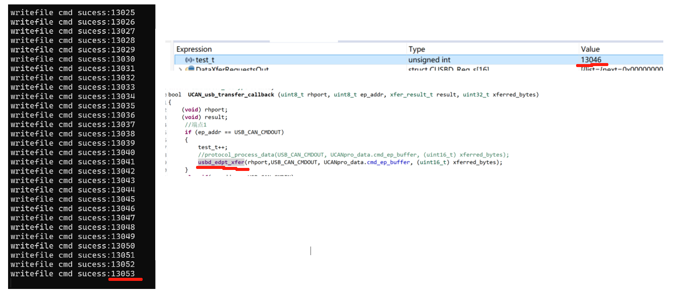

Through debugging, I found that usb_handle.pD->dmaController used 8 channels, and the subsequent channels were not used. I think each channel is related to an endpoint. The configuration of my endpoints is as follows:
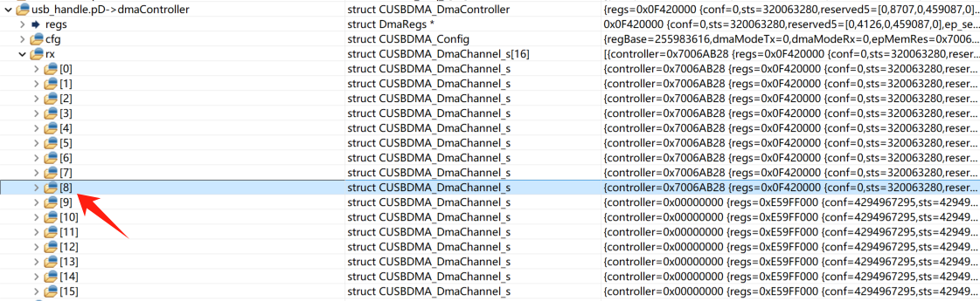
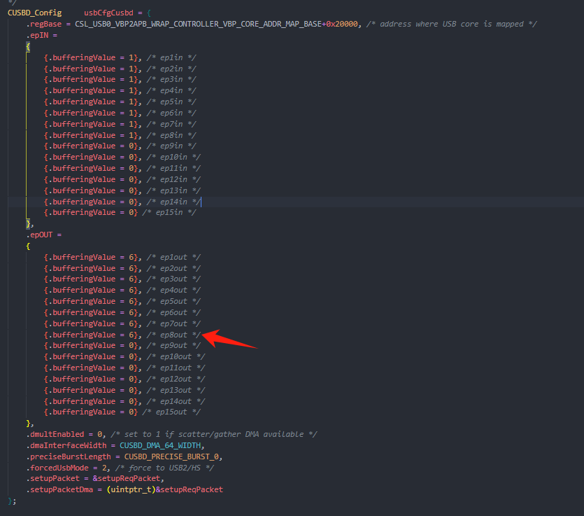

I tried to find the function for 'clearing the DMA buffer or clearing the endpoint interrupt' from within usbd_edpt_xfer and found CUSBDMA_ChannelProgram which configures the DMA controller. Inside it, the value configured for the regs->ep_sel register is something I don’t understand. In other words, could you tell me about the 'DMA buffer clearing process'?

