Question:
Why these two pictures show results with different LargestFreeSize, TotalSize, and totalFreeSize?

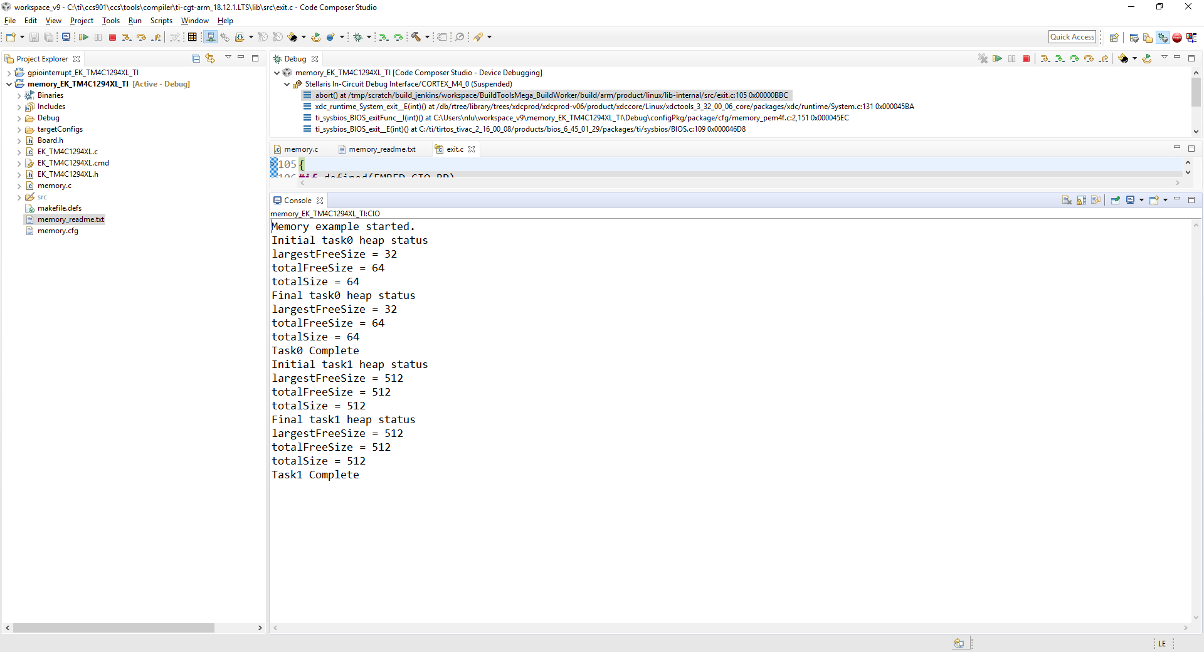

The following is from ROV, 1) You can see the second one is red colored; 2) all the sizes never are changed. 3) the values are different from the ones above.
