Using Stellaris® LM3S9B92 without crystal? Which limitations?

Andy S
132.180.168.179
Intellectual 580 points
Hi guys,
Right now I am reading through the system-clock part of the LM3S9B92's datasheet. But to be honest: I don't get it :)
1. Using the internal osc means, that I can't use the USB-interface, because the USB-PLL doesn't work for the internal clock?
2. The internal osc DOES allow the use of the PLL? So the maximum system-clock will be the same as using an external osc?
3. What is the the maximum frequency with PLL? Is it always those 400 MHz for the internal and an external osc (independet of the frequency of the external osc when using one?)
To put it all together:
4. What is the advantage using an external osc? That I can use USB and nothing more?
Thanks a lot!!
Andy
over 13 years ago
- Like
- More
TI Alex 192.91.75.29 over 13 years ago
TI__Expert 8270 points
Andy,
The "Main Clock Tree" figure in the "System Control" -> "Functional Description" -> "Clock Control" -> "Clock Configuration" does a good job at showing what the clocking is doing.
Andreas Duesel said:
1. Using the internal osc means, that I can't use the USB-interface, because the USB-PLL doesn't work for the internal clock?
Yes.
Andreas Duesel said:
2. The internal osc DOES allow the use of the PLL? So the maximum system-clock will be the same as using an external osc?
Yes.
Andreas Duesel said:
3. What is the the maximum frequency with PLL? Is it always those 400 MHz for the internal and an external osc (independet of the frequency of the external osc when using one?)
The frequency out of the PLL is 200MHz. Our parts do not currently run that fast so be sure to divide down this frequency further.
Andreas Duesel said:
4. What is the advantage using an external osc? That I can use USB and nothing more?
Using a crystal is a lot more stable than the internal PIOSC, over time and temperature.

Regards,
Alex

  - Up0Down
  - More
Andy S 132.180.168.179 over 13 years ago in reply to TI Alex
Intellectual 580 points
Hey Alex,
Thank you very much for your fast and precise answer!!
Using a crystal is a lot more stable than the internal PIOSC, over time and temperature.
I guess this is the argument, that speaks for using a crystal. Is there any recommendation which one to use? ...Or maybe you can give one? :-)
Best regards,
Andy

  - Up0Down
  - More
TI Alex 192.91.75.29 over 13 years ago in reply to Andy S
TI__Expert 8270 points
Andy,
All of our evaluation kits use XTALs. We have the schematics all on the TI webpage. That XTAL would be my recommendation.
http://www.ti.com/litv/pdf/spmu035c

Regards,
Alex
  - Up0Down
  - More
Andy S 132.180.168.179 over 12 years ago in reply to TI Alex
Intellectual 580 points
In the schematics in this manual there is the XTAL and and the OSC input - each is hooked up to a crystal (manual from post before, page 20) - is that correct?
But why is a crystal hooked up to the OSC input? I thought for the OSC input I have to use an oscillator instead of a crystal.

And to round it up: Why are there two clock sources (OSC and XTAL?) on the evaluation board?
In the Main Clock tree I can only see a main OSC (I guess that are the pins labled OSC with the 16 MHz Crystal) and a hibernation OSC (which has only 32kHz). So why is there an additional 25 MHz crystal hooked up to the XTAL pins?
Edit: sorry, the 25 MHz crystal seems to be for the Ethernet...
  - Up0Down
  - More
TI Alex 192.91.75.29 over 12 years ago in reply to Andy S
TI__Expert 8270 points
Andy,
Andy S said:
But why is a crystal hooked up to the OSC input? I thought for the OSC input I have to use an oscillator instead of a crystal.
A crystal is a type of oscillator.
Andy S said:
And to round it up: Why are there two clock sources (OSC and XTAL?) on the evaluation board?
In the Main Clock tree I can only see a main OSC (I guess that are the pins labled OSC with the 16 MHz Crystal) and a hibernation OSC (which has only 32kHz). So why is there an additional 25 MHz crystal hooked up to the XTAL pins?
Edit: sorry, the 25 MHz crystal seems to be for the Ethernet...
Correct.
Regards,
Alex
  - Up0Down
  - More
Andy S 132.180.168.179 over 12 years ago in reply to TI Alex
Intellectual 580 points
Thank you . So the terms "XTAL" and "OSC" are replaceable here...
It doesn't mean that XTAL is a crystal and OSC is a real oscillator ciruit - instead both are crystals..
  - Up0Down
  - More
Andy S 132.180.168.179 over 12 years ago in reply to Andy S
Intellectual 580 points
Here is an excerpt from the datasheet of the LM3S5Y36, regarding the internal oscillator.
The PIOSC generates a 16-MHz clock with a ±1% accuracy at room temperatures. Across the
extended temperature range, the accuracy is ±3%.
What does this 1% mean?
Does it mean, that there could be a deviation in time needed for one clockcycle compared to the time for the next cycle of 1% - or does it just mean, that the time for each cycle is fairly constant, but it could be either 15,86 MHz or 16:10 MHz or somewhere in that ballpark - depending on that single chip.
If the latter applies, it would be possible to get two µCs calibrated right, to run CAN with 1Mbit/s without a problem, I guess.
If the first applies, this will be really hard to achieve :)
  - Up0Down
  - More
Stellaris Ken 192.91.75.29 over 12 years ago in reply to Andy S
TI__Expert 3555 points
Hi Andy,
The PIOSC can be user calibrated for a fixed temperature and nominally the cycle to cycle variation is only +/- 0.25% but could be as high as +/-1% at a fixed temperature.

- Ken
  - Up0Down
  - More
cb1 99.96.44.135 over 12 years ago in reply to Andy S
Guru 47900 points
Andy S said:
:)
Even the "happy face" cannot put this dead horse out of its misery... (it is possible to ask too many questions)
  - Up0Down
  - More
Andy Neil 86.142.244.30 over 12 years ago in reply to TI Alex
Guru 35425 points
Stellaris Alex said:
A crystal is a type of oscillator.
No, that's not true.
A crystal is just a resonant element that can be used in an oscillator:

This is what's inside:
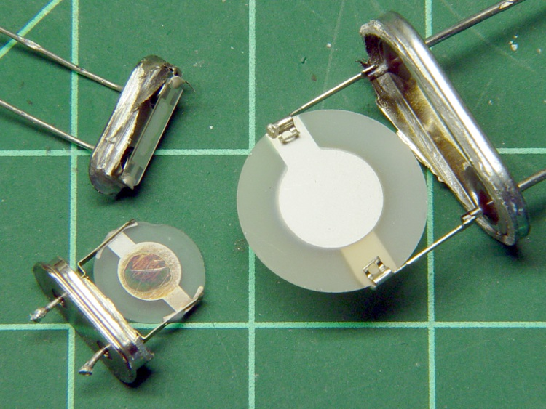
http://softsolder.com/2010/05/15/opening-a-quartz-crystal-can-effects-thereof/
As with most microcontrollers, there is an oscillator circuit within the Stellaris package and it can use an externally-connected crystal between the OSC and XTAL pins;
Alternatively, you can use an external clock source (eg, a crystal oscillator), and feed that into the OSC input.
Crystal Oscillators are available which contain both the crystal itself and an oscillator in a single package:

  - Up0Down
  - More
Andy S 132.180.168.179 over 12 years ago in reply to Andy Neil
Intellectual 580 points
Thanks Ken - this means I have to assume the worst case deviation of 1 % when using the internal OSC. And thanks Andy for the clarification.
@cb1: It isn't hard to guess, that you feel annoyed somehow - I am sorry for that. Please don't bother helping me, if you don't want to or if you think the question is too stupid.
  - Up0Down
  - More
cb1 99.74.78.177 over 12 years ago in reply to Andy S
Guru 47900 points
Andy S said:
isn't hard to guess

Engineering demands judgements/trade-offs - one must balance cost versus benefit. A crystal costs well under 1 USD - its use is a no-brainer. FOUR times skilled TI staff responded - others @ my firm & myself all thought this bordered on "misuse" of a valued TI resource. As fellow "content provider" a. neil pointed out - great detail re: your issue was readily available elsewhere - only marginally was this Stellaris specific.
Far future - when your volume exceeds 10K EAU - xtal elimination possibly make sense. For now - new elements of risk & complexity are introduced - which I do not believe best serve you nor other readers. Over my engineering/business career I've often observed that "over attention" to minor detail most always results in "less than optimal" attention to the more vital and/or impactful.
I do memorialize & applaud your obvious passion - only ask that you bear down a bit more on the essentials - I know this will speed your/others Stellaris understanding... TI far outperforms its sector in direct support and care of this extraordinary forum. Our posts should ease - not add - to TI's support burden...

  - Up0Down
  - More
Andy S 132.180.168.179 over 12 years ago in reply to cb1
Intellectual 580 points

cb1- said:
others @ my firm & myself all thought this bordered on "misuse" of a valued resource.
I am sad to here that.
In this case for me it is vital that the system is as small as possible. This was the only reason, why I asked, if I can omit the XTAL. Using a 64 LQFP with 403 capacitors with or without an XTAL means a difference in pcb size. But I will find room for it.
It had nothing to do with the BOM.

cb1- said:
"over attention" to minor detail
You are for sure right. But for that you need to know what are minor details and what aren't. Telling me stuff about dead horses and that I am almost misusing valued resources doesn't help me to learn that distinction. It does indicate it, yes, but it in a suboptimal way.
Let's please drop that.

  - Up0Down
  - More
Andy Neil 86.142.244.30 over 12 years ago in reply to Andy S
Guru 35425 points
Andy S said:
for me it is vital that the system is as small as possible
It would have been helpful if you had mentioned this key constraint in your original post
http://www.catb.org/~esr/faqs/smart-questions.html#goal

