Hi Sunil,
Yes, I have undergone the example of hetPWM.c
I have a doubt in HALCoGen configuration in HET1 Tab,
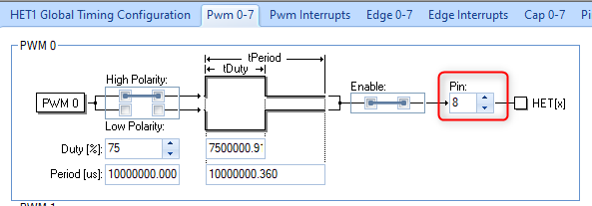
This Pin 8 is refers to HET1[8] or HET1[0] because it says PWM 0 and Pin 8.
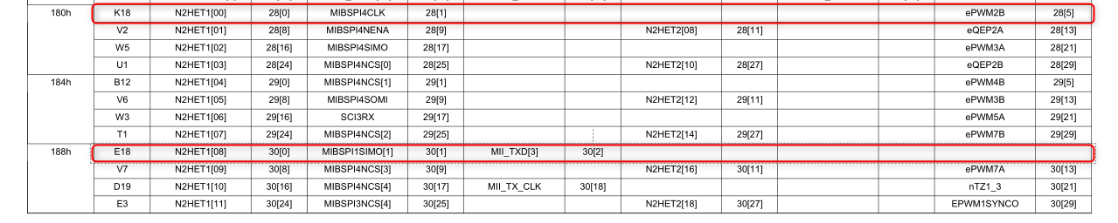
And also Dir should be selected for output is it correct
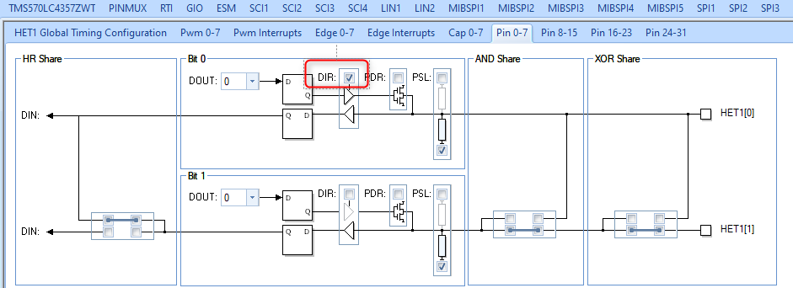

How to configure the particular frequency and its formula ?
Thank you in advance.

