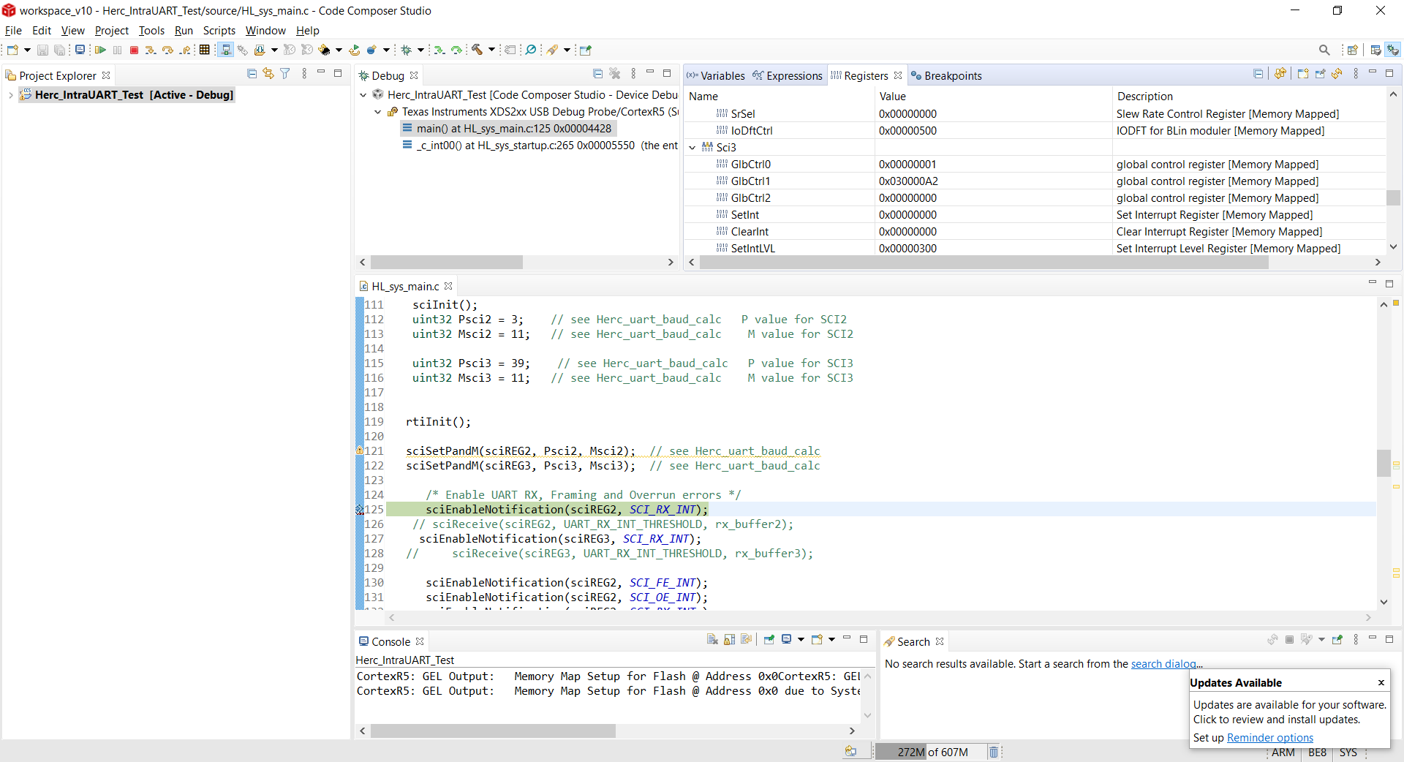

Figure see 'sciSetPandM' function

I call the function and see this in BSR reg for “sci2”.

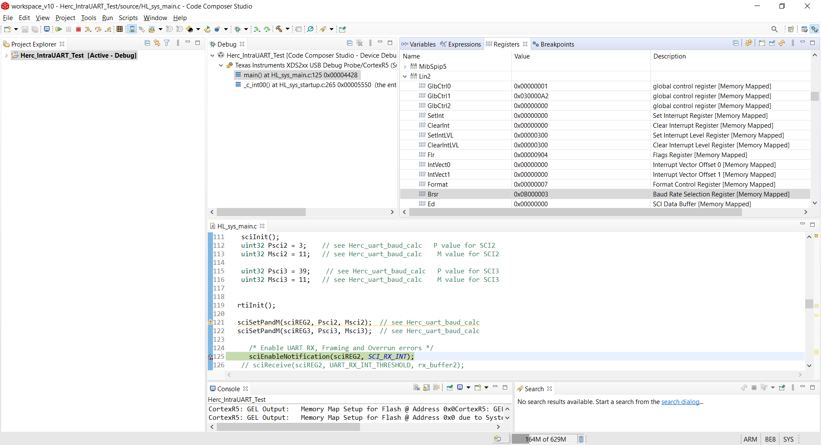

Figure LIN2 (SCI2) loads correcly.....

SCI3 does not load the “M” upper nibble..??????????????

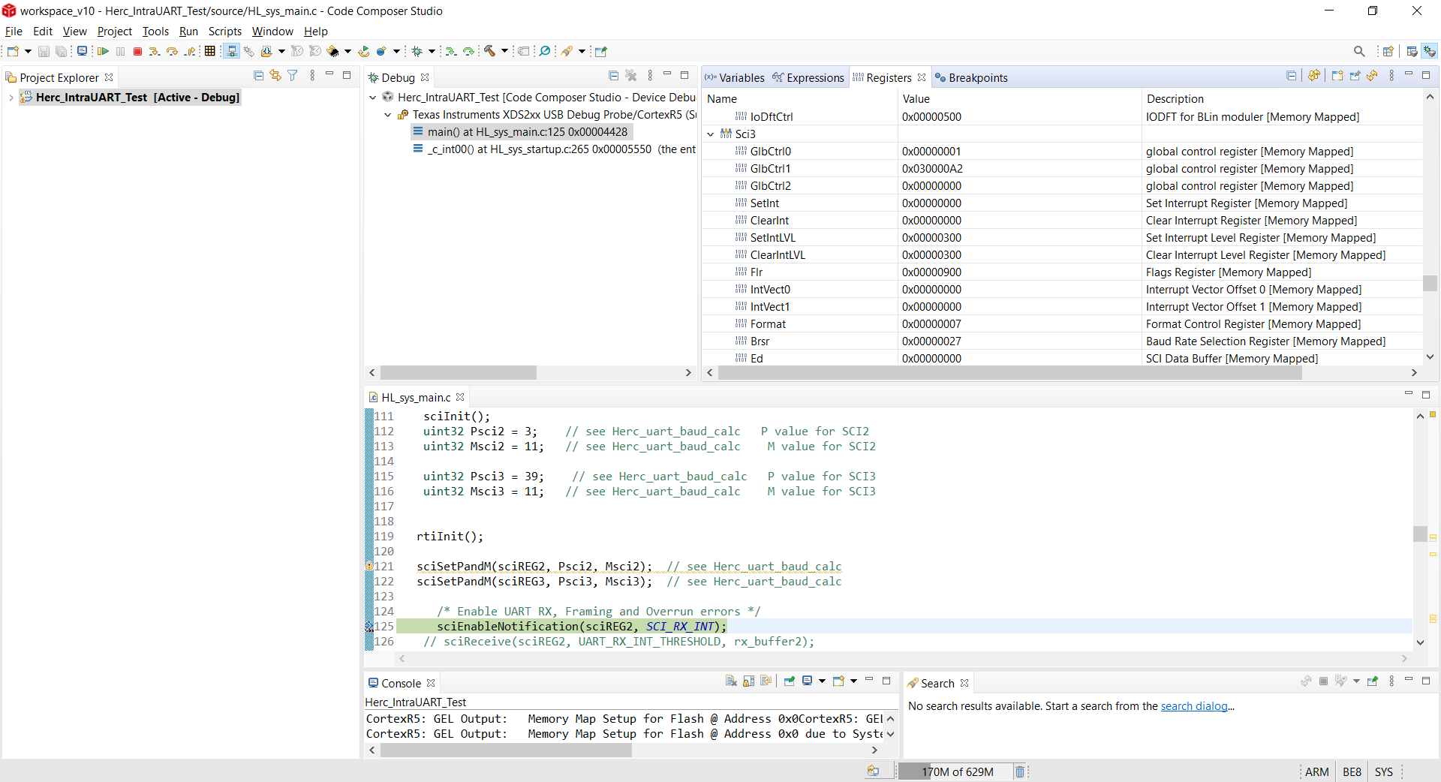

Figure why doesnt M upper nibble at bits 27-24 load?????????