**3.9.1.3 Adding Both Images and Batch Files**

This section covers how to add pattern images and a batch file to the firmware. These steps will allow the

user to add patterns to the flash and have them automatically uploaded to the DLPC900 upon power up.

The GUI should not be connected when starting this process.

1. Check Virtual Connect in the System Controls box on the upper left of the GUI. Then select the

platform, either DLP6500 or DLP9000.

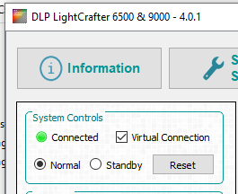

2. Navigate to the Batch File page and check the Enable Command Log box.

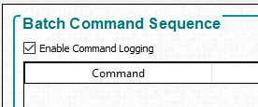

3. In the operating mode box on the left of the GUI select Pattern on-the-fly Mode.



4. Navigate to the pattern mode tab and add images.

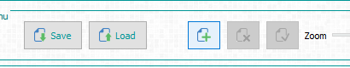

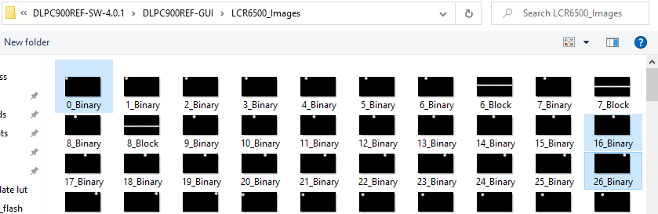

5. Adjust exposure settings and other pattern configurations to desired values.

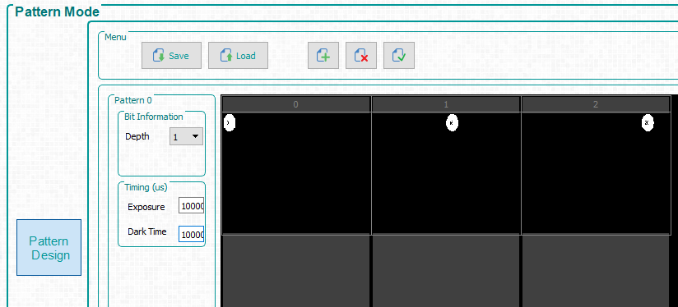

Use exposure time and Dark time as 1Sec (1000000)

6. Click the update LUT button.

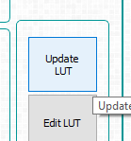

7. Click the start button if it is desired for the pattern sequence to be running upon start-up.

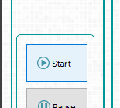

8. Navigate to the Firmware Page and browse to select a firmware to be modified.

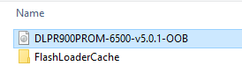

9. Check all four boxes in the Batch File and Patterns Box on the bottom right of the firmware page.

10. Type in a name for the batch file.

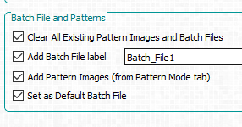

11. Press the Update Firmware button.

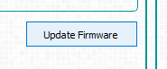

This will generate a new firmware image containing the pattern images and batch file located in the

pattern mode tab and the batch file tab respectively. This firmware file is ready to be uploaded to the

system when connected.

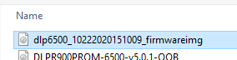

Now this firmware contains Batch file with Patter image information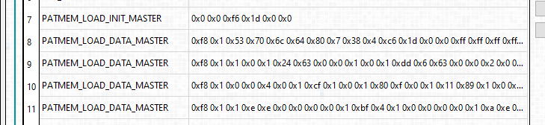

After this firmware is uploaded, you can see this batch file listed here and when you click execute, batch file stored in the firmware will be executed. This batch file can also be selected and executed using Commands.

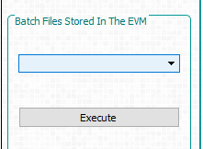

Note:

1. Instead of storing pattern image information in Batch file, you can store the images in the Firmware. This feature is called **Pre Stored Pattern Mode.** In step 3, choose “Pre stored pattern mode” for this option.

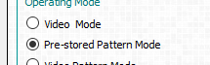

Then use batch file to choose which pattern image from the flash to be displayed.

1. When you store the Pattern images in firmware (**Pre Stored Pattern Mode),** you can access it using “Images from flash” option also. Refer to section ***3.9.1 Adding or Removing Patterns from the Firmware***

