DLPC900 Storing more than 400 one-bit patterns to Flash and Displaying

Problem Statement
- DLPC900 internal memory is designed to store maximum 400 one-bit patterns. How to store and display more than 400 one-bit patterns?

From EVM User guide: Section 3.9.1 Adding or Removing Patterns from the Firmware
For most efficient storage and compression of images, the GUI will pack the images into groups of 24-bit
RGB bitmap images. This means if there are 1-bit black and white images, 8-bit gray scale images, or any
other image bit-depth (up to 24-bit images), they will be combined to create a composite image.

For example, a composite image could be composed of 24 1-bit images, 3 8-bit images, or a combination of
images of various bit-depths which add up to a 24-bit composite image.
The GUI will then compress each 24-bit image using the Enhanced Run-Length Encoding described in the
DLPC900 Programmer's Guide. These compressed images are then decompressed as they are loaded
into the DLPC900 internal memory when operating in Pre-Stored Pattern Mode or Pattern On-The-Fly
Mode.

The EVM is capable of holding up 400 1-bit binary or 50 8-bit binary compressed patterns in flash
memory. Depending on the compression ratio, more than 400 patterns can be stored to have multiple
pattern sets for multiple pattern sequences. These patterns are then loaded when the operating mode is
set to Pre-Stored Pattern Mode. The remainder of this topic will apply only to Pre-Stored Pattern Mode.
The DLP LightCrafter 6500 and 9000 EVMs are pre-loaded with a pattern sequence that is displayed
when power is applied to the EVMs. Since the GUI does not know the images that are stored in flash
memory, it is advisable to delete all images from flash before storing new ones. When adding images to
the Pattern Design panel, the GUI will always begin with image index Zero. However, the GUI saves the
images to the firmware by appending them to the end of the last image that is in the firmware if any.

For example, assume there are two 24-bit images stored in the firmware. These two images will have
index values of 0 and 1. If then a pattern sequence is created in the Pattern Design panel, where the GUI
packs all the images into four 24-bit images, and then saved to the firmware, the four images will be
appended to the firmware and have index values of 2, 3, 4, and 5. When the firmware is uploaded to the
EVM and the pattern sequence is started, the sequence of images will be 0, 1, 2, 3 rather than 2, 3, 4, 5.

Sample One-Bit pattern images and its splash, Bit positions on the memory

Procedure to Store and display 1080 one-bit patterns with DLPC900 controller?
- Clearing internally stored pattern images from OOB firmware image.
  - Open DLP LightCrafter DLPC900 GUI, Set to virtual connection
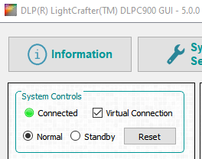

  - Set Chipset type to DLP6500
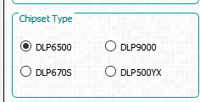

  - Browse and Select OOB firmware image.
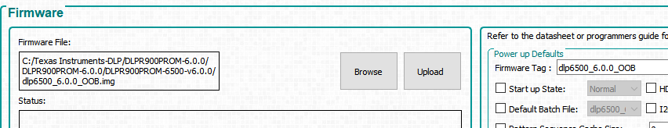
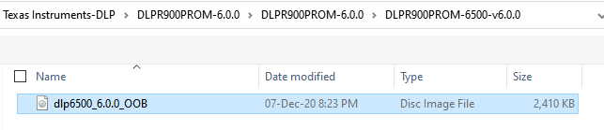

  - Change Firmware tag
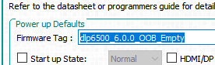

  - St check box “Clear all Existing Pattern Images”, Click Update Firmware button to generate firmware without any internal stored patterns.
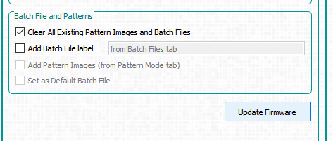

  - New Firmware will be generated.
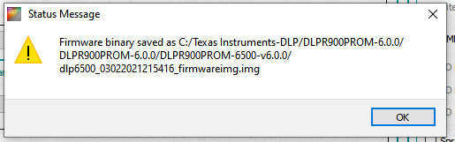

  - Click ok and browse to the firmware generated location, Rename the file
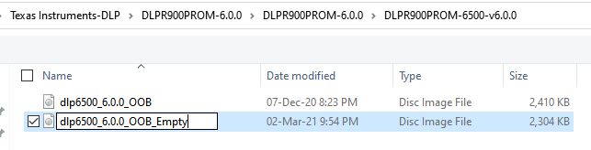

- Adding Pattern images to Firmware.
  - Browse and Select newly created firmware image
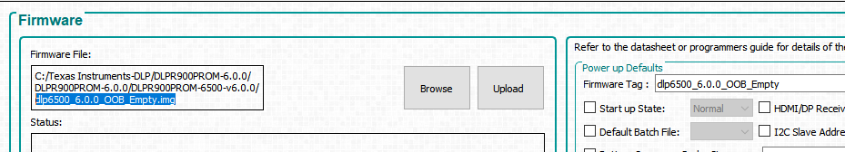

  - Select Pre-Stored Pattern Mode from Operating mode.
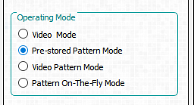

  - Add all the 1080 one-bit patterns. Make sure the patterns are added in proper order.

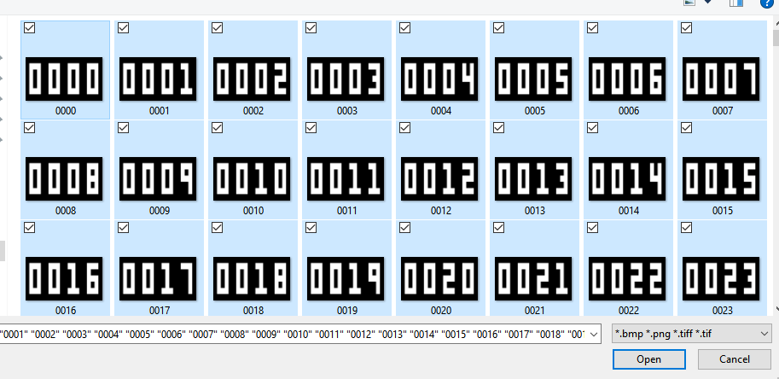

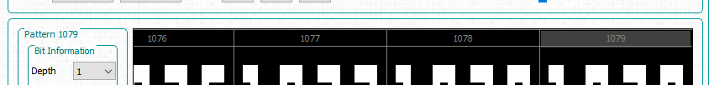

  - Select all the added bit planes and set to One-bit depth
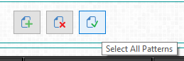

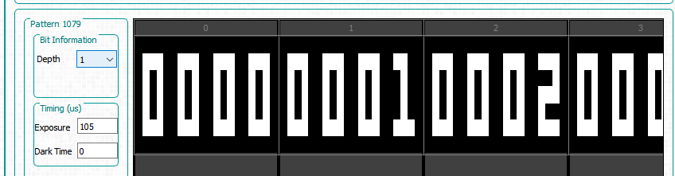

  - Click Firmware page and Change the Firmware Tag
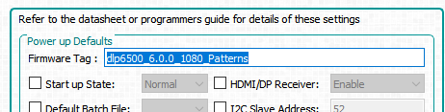

  - Select “Add Pattern Images (from Pattern Mode Tab)” check box and click Update Firmware
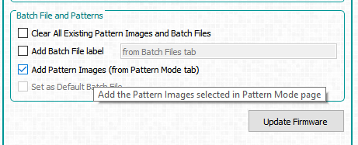

  - Firmware Generation takes few seconds.
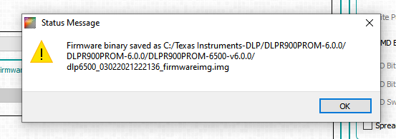

  - Click OK and Open the newly generated firmware and rename the file.
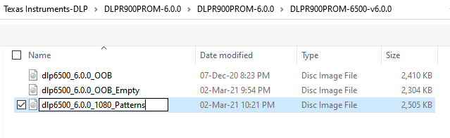
- Loading the newly generated firmware.
  - Power up the hardware, Connect USB cable.
  - Close the GUI and Re open.
  - Go to firmware page
  - Browse and select newly created “dlp6500_6.0.0_1080_Patterns.img” file
  - Click upload.
  - Wait for the upload to complete.
  - After the firmware upload, make sure firmware Tag is shown properly.
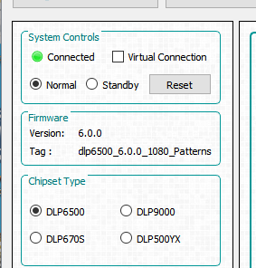

- Steps for Displaying Pre-Stored Patterns from Flash.
Note: Capture serial debug logs when performing below steps to identify any error reported.

  - Switch to pre stored pattern mode
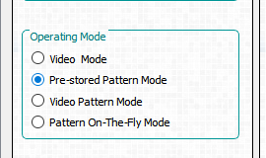
  - Add a pattern image by clicking on “Plus” Icon,
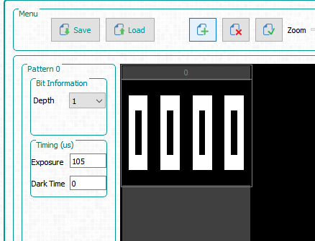
  - Since 24 one-bit patterns are stored as one Splash image, to display patterns from flash memory, Correct Splash index and bit position need to be specified. Refer to attached excel file.
  - To display 55th pattern, Splash index is 2, Bit position is 7
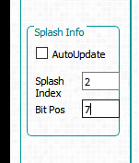
    - Click Stop, Enter the Splash index and Bit Position, Click update LUT, Start
  - To display 450th pattern, Splash index is 18, Bit position is 18
    - Click Stop, Enter the Splash index and Bit Position, Click update LUT, Start
  - To display 1001th pattern, Splash index is 41, Bit position is 17
    - Click Stop, Enter the Splash index and Bit Position, Click update LUT, Start
- Loading Multiple patterns from Flash to Internal memory and Display continuously.
  - Batch file is created to load set of 384 (24x16) one-bit patterns from flash memory and display them continuously. Following batch will display patterns every 100 mili seconds. Refer to DLPC900 software programmers guide for command details. Refer to EVM user guide for details on creating Batch Files.
  - To execute batch file
    - Navigate to Batch file page
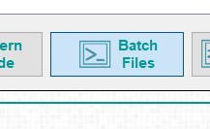
    - Load Batch file
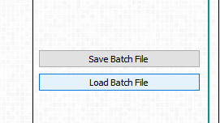
    - Select the batch file to be loaded
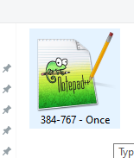
    - Click execute all
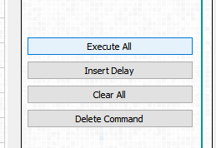
    - Now DMD will start showing patterns from 384 to 767
    - Repeat the same procedure for displaying other patterns.

