1. **Applications FPGA PROM programming**
   1. Attach the Xilinx programming cable to connector H1 with the other USB end to the PC with the Xilinx iMPACT software (or similar programming software). Texas Instruments strongly recommends using Xilinx iMPACT 32-bit v14.1, v14.2, or v14.5
   2. Launch the iMPACT software. If prompted to load a project, click Cancel.  
      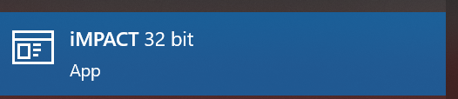
   3. Create a new project and click on **Boundary Scan**.  
      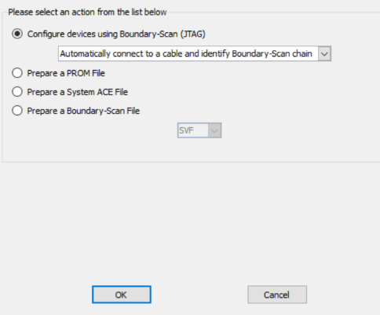
   4. If you are already using an existing project, right click anywhere in the main window and select **Initialize Chain**.
   5. The iMPACT tool should find 2 devices. You will be asked to assign configuration files. Select ‘Yes’ to begin assigning *.bit files to your apps FPGA.  
      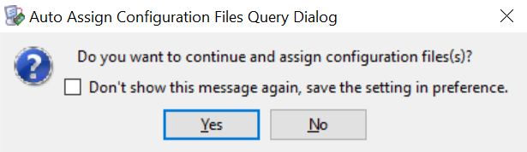
   6. Assign the ddc4100_merge-freq400-space32.bit file to the apps FPGA (XC55VLX50, which will be called the LX50 from this point onward). You will be prompted to assign a SPI or BPI PROM to this device. Click ‘Yes.’  
      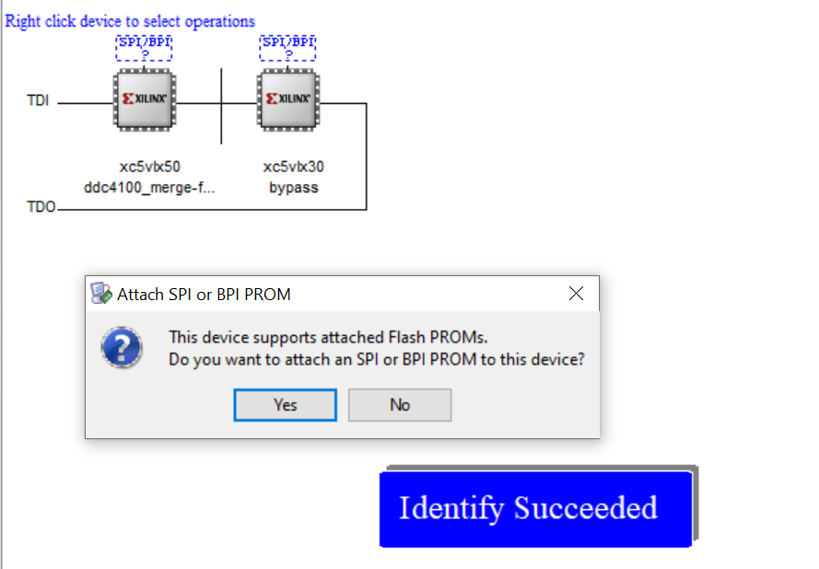
   7. Assign ddc4100_merge-freq400-space32.mcs to the appropriate SPI or PROM and then select with SPI or BPI PROM you are using. TI installs the following 32 Mbit SPI PROM with a data width of 1:  
      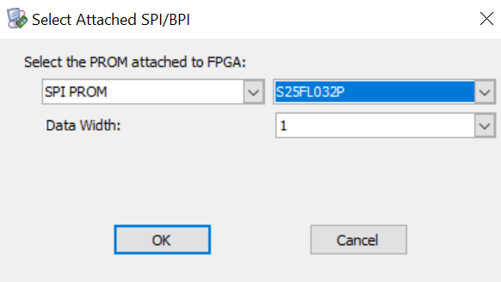
   8. The following dialog box appears. Click ‘Yes’ after you have carefully checked that this applies to you.  
      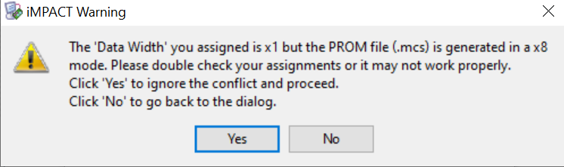
   9. The dashed SPI or BPI box now turns into a solid box that says FLASH. You will get a second window asking to configure the controller FPGA (XC5VLX30). You may click ‘Bypass’ or ‘Cancel’ to bypass this device.
   10. Device Programming Properties is now opened. You may access this by right-clicking on either the PROM or FPGA you wish to program. Ensure you have “verify” enabled and “design-specific erase”. For the drop-down box, have the FPGA automatically loaded with flash contents.  
       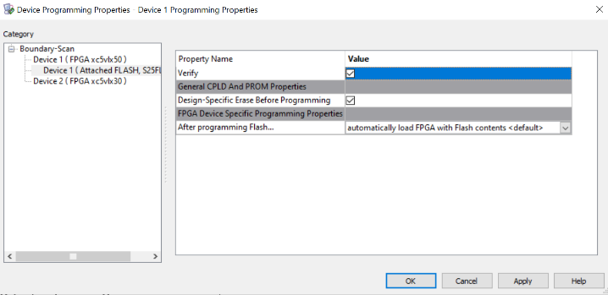
   11. Right click on the SPI or BPI PROM device and select **Program**. Check **Verify** and **Erase Before Programming** in the ensuing pop-up configuration window if you have not done so already. This may have been done in the previous step already.
   12. After all programming is complete, test the board to verify functionality and proper version ID.
       1. Please ensure the board is recognized by the Discovery4100 GUI. The bottom left of the GUI should say that it is connected via USB. This is what it looks like with no DMD connected.  
          