**Tx Spurious Emissions: 802.11b Channel 6 (2437MHz)**

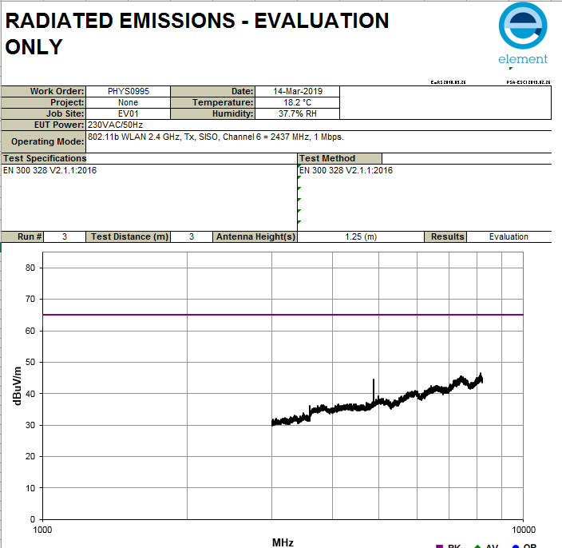

**Rx Spurious Emissions: 802.11b Channel 6 (2437MHz**

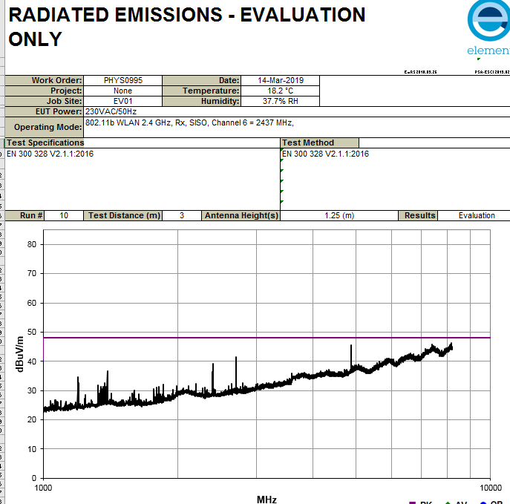

**Maximization performed on 2nd harmonic Rx Spurious emissions for 802.11b Channels 1, 6, 11**

