TI E2E Forum Inquiry:
CC3200: Http Client Demo- case insensitive compare of HTTP message header fields
Linker Library Settings:
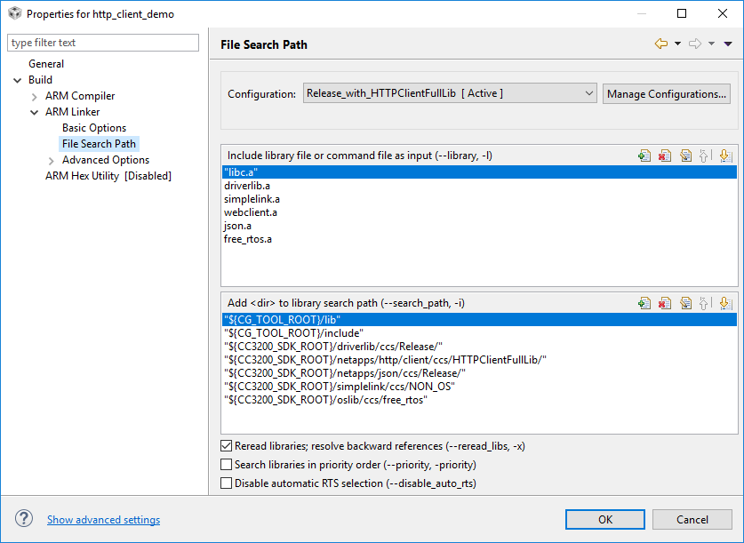
Error messages from build:
