How are you sending data from the CC3200 AP to the PC? Is it a TCP socket?
Tcp socket

Step 1 Set PIN55/57 for Uart,and set PIN62 for NWP logs according to the Application document
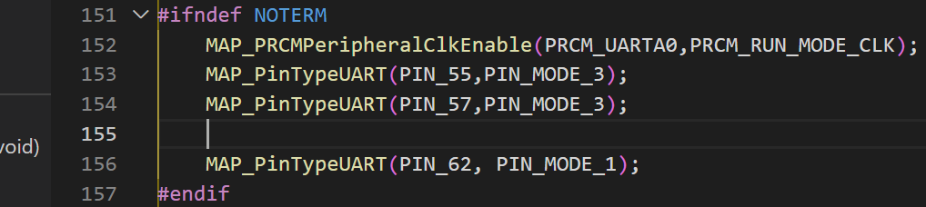

Step 2 set Terminal Property
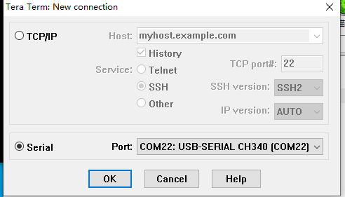

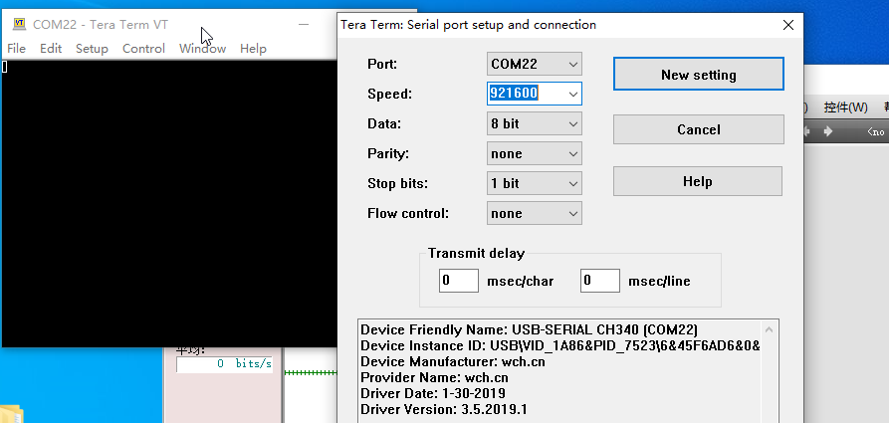
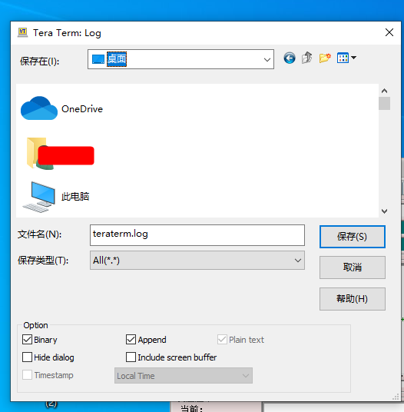

Step 3 Capture the running log
The UART 0 , print the log When the system transmission is abnormal can be as listed the figure
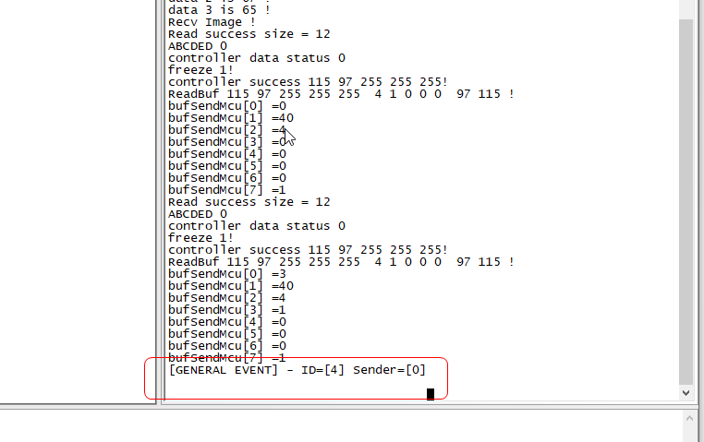

The NWP log is in the file teraterm0617.log

