Hardware :LAUNCHXL-CC3235SF TEST
Signal
YELLOW : nRESET
BLUE: VBAT
GREEN: Ibat
SOFEWARE:
TI software

TEST POINT：VBAT and Ibat

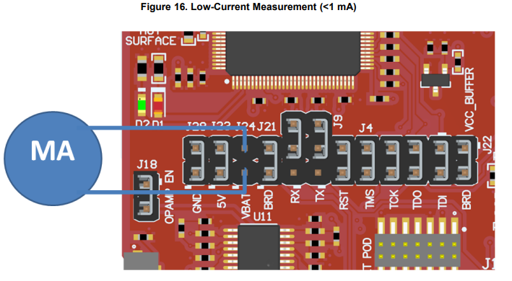
TEST POINT: nRESET
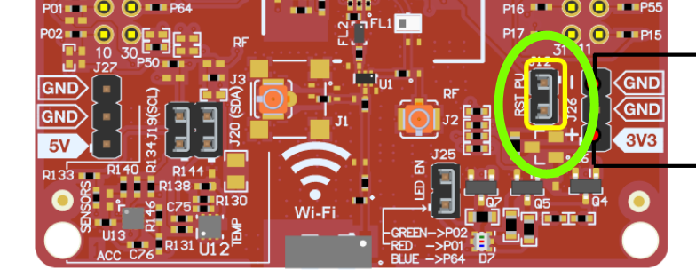

After n_RESET turn high, about 1.2s later, it appears rush current

