CC3301 communication reference from TI

Waveform: ThickMAC_R9_init_roleUp_scan_connect.sal
Overall Waveform
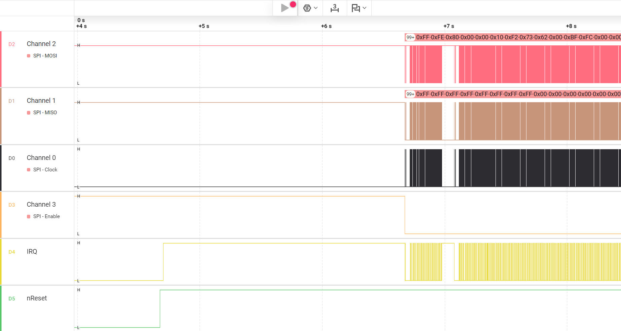

Reset
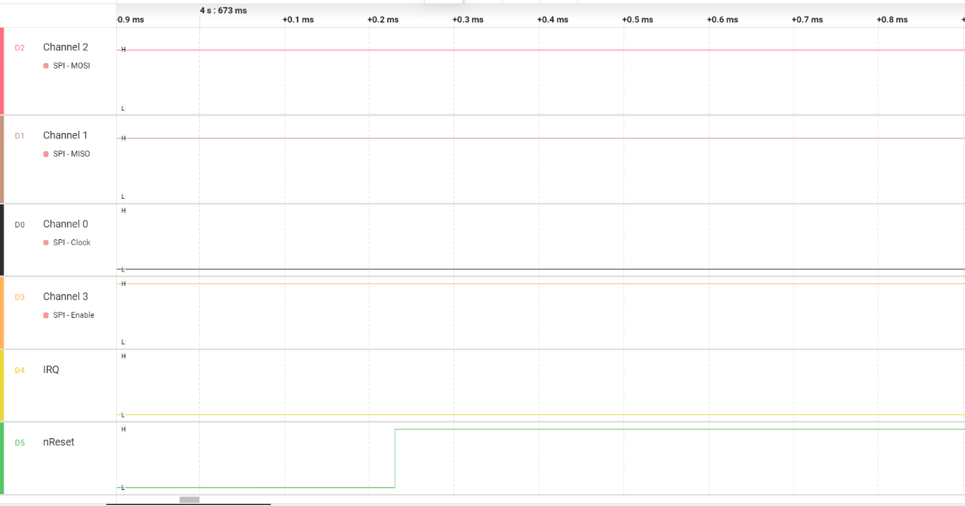

IRQ
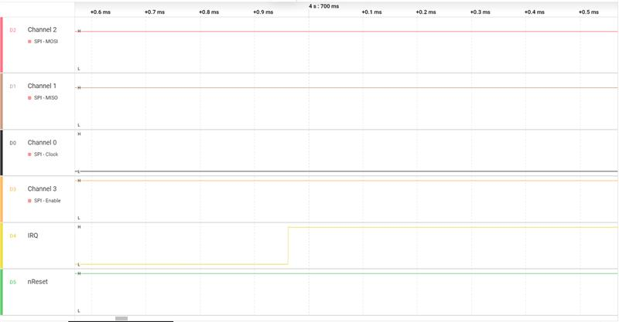

Enable SPI and Host initiated communication (TI Reference)
- IRQ remain high
- Host send dummy command FF FE 80 00 00 10 F2 73
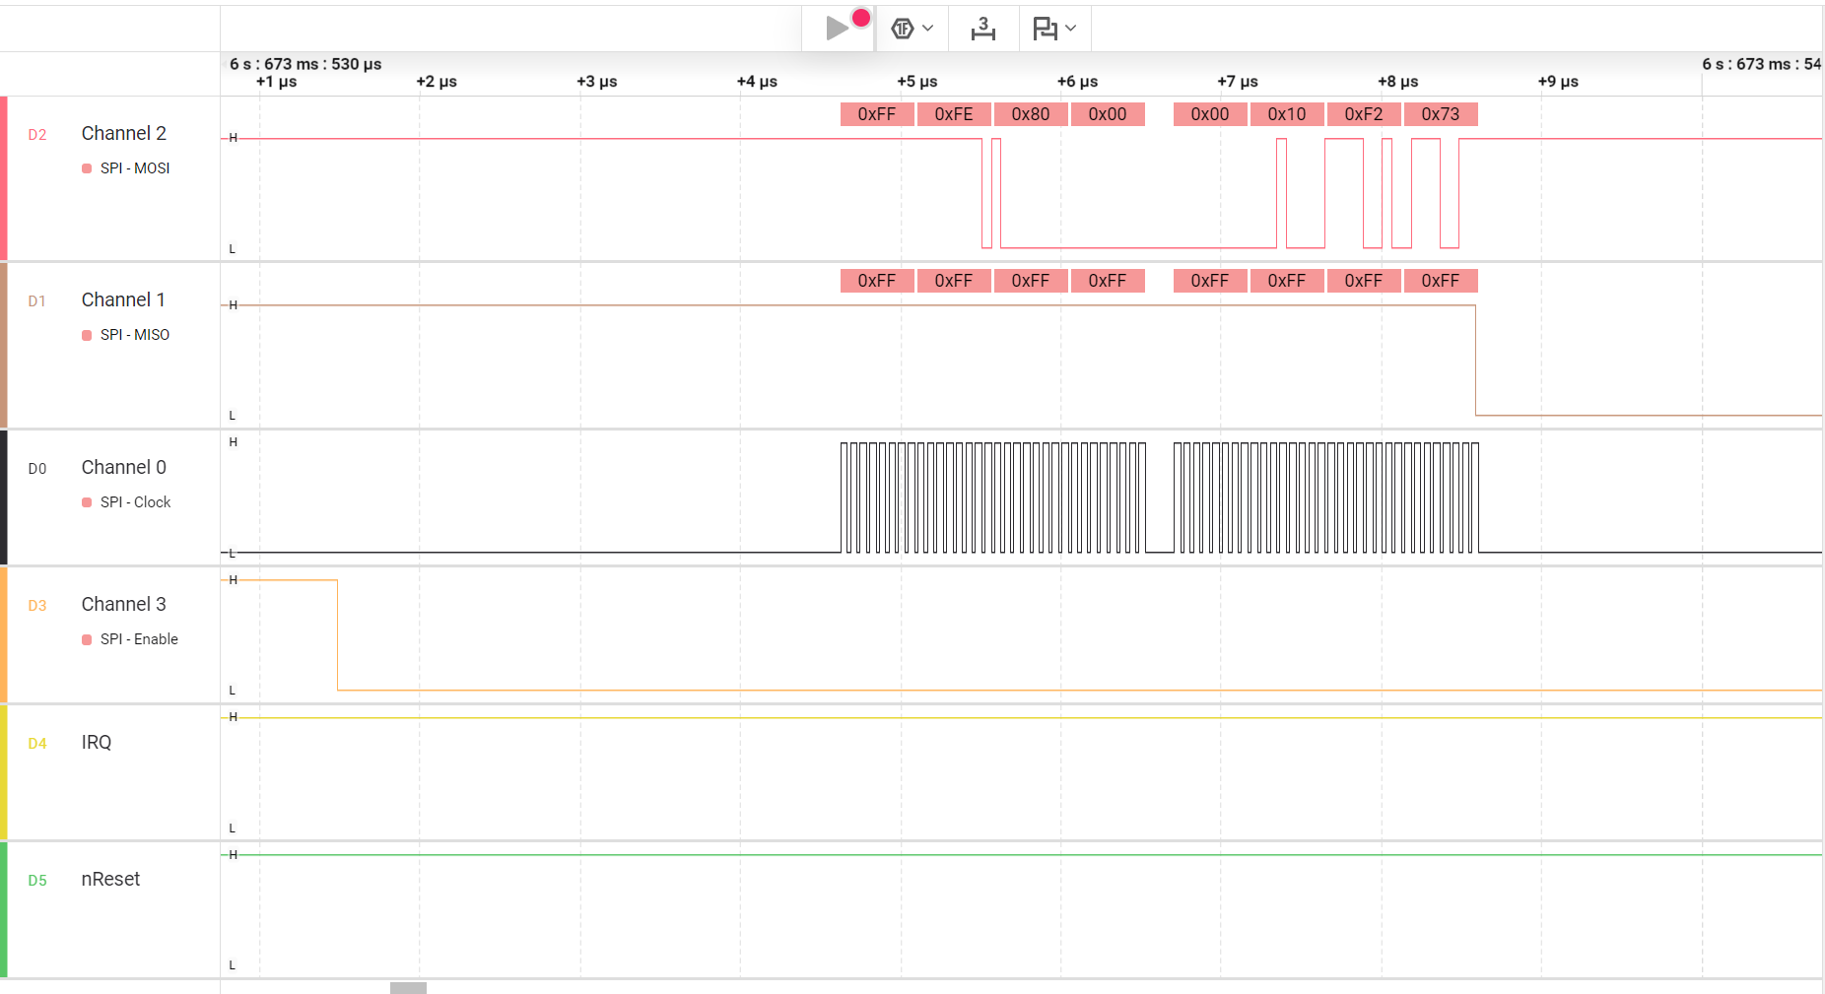

Second command
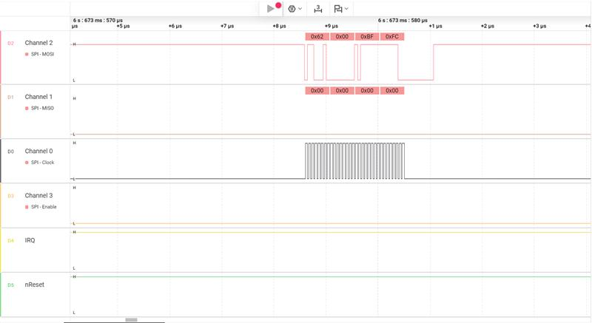

Third command as 0 and IRQ turn low
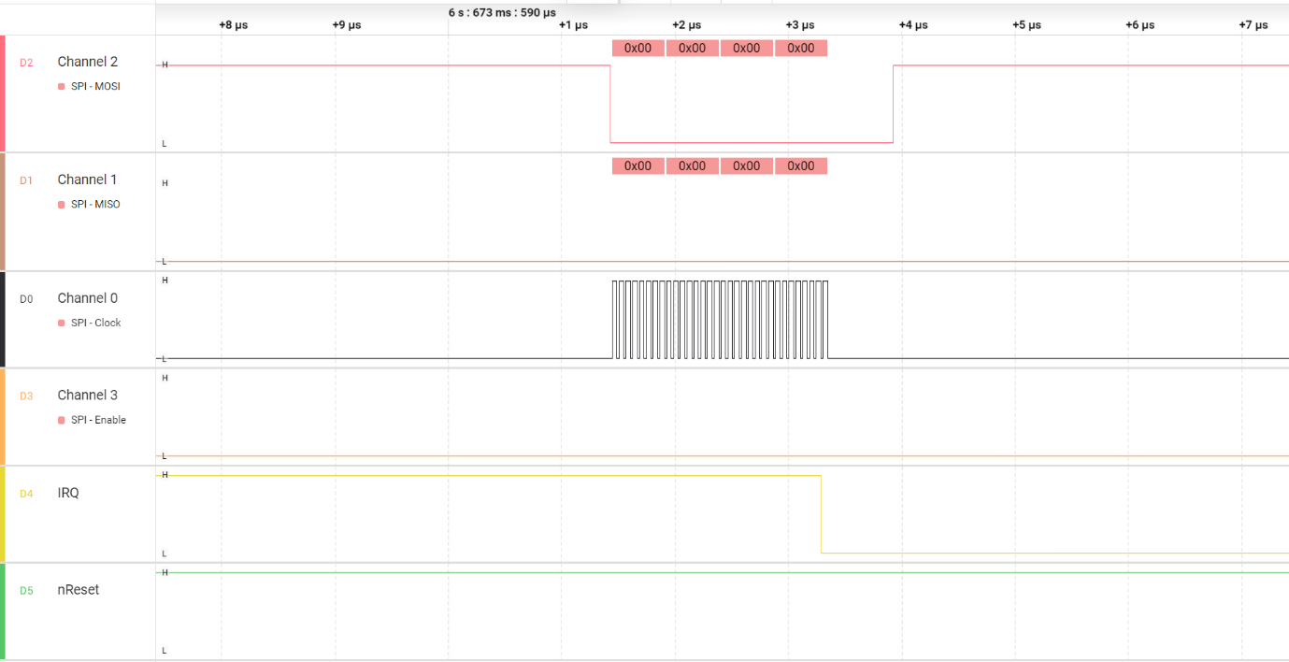

First data over MISO
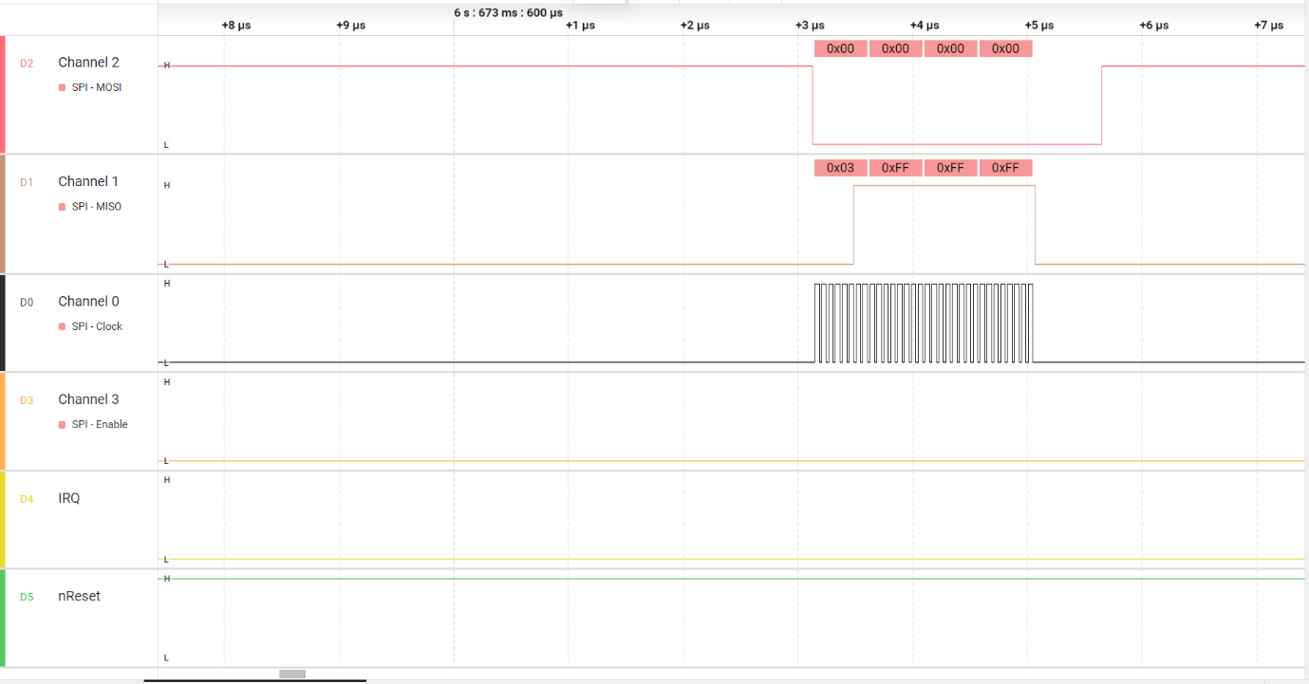

Subsequent data over MISO
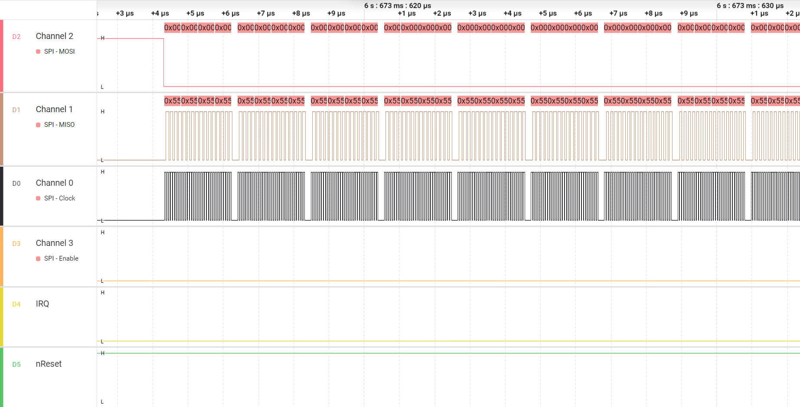

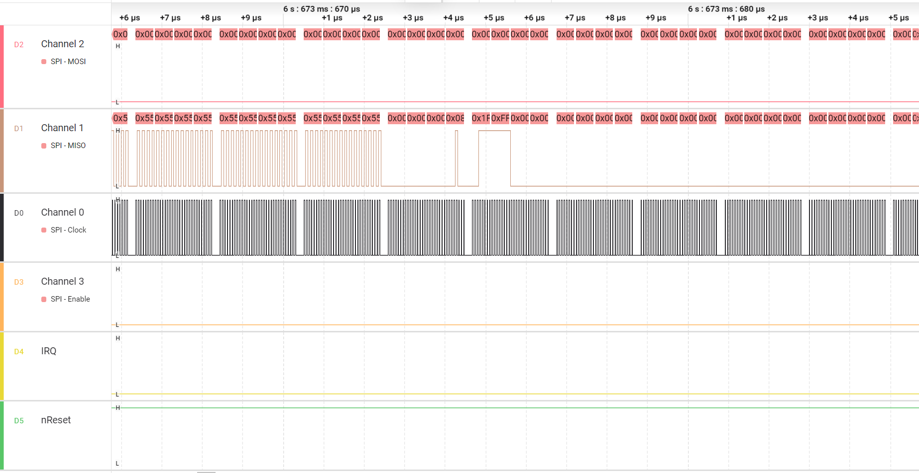

Data transfer finished
