Wlan_start initial sequence:
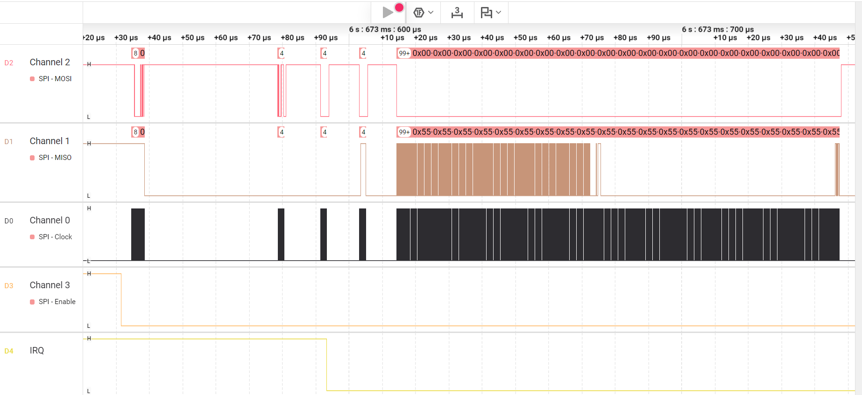
5
4
3
2
1

Wlan_start initial sequence - HOST_SYNC_PATTERN 0x5C5C5C5C observed after some time – Does this part of ctrlCmdFw_WLSendCommand?

