Using CCS 10.2.0, Ubuntu 18.04.05 LTS, Kernel 4.15.0-130-generic

Installed CCS 10.2.0 From download, CCS10.2.0.00009_linux-x64.tar.gz and ran the extracted compress file. Then ran the setup as shown.
$ cd CCS10.2.0.00009_linux-x64
$ ./ccs_setup_10.2.0.00009.run

1. Selected Custom Installation
2. Selected the following components:
Simplelink MSP432 low power + performance MCU’s
SimpleLink CCWi-Fi CC32xx Wireless MCU’s
TM4C12x ARM Cortex-M4F core-bsed MCU’s
3. Skipped the Install debug probes
4. Install finished without error then did the following from my console

$ cd ../ccs1020/ccs/install_scripts
$ sudo ./install_drivers.sh
TI permissions file installation completed successfully. Some distros of Linux
may require a reboot in order for the driver to function properly. For other
distros, restarting udev is sufficient. Restarting udev now ...

Using my desktop ICON launched CCS 10. I then successfully built my MSP432 and Tiva applications. Ran those applications successfully with the onboard debug/emulator on the MSP432 and Tiva Launchpad products.

Next with the MSP432 and Tiva Launchpads removed connected my:
Simplelink Wi-Fi Family
CC3200 LaunchPad

Board info:
Model: CC3200-LAUNCHXLA
FCC ID: Z264-CC3200KITA
IC ID: 4511-CC3200KITA

All jumpers are installed as shown in Figure1. Of SWRU376E User’s Guide.

Connected then disconnected to see if the board was connected properly using dmesg, with the result as shown.

$ dmesg
[ 2963.175710] ftdi_sio 5-1:1.1: device disconnected
[ 2963.466060] usb 2-1.3: reset high-speed USB device number 5 using ehci-pci
[ 2965.278062] usb 5-1: new full-speed USB device number 3 using xhci_hcd
[ 2965.539862] usb 5-1: New USB device found, idVendor=0451, idProduct=c32a
[ 2965.539880] usb 5-1: New USB device strings: Mfr=1, Product=2, SerialNumber=3
[ 2965.539882] usb 5-1: Product: USB <-> JTAG/SWD
[ 2965.539884] usb 5-1: Manufacturer: FTDI
[ 2965.539886] usb 5-1: SerialNumber: cc3101
[ 2965.544157] usb 5-1: Ignoring serial port reserved for JTAG
[ 2965.546609] ftdi_sio 5-1:1.1: FTDI USB Serial Device converter detected
[ 2965.546657] usb 5-1: Detected FT2232C
[ 2965.547227] usb 5-1: FTDI USB Serial Device converter now attached to ttyUSB0
[ 2969.178079] usb 2-1.3: reset high-speed USB device number 5 using ehci-pci

Notice the line that states “usb 5-1: Ignoring serial port reserved for JTAG.
Then used the utilities found from the installation of ccs10.

Following the same procedure above with Windows 10 and using the device manager.
The com ports installed message was as follows.
COM6 dual port, port B

1. Installed example from Resource Explorer, as shown:
Images are from Resource Explorer and Project Explorer after import

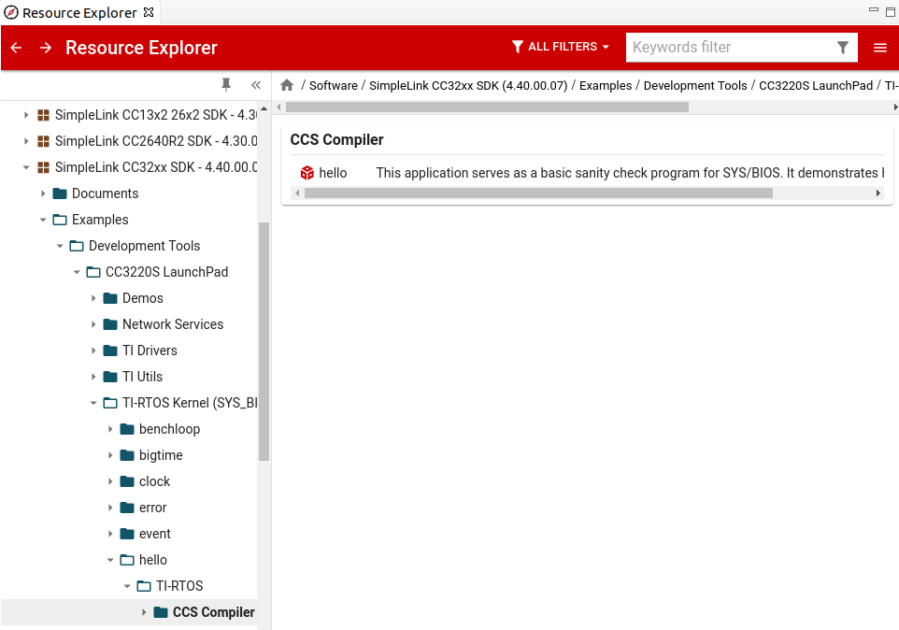
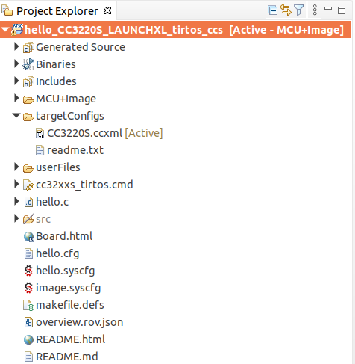

Successfully built the project hello_CCS320S…. With the following Problems

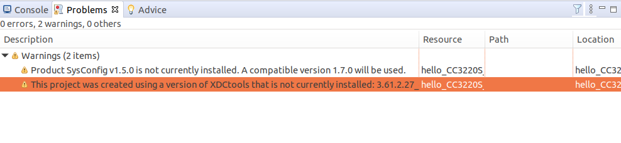
The tools that are installed are xdctools_3_62_00_08_core.

From ccs launched the debugger Run->Degug

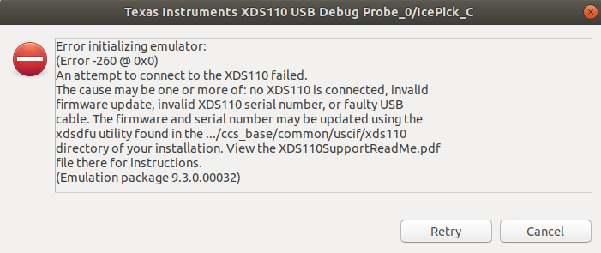
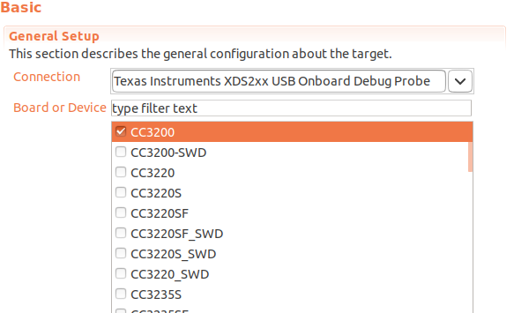
From their I opened the target Configs CC3220S.ccxml file and selected the CC3200 with the Onboard Debug Probe as shown.

Saved the target configuration file and tried to relaunch the debugger with the following result

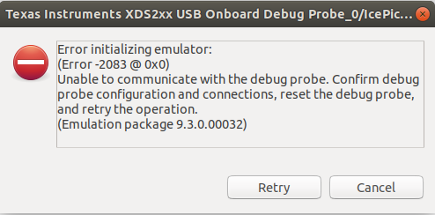

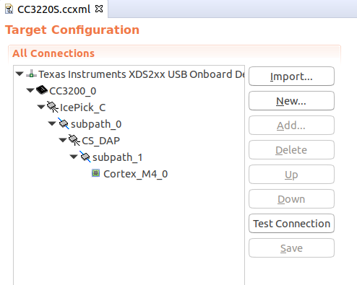

Using the “Test Connection” the result is shown

[Start: Texas Instruments XDS2xx USB Onboard Debug Probe_0]
Execute the command:
%ccs_base%/common/uscif/dbgjtag -f %boarddatafile% -rv -o -S integrity
[Result]
-----[Print the board config pathname(s)]------------------------------------
/home/xxxx/.ti/ccs1020/0/0/BrdDat/testBoard.dat
-----[Print the reset-command software log-file]-----------------------------
This utility has selected a 560/2xx-class product.
This utility will load the program 'xds2xxu.out'.
E_RPCENV_IO_ERROR(-6) No connection: DTC_IO_Open::dtc_io
Failed to open i/o connection (xds2xxu:0)

An error occurred while soft opening the controller.
-----[An error has occurred and this utility has aborted]--------------------
This error is generated by TI's USCIF driver or utilities.
The value is '-250' (0xffffff06).
The title is 'SC_ERR_ECOM_EMUNAME'.
The explanation is:
An attempt to access the debug probe via USCIF ECOM has failed.
[End: Texas Instruments XDS2xx USB Onboard Debug Probe_0]

Listing of the CCS3200S.ccxml file

<?xml version="1.0" encoding="UTF-8" standalone="no"?>
<configurations XML_version="1.2" id="configurations_0">
<configuration XML_version="1.2" id="Texas Instruments XDS2xx USB Onboard Debug Probe_0">
<instance XML_version="1.2" desc="Texas Instruments XDS2xx USB Onboard Debug Probe_0" href="connections/TIXDS2XXUSB_onboard_Connection.xml" id="Texas Instruments XDS2xx USB Onboard Debug Probe_0" xml="TIXDS2XXUSB_onboard_Connection.xml" xmlpath="connections"/>
<connection XML_version="1.2" id="Texas Instruments XDS2xx USB Onboard Debug Probe_0">
<instance XML_version="1.2" href="drivers/tixds560icepick_c.xml" id="drivers" xml="tixds560icepick_c.xml" xmlpath="drivers"/>
<instance XML_version="1.2" href="drivers/tixds560cs_dap.xml" id="drivers" xml="tixds560cs_dap.xml" xmlpath="drivers"/>
<instance XML_version="1.2" href="drivers/tixds560cortexM.xml" id="drivers" xml="tixds560cortexM.xml" xmlpath="drivers"/>
<platform XML_version="1.2" id="platform_0">
<instance XML_version="1.2" desc="CC3200_0" href="devices/CC3200.xml" id="CC3200_0" xml="CC3200.xml" xmlpath="devices"/>
</platform>
</connection>
</configuration>
</configurations>

At this point I tried all the probes available for the CC3200 in the Connection drop down list with similar results.

I even tried to connect to my USB port devttyUSB0 at 115200 baud and this is what I get after reset

**********************************************
CCS3200 Out of Box Application
**********************************************
I2C readfrom failed Error [-1] at line [1159] in function [main]

Lastly using the tools available I am still having failures as shown.

$ cd /ti/ccs1020/ccs/ccs_base/common/uscif/xds2xx
$ ./xds2xx_conf get xds2xxu /dev/ttyUSB0
Error : Failed to open port connection : xds2xxu : 0x0
Error : test failed

$ ls /dev | grep ttyUSB
ttyUSB0

I believe their should be to ports/decices shown USB0 and USB1 similar to the MSP432’s connection.

$ ls /dev | grep ttyACM
ttyACM0
ttyACM1

My conclusion is that the boards are the issue based on the same kind of behavior with Windows 10.

I have bought 2 of these boards one is at my workplace and will wait until I get a chance to test it also.

