The problem about IWR6843 IWR6843ISK-ODS
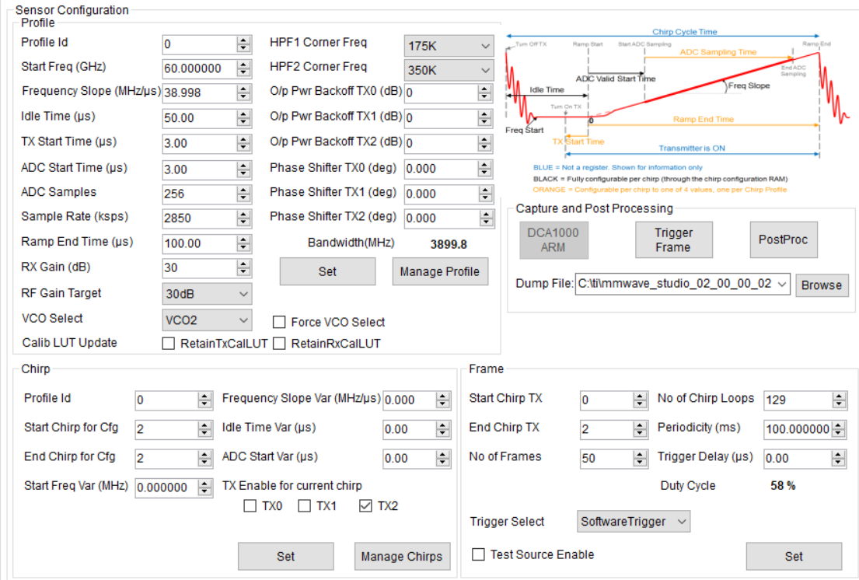
Figure 1 Parameter setting interface
Step1: pulse compression
After setting the No of Chirp Loops and Periodicity parameters in Figure 1, I start collecting the data. The first PRT of the collected data is taken as the first row of the matrix, the second PRT as the second row of the matrix, and so on, so a matrix named Data will be obtained. Then pulse compression was carried out for each row of the data matrix in turn to obtain a new matrix named Distance, which was drawn into an image using the imagesc function of MATLAB, and the result was shown in Figure 1.
Figure 2 Range profile
Because of the strong clutter generated by the stationary target in the environment, the Distance change generated by the target sloshing cannot be seen directly after pulse compression, so the Distance matrix needs to be further processed.
Step2:MTI(Moving Target Indicator)
I use the method of adjacent pulse subtraction for static clutter suppression, that is, subtract the first row of the Distance matrix from the second row of the Distance matrix, subtract the second row of the Distance matrix from the third row, and subtract the second row of the Distance matrix until the last row of the Distance matrix subtracts the second to last row of the Distance matrix.
When all the rows in the Distance matrix are completed, a new matrix, Distance_MTI, with one row less than the Distance matrix is obtained. After all the rows in the Distance matrix are completed, a new matrix Distance_MTI will be obtained with one row less than the Distance matrix. Similarly, the Distance_MTI is plotted using the matlab function imagesc to get the results as shown in the figure.
Figure 3 Range profile after MTI
Enlarge part of Figure 2 to get the result as shown in the figure.
Figure 4 FIG. 2 Partial magnification results
As can be seen from Figure 3, a bright line appears in the distance after MTI at equal intervals, and this interval is the same as the number of cycles in a frame of data emitted by the set radar.
Problem：When the last PRT of the previous frame is subtracted from the first PRT of the current frame, a bright line appears, while the next PRT within each frame is subtracted without a bright line. Is there a problem between each frame when the radar transmits a signal?

