**The areas where I need more clarification**

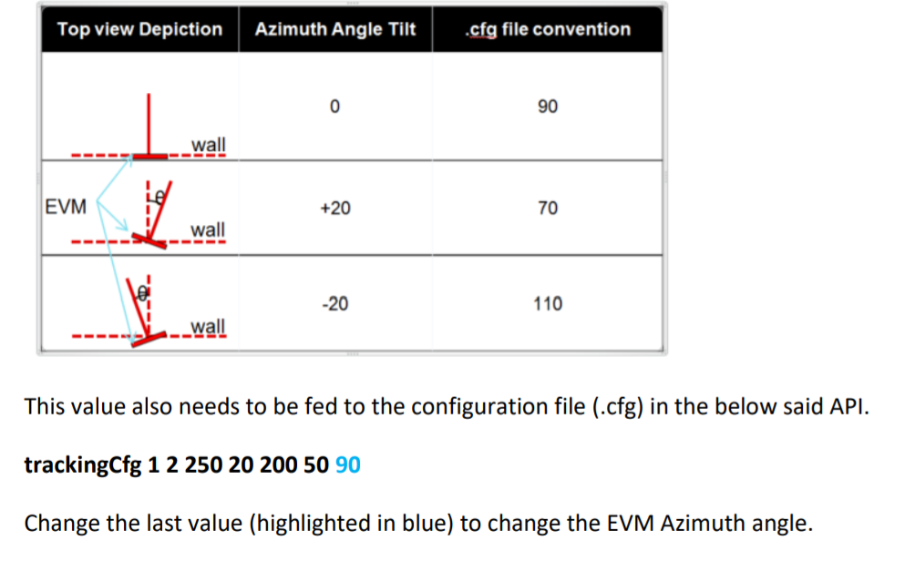

**Where does the above trackingcfg has to uploaded?**

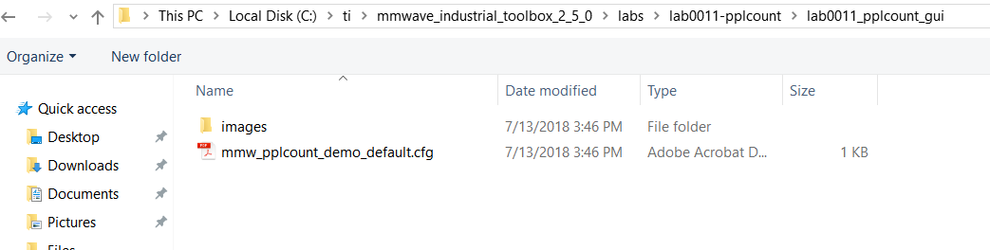

**Is this the .cfg file which must be uploaded??**

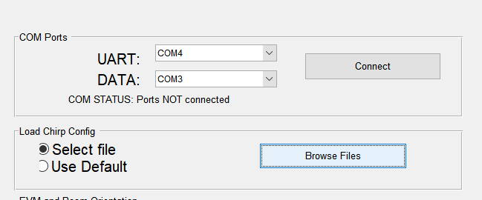

1. **Where do I find these parameters?**

