Hi
I have some Application issue in TI XIO2001

Currently, we are debugging AT-2916SX PCI card issue on platform AmazonDT.

AT-2916SX web : http://www.alliedtelesis.com/media/datasheets/2916sx_ds.pdf

We use AT2916SX with onboard XIO2001 , we can not open system.
Let me describe the symptom I found on on-board PCI slot (connected to TI PCIe-to-PCI [XIO2001]) with AT-2916SX as following:
(Environment: BIOS does not assign Expansion ROM base address. I manually assign the address under runtime.)
1. After reading device option rom from offset 0x1f84~0x1f87, system will hang if we continues to perform some reading action on other locations.
2. Per item#1, after reading any byte from offset 0x1f84~0x1f87, reading other locations which their data are not 0xff will become 0xff as well.
With the PCIe-to-PCI add-on card[TI XIO2001 EVM], I found that PCI CMD register is sometimes cleared after we enable device decode.
It causes option rom not dispatching and no PXE boot capability.
Observed this symptom on other platforms as well.
Did you have any experience/suggestion about these symptoms?

The register of PCI bridge. Is it register ?
Oboard XIO2001
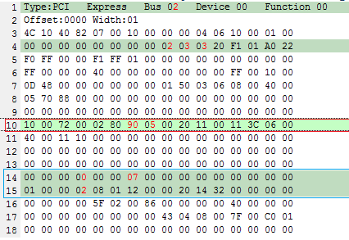
TI EVM
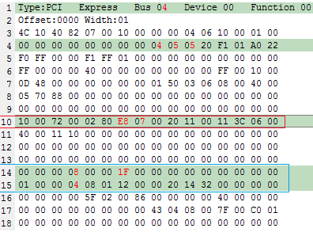

PCI offset : 18H
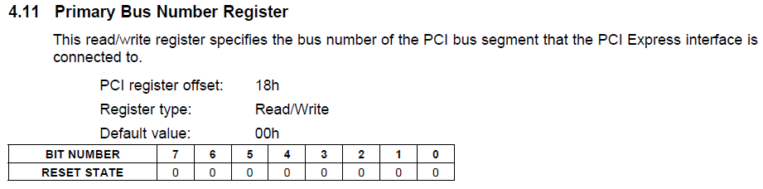
Board | add-on
0x02 | 0x04

PCI offset : 19H
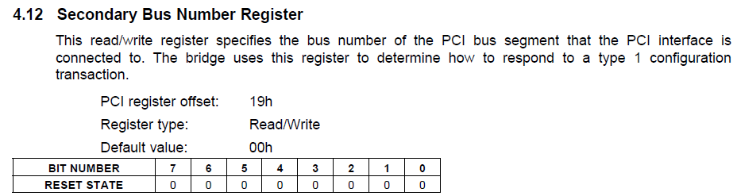
Board | add-on
0x03 | 0x05

PCI offset : 1AH
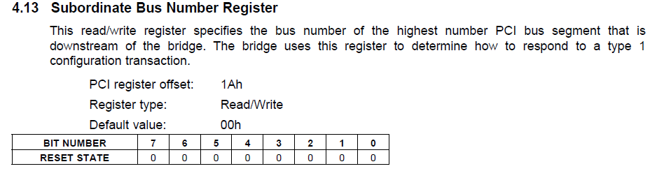
Board | add-on
0x03 | 0x05

PCI-offset : 76H / 77H
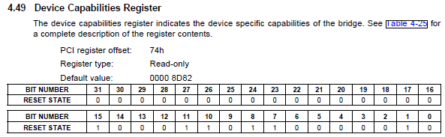
76H | 22 | 21 | 20 | 19 | 18 | 17 | 16 | 15
on Board | 1 | 0 | 0 | 1 | 0 | 0 | 0 | 0
EVM | 1 | 1 | 1 | 0 | 1 | 0 | 0 | 0
77H | 31 | 30 | 29 | 28 | 27 | 26 | 25 | 24
on Board | 0 | 0 | 0 | 0 | 0 | 1 | 0 | 1
EVM | 0 | 0 | 0 | 0 | 0 | 1 | 1 | 1

PCI-offset : B3H
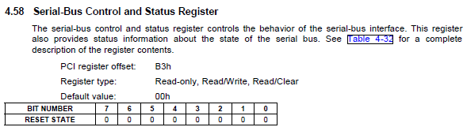
B3H | 7 | 6 | 5 | 4 | 3 | 2 | 1 | 0
on Board | 0 | 0 | 0 | 0 | 0 | 0 | 0 | 0
EVM | 1 | 0 | 0 | 0 | 0 | 0 | 0 | 0
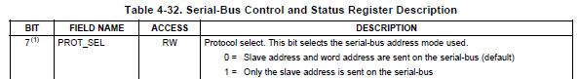

PCI-offset : B6H
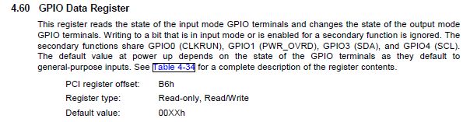
B6H | 7 | 6 | 5 | 4 | 3 | 2 | 1 | 0
on Board | 0 | 0 | 0 | 0 | 0 | 1 | 1 | 1
EVM | 0 | 0 | 0 | 1 | 1 | 1 | 1 | 1

PCI-offset : C3H
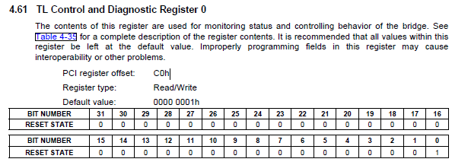
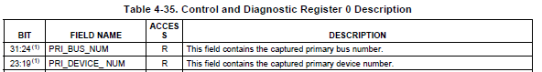
C3H | 31 | 30 | 29 | 28 | 27 | 26 | 25 | 24
on Board | 0 | 0 | 0 | 0 | 0 | 0 | 1 | 0
EVM | 0 | 0 | 0 | 0 | 0 | 1 | 0 | 0

