TI XIO2213B SPEC

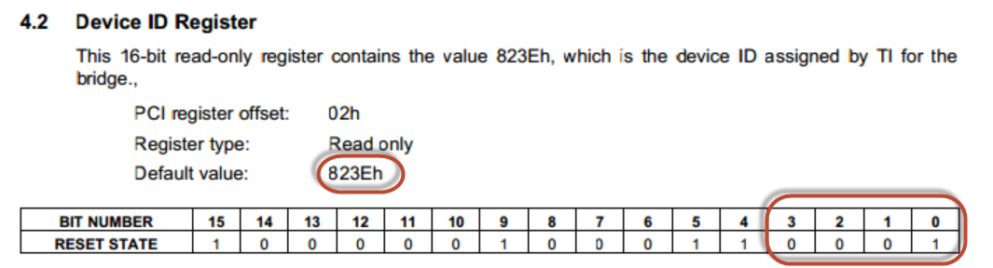

Device ID register is 823**E**. but Reset state is 823**1.**

But Device Manager show 823F

Could you help to check this issue? What device ID is right?

If Device is 823E , Why the device manager will show 823F?

