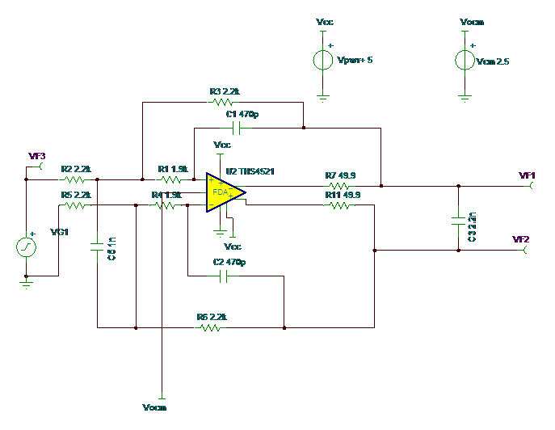

The ADS1278IPAPR datasheets recommends THS4521 as ADC I/P drivers & OPA1632 as alternate driver with bipolar supply.

Question: Can THS4521 Driver Works with Negative swing input when power with only positive Supply (i.e Vs+ = 5V,Vs- = 0V, VCOM= 2.5V), Following is the proposed Circuit configuration using as Single-ended to differential Out MFB-Anti-aliasing filter for ADS1278

My preliminary simulation results using TINA-7 shows the device accepts negative swing with VCOM = 2.5V.

The customer is more positive towards using THS4521 because of excellent Iq Current which suits for multi-channel ADC application
Please confirm this so that I can ask the customer to freeze the design.

