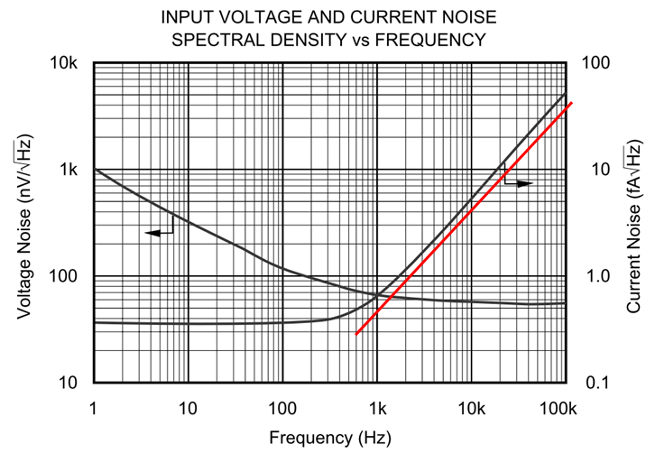
This is OPA347’s voltage & current noise density, and it’s similar in JFET/CMOS OPAs, the 1/f part of current noise is disappeared may because their tiny bias current, but why the red part of current noise density occur? Why the frequency’s increasing cause current noise density increase?

Comparing Bipolar OPA OPA277’s noise density plot, why Bipolar OPA has regular noise density?
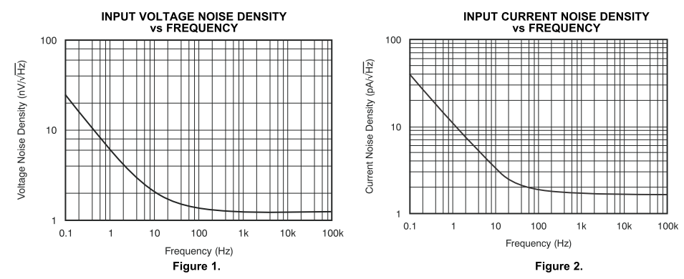

Art, Thanks a lot for your kind reply.

B. Regards,
Frank Huang

