REVISIONEN / REVISIONS
Rev. | Beschreibung / Description |  | Datum / Date |  | Erstellt / Prepared
1 |  |  | 2013-04-05 |  | Bach /S. Kumar
Test of Comparator TLV3491
60 269 33A

Copyright © UTC Aerospace Systems. This document is the property of UTC Aerospace Systems. You may not possess, use, copy or disclose this document or any information in it, for any purpose, including without limitation, to design, manufacture or repair parts, or obtain any government approval to do so, without UTC Aerospace Systems’ express written permission. Neither receipt nor possession of this document alone, from any source, constitutes such permission. Possession, use, copying or disclosure by anyone without UTC Aerospace Systems’ express written permission is not authorized and may result in criminal and/or civil liability.

Subject to the EAR, ECCN [9E991].
This information is subject to the export control laws of the United States, specifically including the Export Administration Regulation (EAR), 15 C.F.R. Part 730 et. seq. Transfer, retransfer, or disclosure of this data by any means to a non-U.S. person (individual or company), whether in the United States or abroad, without any required export license or other approval from the U.S Government is prohibited, including without limitation any diversion to a military end user or use in a military end use application.
ERSTELLER / AUTHOR(S) |  | 
 |  | PRODUKT – PROZESS / PRODUCT – PROCESS: |  |  |  | Rev.:  1
 |  | PROJEKT / PROJECT:  A350 |  | Bericht Nr. / Report No.:  E141302
 |  | Datei / File: E141302.docx |  | Seite / Page 1 von / of 3

Inhaltsverzeichnis / Table of Contents

1. ÄNDERUNGSHISTORIE / HISTORY OF CHANGES 3
2. AUFGABENSTELLUNG / TASK 3
3. BESCHREIBUNG / DESCRIPTION 3
3.1. Test on new part 3
3.1.1. Start up test 3
3.1.2. Normal operation 6
3.2. Test on old part 8
3.2.1. Start up test 8
4. FAZIT / CONCLUSION 9
5. VERTEILERPLAN / DISTRIBUTION 10
6. ANHANG / APPENDIX 10

ÄNDERUNGSHISTORIE / HISTORY OF CHANGES
Revision | Datum / Date: | Änderungsbeschreibung / Change Description

AUFGABENSTELLUNG / TASK
This Test Report shows the behavior of the comparators TLV3491 at startup.
There is a new components from the reel tested and an old used from an S1 board.

BESCHREIBUNG / DESCRIPTION
Basic functionality check on the comparator TLV3491

Test on new part

Start up test
The following test is performed to check the behavior of the comparator TLV3491 in the basic application circuit at lower supply voltage during power up.

Schematic of basic application circuit
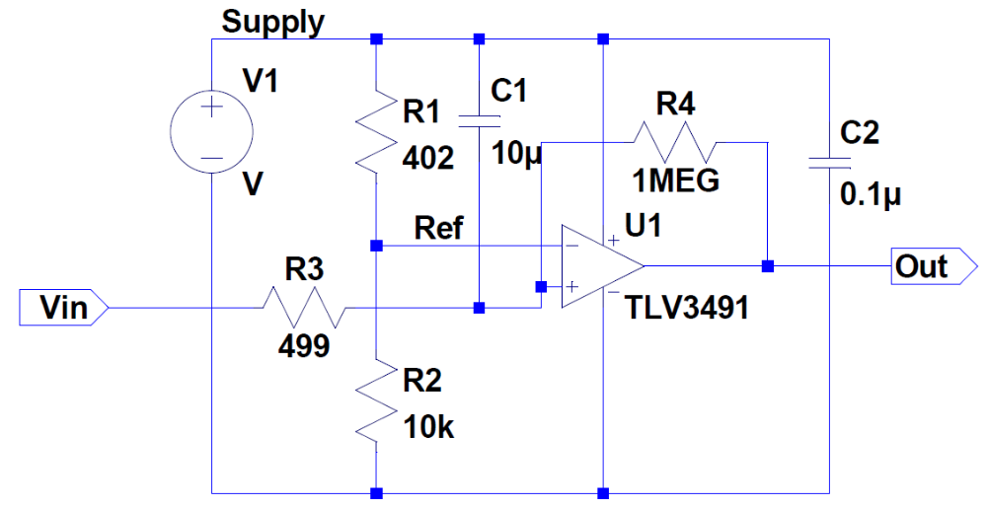

V
--
++
Ch4

V
--
++
Ch3

V
--
++
Ch2

V
--
++
Ch1
Figure 14: Basic application circuit using TLV3491

Note: Signal probed on oscilloscope(M1) is mentioned below,
Ch1: Vin, input voltage applied
Ch2: Supply, Power supply input of comparator,
Ch3: Ref, reference input of comparator
Ch4: Out, output pin of comparator

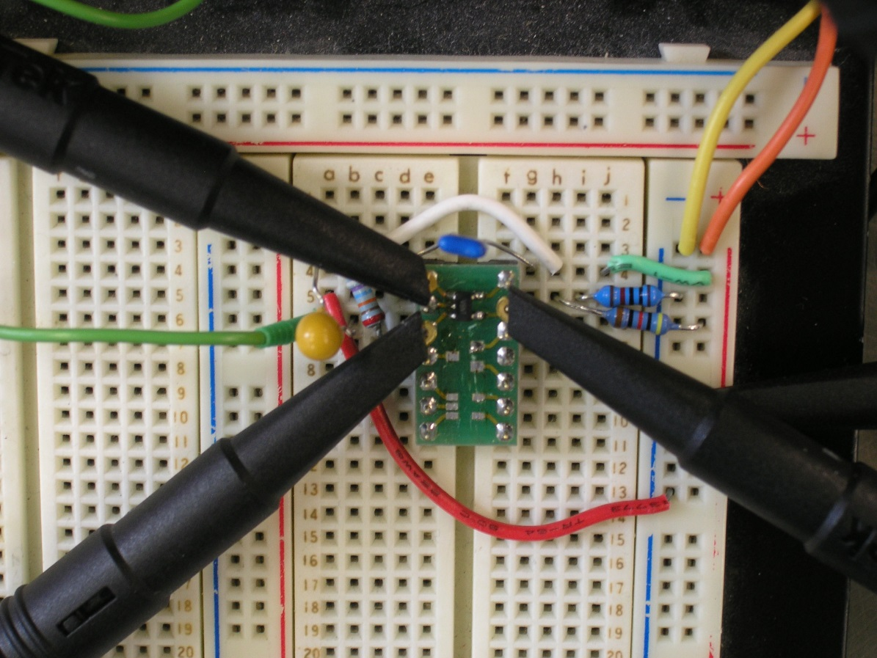
Figure 15: Snapshot of the circuit rigged up on bred board

Lab equipment used:

Instrument | Type | ID | equipment list
Supply | Knurr, 0-30V, 0-2A
Oscilloscope | Tektronix MSO 3034, Oscilloscope | 7177301
Function generator | Rohde & Schwarz 10mHz to 20MHz range | 2210300

Date code of the comparator sample: 0606 (100330000027)

The marking mentioned beneath this part is 62Z0.

As shown in Figure 14, when the input (Vin) and the Supply are shorted together and a voltage of 1.8VDC is applied, the delayed response in the comparator output is shown below,
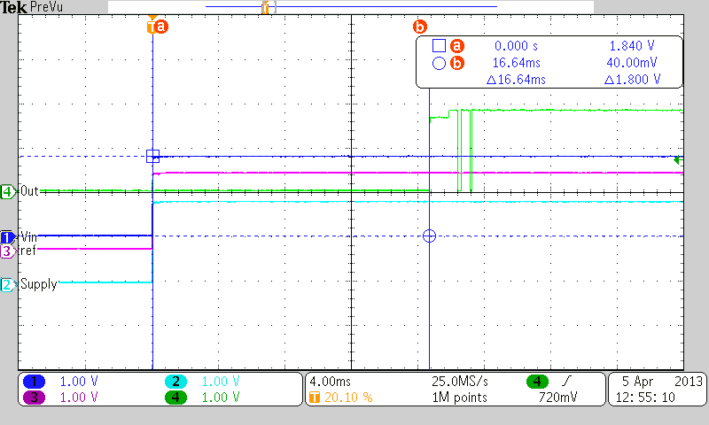

As shown in the above waveform the output goes high after 16.64ms.

The magnified view of the comparator output response below shows that it toggles even if there is no change in input state,
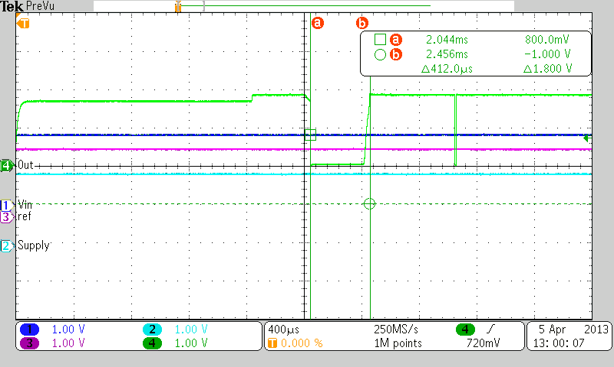

The below response is recorded when 3V is applied across the Supply and Vin signals,

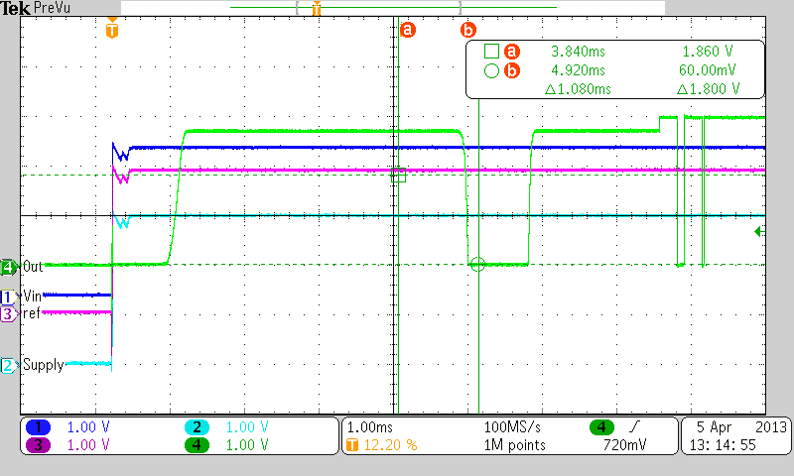

Normal operation
Under steady state condition of the power supply input, the comparator output is respnding to the change in input state as expected with fast response.

Schematic of basic application circuit
2V, 10Hz, square wave input

V
--
++
Ch1

V
--
++
Ch4

V
--
++
Ch3

V
--
++
Ch2
Figure 14: Basic application circuit using TLV3491

Note: Signal probed on oscilloscope(M1) is mentioned below,
Ch1: Vin, input voltage applied
Ch2: Supply, Power supply input of comparator,
Ch3: Ref, reference input of comparator
Ch4: Out, output pin of comparator

The response of comparator at 1.8V supply voltage is as shown below,

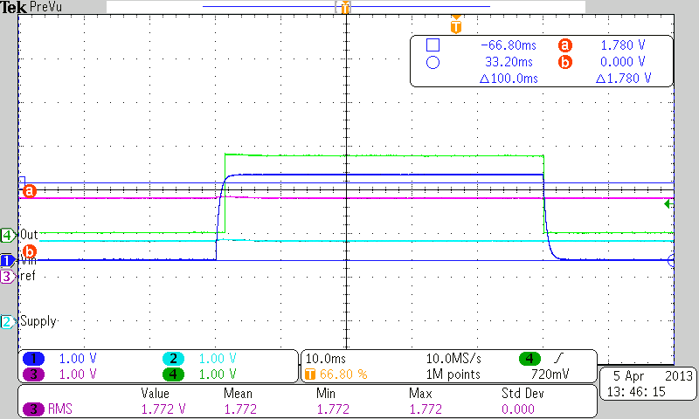

Test on old part

Start up test
The comparator TLV3491 that was consistently providing the PS_OUT signal on DC6 module with Serial no: 223CE06001000 was replaced on this bred board and the power up test with lower supply voltage was repeated.

The marking mentioned beneath this part is 04Z1.

The response of comparator at 1.8V supply voltage is as shown below,
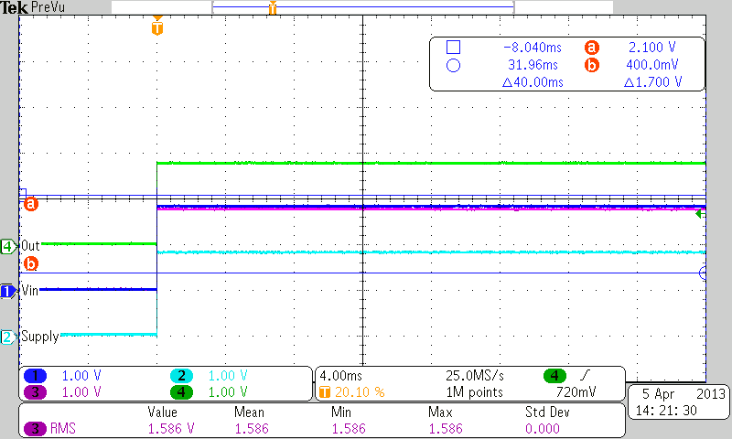

As shown in the above response, the comparator output is stable and as expected.

The magnified view shows that output responds to the change in input state within 6.36us as expected,

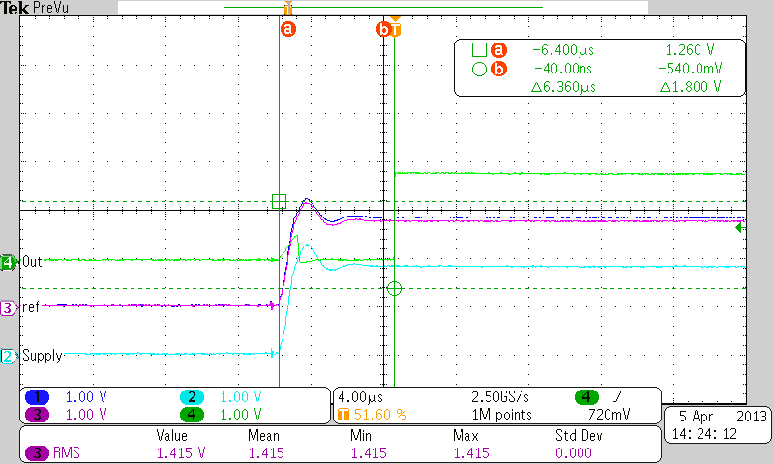

The output response at 3V supply voltage is shown below,

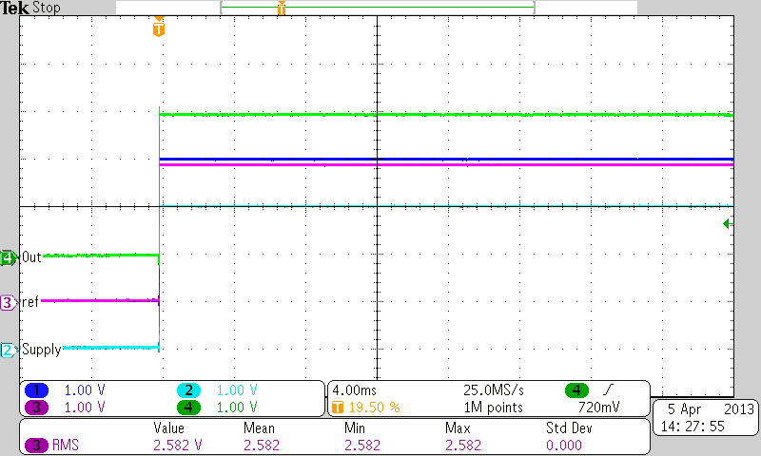

FAZIT / CONCLUSION
The malfunction of the new comparators could be shown.

VERTEILERPLAN / DISTRIBUTION

ANHANG / APPENDIX

