English Translation of: http://reanimator-h.narod.ru/bridge.htm

Overhead power amplifiers
Known class amplifiers, called bridge, in which the load is connected to an ungrounded amplifier outputs with antiphase output signals. The advantages of such schemes include a maximum output power quadrupled with the same supply voltage, in comparison with the power amplifiers with a single output and a grounded load. Moreover, such schemes create symmetrical current ripple on the supply lines at twice the frequency of the signal, which simplifies the construction of power sources (corresponding capacity), excluding possible conditions for the occurrence of bipolar voltage output distortions. This is true for DCA amplifiers type and not only. Furthermore bridgeable amplifiers do not cause the appearance of high signal currents on the "common" wire that greatly improves compatibility in multi-node (eg, stereo) equipment.
Bridge amplifier circuits are found in some of the recommendations on the use of chip-power amplifiers. If disassembled, eg datashitovskuyu diagram of TDA2030 by "bones", we obtain two power amplifiers connected in series. The first amplifier - inverting, second - inverting. Between their outputs enabled load. It is understood that the output of the second amplifier is an increased level of harmonics, as the input signal to pass through a chain of two amplifying units. Also a second amplifier adds a time delay during the signal transmission therethrough. Resulting disadvantages - are obvious.
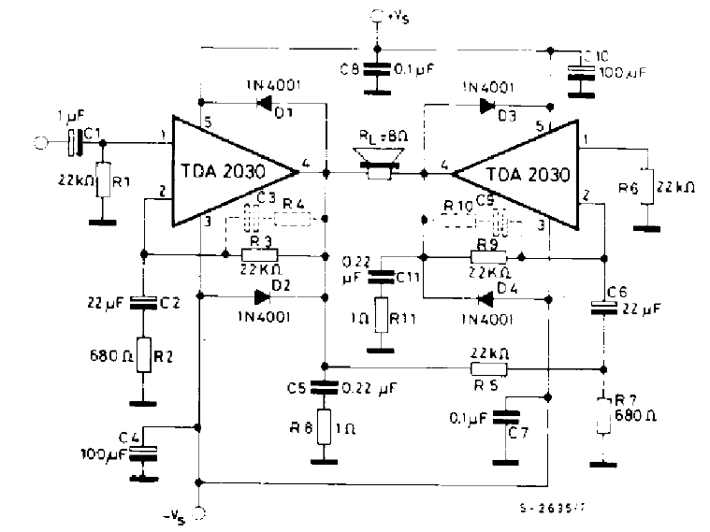
Fig.1
Known symmetric bridge amplifier circuit with interconnections. For example, the scheme of the book P. Shkriteka "Reference guide for the audio circuitry" (Chapter 13. Amplifiers) is good in many ways but one - the operating point of the power amplifier does not set. Mind set on the outputs of the amplifier voltage, for example, close to the supply voltage (simultaneously) - and the balance of the scheme can not be broken, as it suppresses the common mode noise as the input of the amplifier, and on exit :-), due to its symmetrical topology. In order to maintain the working point of output stages need a special servo circuit. Otherwise, the amplifier output arms will unbalance on power dissipation and eventually may fail such a device.
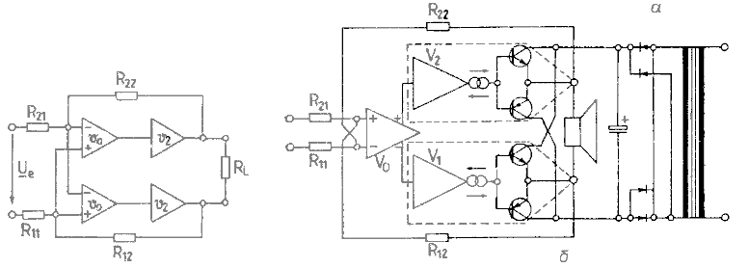
Fig.2
In the proposed scheme INUN me address this shortcoming by adding two resistors (R3, R4) of the differential amplifier inputs. Now the in-phase output voltages care from zero will cause the voltage unbalance between dif. amplifier inputs and return them to their original state. In other respects, the topology scheme are identical. The advantages of symmetrical bridge circuits include the fact that no alteration can be used in circuits with both balanced and unbalanced inputs. Besides symmetrical bridge circuits differ reduced levels of even harmonics. The disadvantages are the need for an accurate selection of denominations scheme. The gain of this circuit voltage is equal to Ku =-R5 / (R1 + R3 / 2), the input resistance Ri = 2 * R1 + R3 / 2.
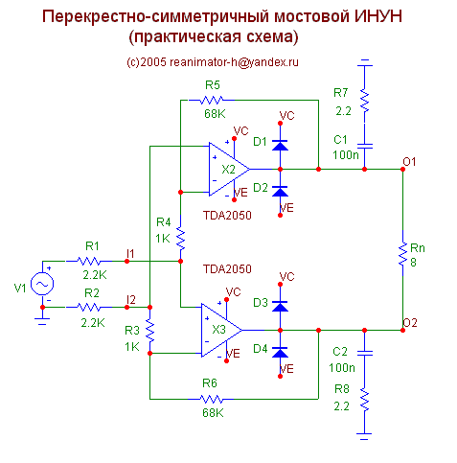
Figure 3
Built on a similar principle Yitong (voltage-controlled current source). In the output circuits introduced current sensors (R7, R8), and feedback signals are taken from the voltage dividers. Thus, by connecting a load, with the advent of the input signal occurs unbalance of the bridge formed by the described elements, which is eliminated by the negative feedback. Irrespective of the size of the load (theoretically) the current through it will not change, because the balance scheme is preserved only in the flow of a given input signal the output current through resistors - current sensors. The main parameter is the steepness of the Yitong conversion, it can be for this scheme to calculate the formula Si =-R1 / (R7 * R5). For these denominations Si = -4,68 A / V. Rin = R1 + R2, neglecting the values ​​of R3 and R4, because of their relative smallness.
INUN scheme and Yitong format MC7 can be downloaded here .
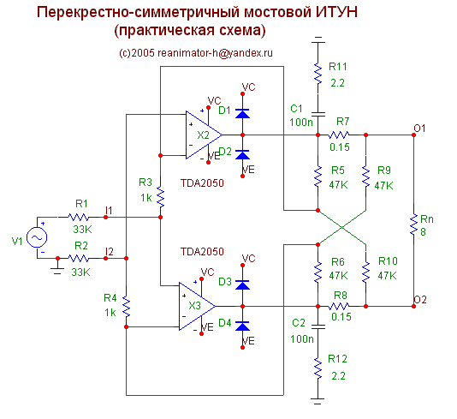
Figure 4
Using the same current sensors and replacing NFB on PIC when adjusted denominations resistive dividers can receive amplifier with negative output impedance. Anyone can analyze his own work :-)
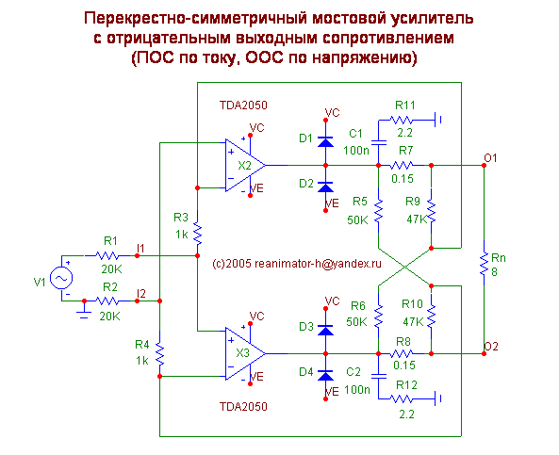
Figure 5
Power amplifier with negative output impedance is used in phonics in cases where it is necessary to increase the amount of electric damping ie deluxe rid of Q in the AS, such as the resonance frequency of the speaker. By definition, a negative output resistance with increasing load resistance voltage drops on it (reduced gain), and a decrease - increase (increased gain). This is accomplished due to positive feedback current in the amplifier. In this regard, there is a risk of self-excitation of the amplifier, if the load resistance becomes smaller in absolute value of the negative output impedance, as in this case, the gain becomes infinite :-).
Without going into the details of the derivation of formulas based on the laws of Kirchhoff symmetry scheme (R1 = R2, R5 = R6, R7 = R8, R9 = R10), taking into account the fact that R3, R4 - have little effect on the result, you can calculate the parameters of the scheme on the following formulas:
Rin = R1 + R2
= Ku-R5 R9 * / (R1 * (R5-R9)) at no load.
Rout = 2 * R7 * R9 / (R9-R5)
For denominations specified in the scheme, respectively, we obtain
Ri = 40 ohms;
Ku = -39.16 dB or 31.85
Ro = -4.7 ohms.
PS I must say that the chip type used in Example (TDA2050), does not play any decisive role of, you can use any suitable parameters for integrated circuit (or discrete) UN made on the circuit design of a powerful OS. Desirable to perform compliance datasheet general recommendations for inclusion of any type of chip.
For example, on the basis of TDA7293 bridge was built Yitong subwoofer with EMOS as follows:
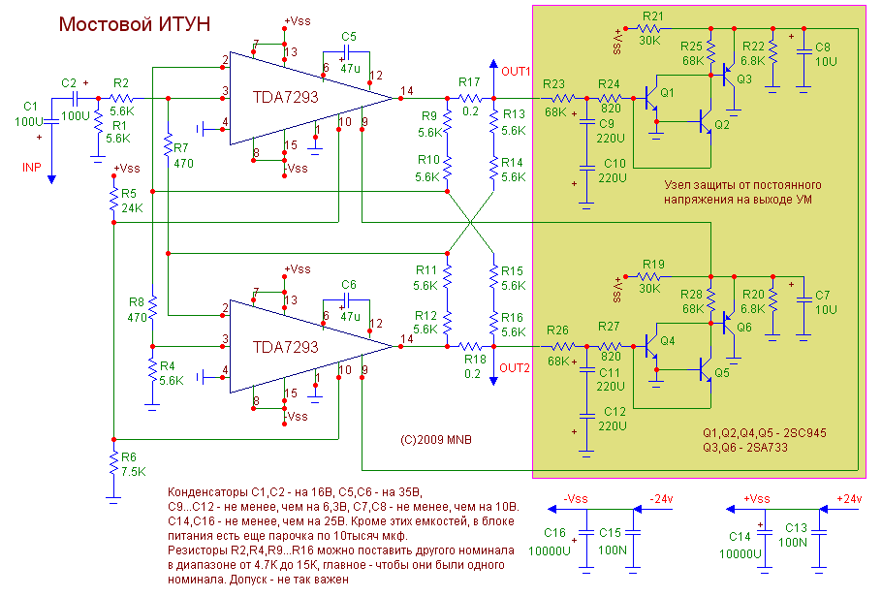
Figure 6
View the board from the details (PCAD2006) in the following figure:
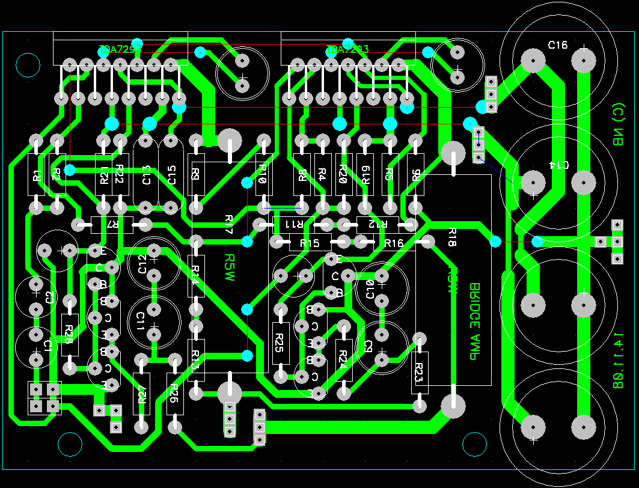
Figure 7
PCB can be downloaded in pdf format or in the format of the program SprintLayout5.0
Once assembled, it looks so -
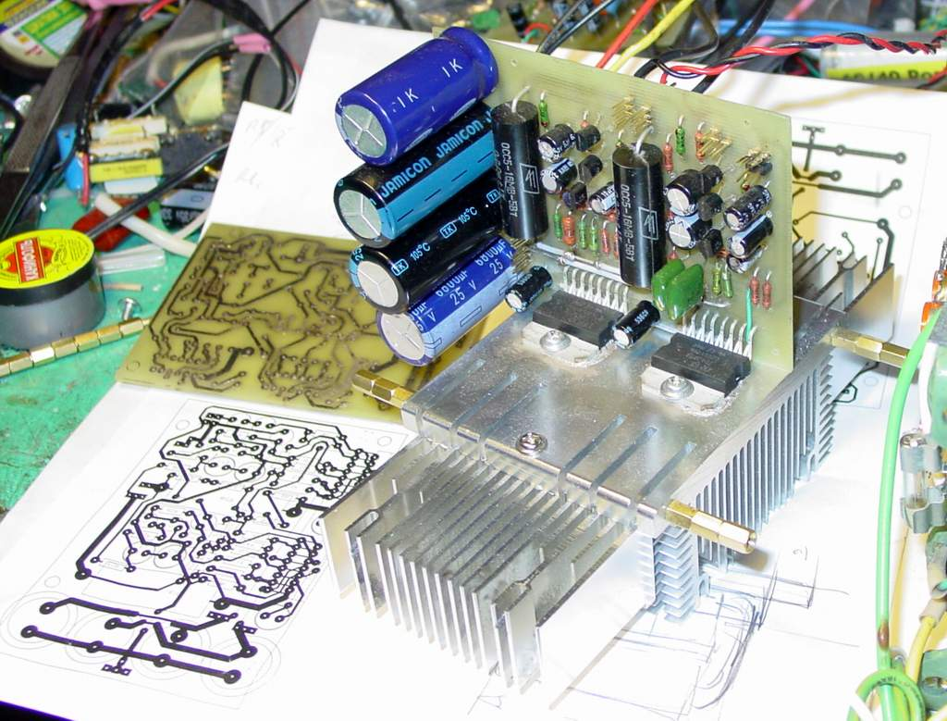
Figure 8
For systems with EMOS desirable Yitong with frequency dependent frequency response - or rather, with a frequency dependent impedance. With increasing frequency output impedance UM should fall. Implementation Example - bridge UMZCH crosslinked that implements this principle by introducing a capacitor C8 scheme becomes necessary properties. When using TDA2050 optimum load resistance is 8 ohms.
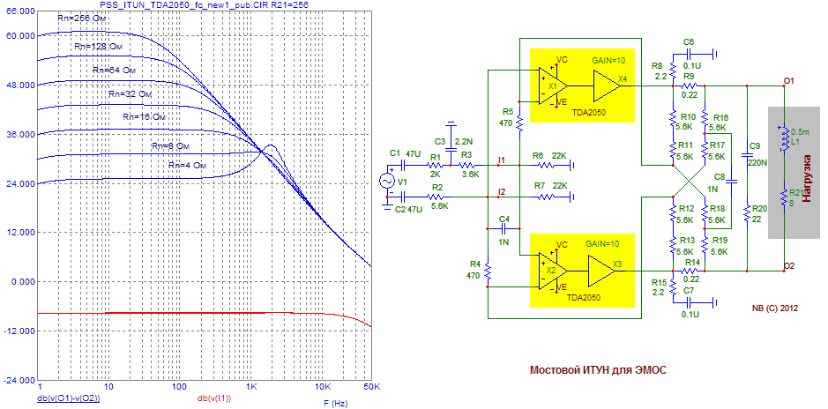
Figure 9.
Below its printed circuit board (added protection diodes on the outputs TDA2050):
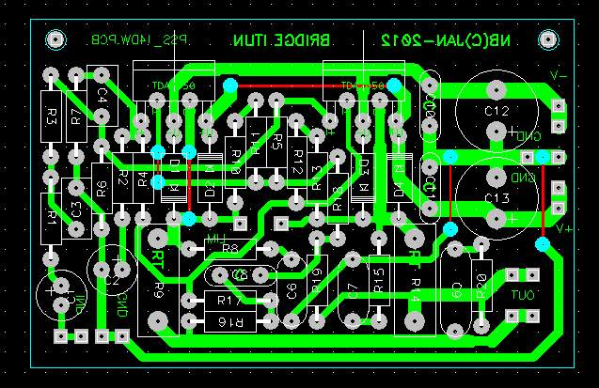
Figure 10.
And photos assembled amplifier. Note that the arrangement of elements is somewhat different from the above PCB. Just in the process of finishing one of the circuit elements (he is no longer on the concept) had completely removed.
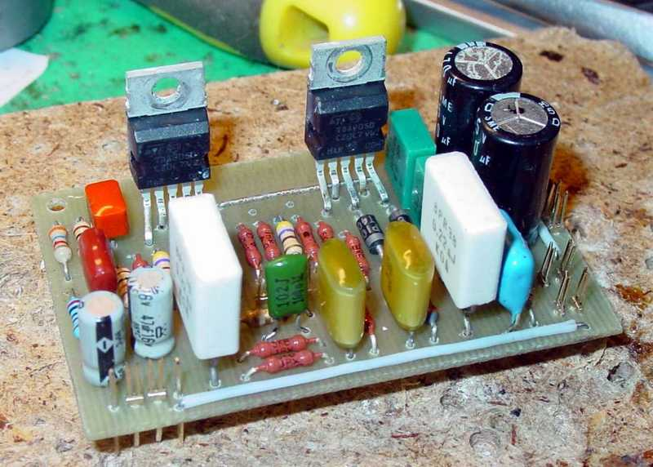
Figure 11.

Discussion of these schemes on the forum held Vegalab'a .
Mukhamedzyanov N. (aka Nota Bene ) (C) 2007 (c) 2009 reanimator-h <at> yandex.ru
On the main page

