Package | Die Size  (mils) | Pad Size  (mils) | Low or  High K | Data  Source | Tja |  |  |  | Pjt |  |  |  | Tjc | Tjp | Tjb | Derating  Curve | Update
 |  |  |  |  | 0 LFM | 150 LFM | 250 LFM | 500 LFM | 0 LFM | 150 LFM | 250 LFM | 500 LFM
14PW | 48 x 53 | 71 x 71 | High | Model | 112.6 | 105.6 | 102.3 | 97.0 | 2.40 | 4.00 | 4.60 | 5.60 | 46.6 |  | 72.7 | Top of Form  Bottom of Form  Plot | Update
16PW | 62 x 62 | 104 x 104 | High | Actual | 108.4 | 102.3 | 99.9 | 95.9 | 1.10 | 2.40 | 2.90 | 3.70 | 33.6 |  |  | Top of Form  Bottom of Form  Plot | Update
20PW | 53 x 69 | 102 x 106 | High | Model | 83.0 | 77.9 | 75.4 | 71.4 | 1.00 | 2.20 | 2.60 | 3.40 | 32.3 |  |  | Top of Form  Bottom of Form  Plot | Update
24PW | 62 x 62 | 94 x 140 | High | Actual | 87.9 | 82.4 | 80.4 | 77.4 | 0.60 | 1.70 | 2.00 | 2.70 | 25.7 |  |  | Top of Form  Bottom of Form  Plot | Update
28PW | 78 x 137 | 110 x 198 | High | Model | 61.7 | 55.1 | 52.7 | 49.2 |  |  |  |  | 16.4 |  |  | Top of Form  Bottom of Form  Plot | Update
8PW | 62 x 62 | 67 x 79 | High | Actual | 149.4 | 142.0 | 138.2 | 132.4 | 7.60 | 10.00 | 10.90 | 12.40 | 65.1 |  |  | Top of Form  Bottom of Form  Plot | Update

Thermal Database - Derating Curve Plot Results
The requested derating curve plot is shown below. Values for the device junction temperature and the ambient temperature range can be varied and a new plot generated. Please see the text below for important information about these derating curves and the thermal models used to generate them.
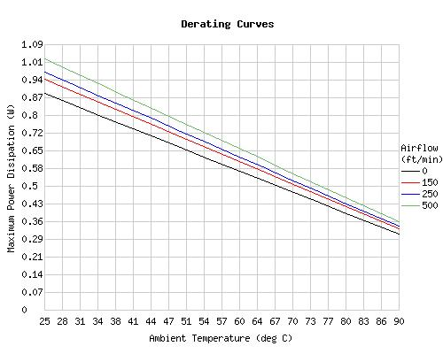
Junction Temp:
  °C
  Ambient Temp Range: | °C to °C
  Theta-ja: 112.6°C/W @ 0 lf/m
  Theta-ja: 105.6°C/W @ 150 lf/m
  Theta-ja: 102.3°C/W @ 250 lf/m
  Theta-ja: 97.0°C/W @ 500 lf/m

Derating Factor
Input realistic maxium junction temperature based off of mold compound Tg value and wire life data.
If you need help please contact packaging.
Max Junction = | TA <= C | TA = C | TA = C

Low/High K | Package | Derating Factor  Above TA | TA <= 25C | TA = 70C | TA = 85C
High | 14PW | -8.88 mW/C | 888.10 mW | 488.45 mW | 355.24 mW

 | A direct relationship exists between junction temperature and device reliability. Therefore, the maximum allowable junction temperature is limited to 150°C. The table to the left shows the relationship between failure rate at 100,000 hours and junction temperature. This utility uses an initial value of 125°C for the device junction temperature.
  Tj (°C) | %FR  (at 100,000 HR)
  150 | 96
  140 | 80
  130 | 46
  120 | 11
  110 | 1
  100 | 0.02

The derating curves above are generated from TI thermal models. These models are based upon TI package materials and run under specific environmental conditions. Should package material or environmental conditions change, actual measured values may differ from model results. Product data sheets should also be consulted to determine acceptable operating conditions, such as the operable ambient temperature range.

