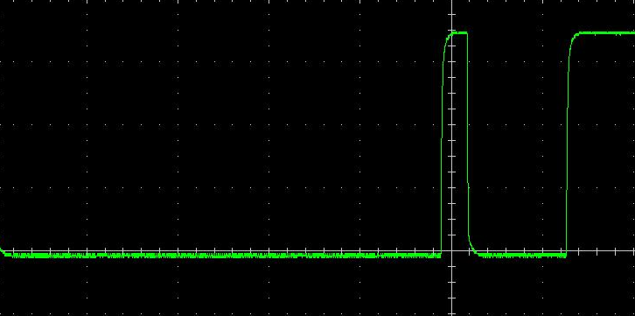
Reset pulse and presence pulse back from DS18B20

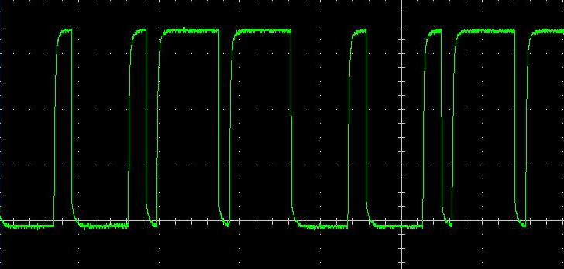
Write byte of xCC (skip ROM)

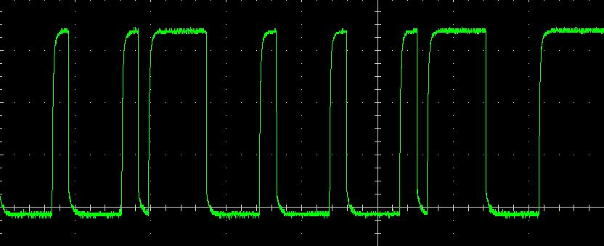
Write byte of x44 (convert Temperature)

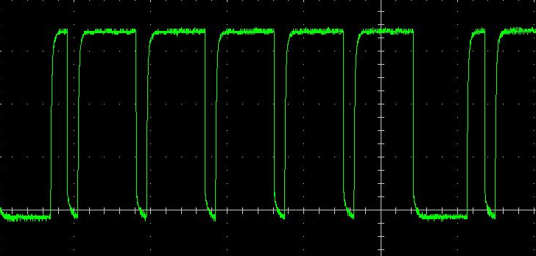
Write byte of xBE (Read scratchpad)

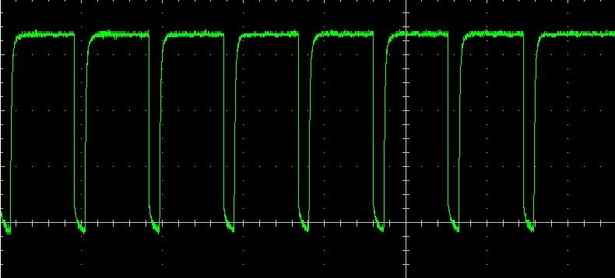
Read byte. The DS18B20 is not pulling the line down at all

