Questions:
- I tried to use the GUI "InstaSPIN-BLDC_GUI_DRV83xx_v104.exe" but I didn’t manage to get the motor running. It only works when I use the GUI “DRV8312GUIv5.exe”.
Please explain, why.
- May I kindly ask for a description of the terms “Phase A Space Vector Waveform”, “Phase A Reconstructed Phase to Neutral Voltage” and “Estimated Commutation Angle” which I found in the User’s Guide:
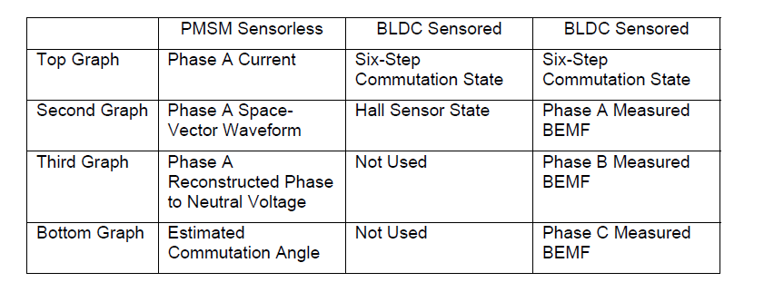
- Please provide a description of the numbers in the 4 screens. E.g. how much current does 460.00 mean in the top screen, please. What is the timing?
