Problem Description

I upgraded the CCS version to 5.5 today. Then I compiled and downloaded the new bootloader code to device. With this procedure, device got detected on PC. So we went one step ahead where we had stuck yesterday.
Once the device got connected to PC, we tried to open the new dfuprog utility from command prompt. My Laptop’s OS is Windows7 – 32 bit. We tried to open the utility from the folder C:\ti\controlSUITE\device_support\f2806x\version\MWare\tools\dfuprog\Debug
It gave the error as shown below.
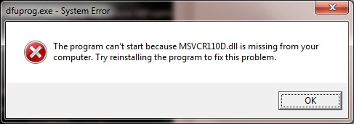

Then we tried to open the dfuprog utility from the other x64 folder i.e. C:\ti\controlSUITE\device_support\f2806x\version\MWare\tools\dfuprog\x64\Debug
It gave the error as shown below:
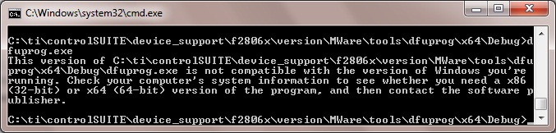

So then we thought of trying using the older version of dfuprog utility from the v135 folder i.e. C:\ti\controlSUITE\device_support\f2806x\v135\MWare\tools\dfuprog\Release
With this old dfuprog version, and the new bootloader code downloaded to device, we could run the commands enumerate, erase and download hex file bl_app successfully.
But when we tried to download the hex file of our project code, it gave us error (-7).
It is as shown below:
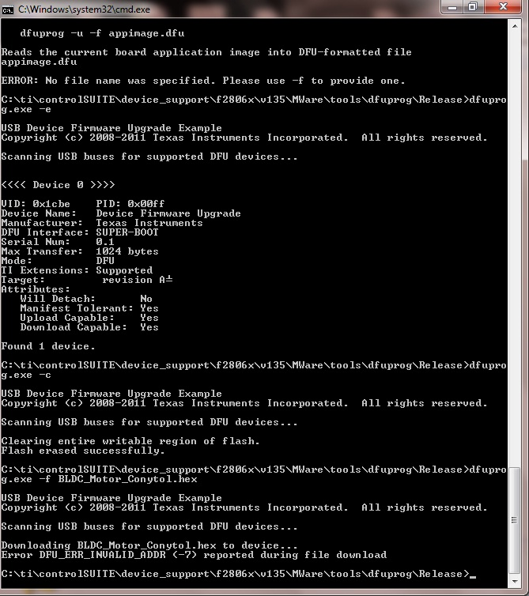

Not sure yet,
- Why new dfuprog utility is not opening up on my PC. What installation it requires.
- Why bl_app.hex got downloaded using old dfuprog utility but using the same utility, other hex file is not getting downloaded.

Please help.

