Full charge capacity not correct
Condition: Battery pack is empty
Operation: Charge @ C/5 rate to 4200mV and wait for 2 hours.

1. After I charge done (wait for a few minutes), and I saw DataRAM like this:
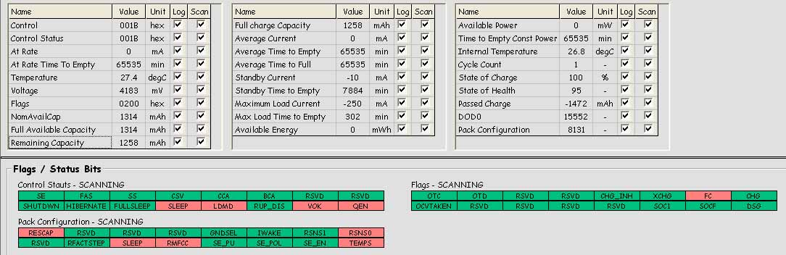
Figure 1
We can see that:
PassedCharge = -1472mAh
State of Charge = 100%

And DataFlash like this:
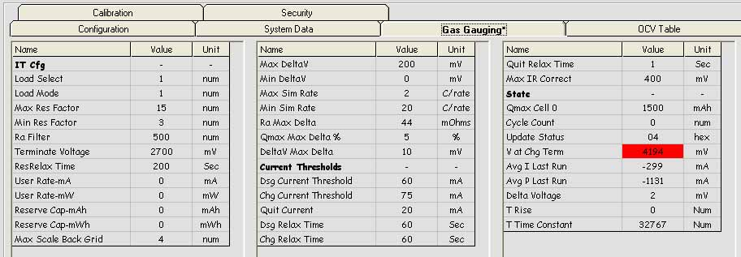
Figure 2

2. After I wait for 2 hours, and I saw DataRAM like this:
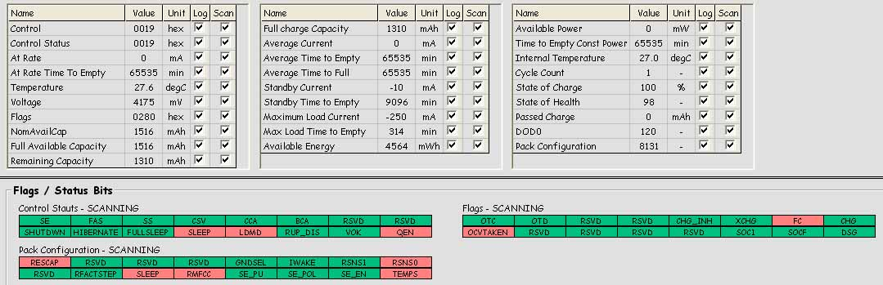
Figure 3
We can see that:
Full charge Capacity has been updated to 1310mAh

DataFlash like this:
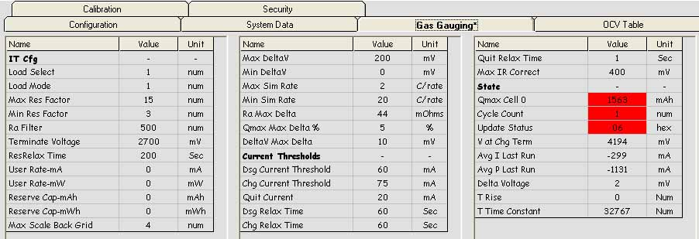
Figure 4
We can see that Qmax cell 0 = 1563mAh

3. Question
From “Theory and Implementation of Impedance Track Battery Fuel-Gauging Algorithm in bq2750x family” article (Issued by Ming Yu, Yevgen Barsukov, and Michael Vega). We can derive that
FullChargeCapacity = Qstart + PassedCharge + RM > PassedCharge
From figure 1 and figure 3, FullChargeCapacity = 1310 < PassedCharge =1472, why?

