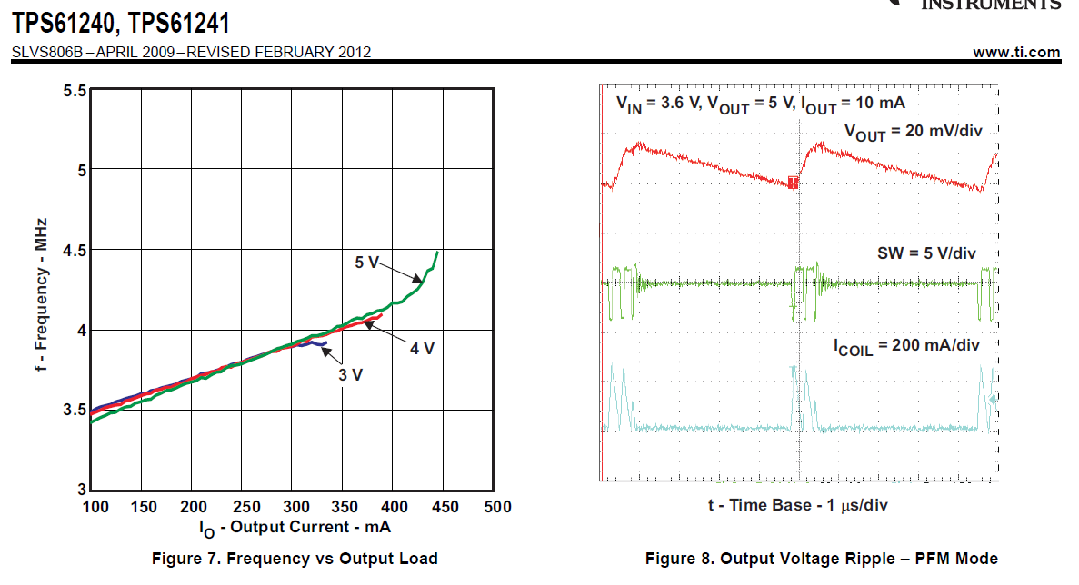
At 10mA output current, the TPS61240 switching frequency is approximately 200kHz.
Would 0-1mA output current = 20kHz switching freq.
Could we add less output capacitance to guarantee 0.01mA switching freq > 30kHz?
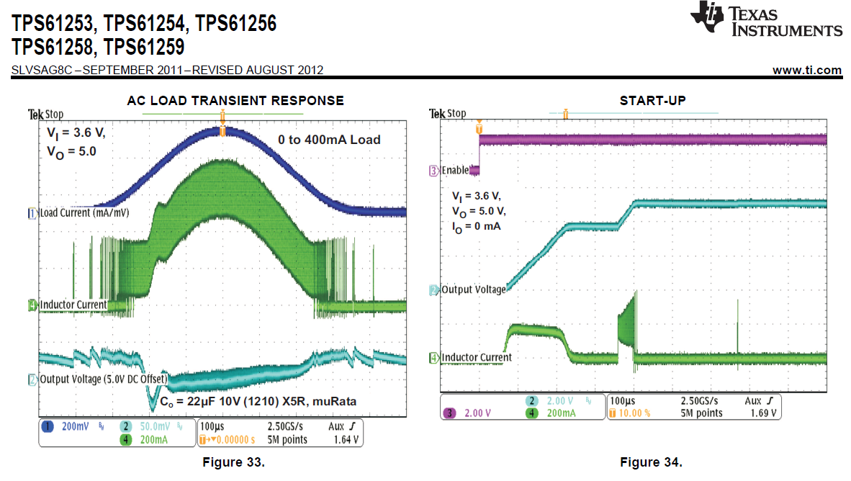
At 0mA output, the TPS6125x switching frequency is approximately 1/50usec = 20kHz
Could we cut the output capacitance from 22uF to 10uF & guarantee >30kHz switching freq at 0mA output?

