- Test Configuration
POWER
SUPPLY
LM22672
EVM
Oscilloscope

CH1: Voltage
CH2: Current
CH3: Voltage

- EVM Test Result
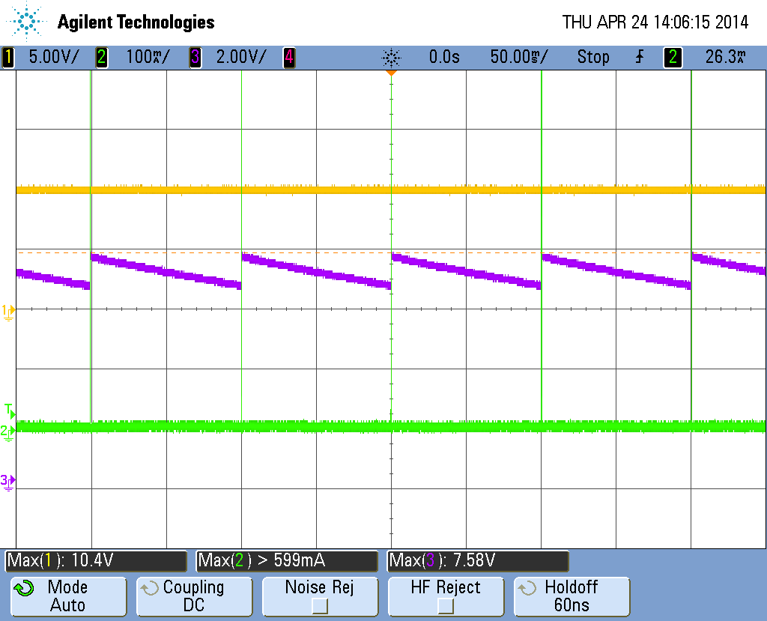
CH1(Orange): Vin : 10V
CH2(Green): current
CH3(Purple): Vout : 7.3V

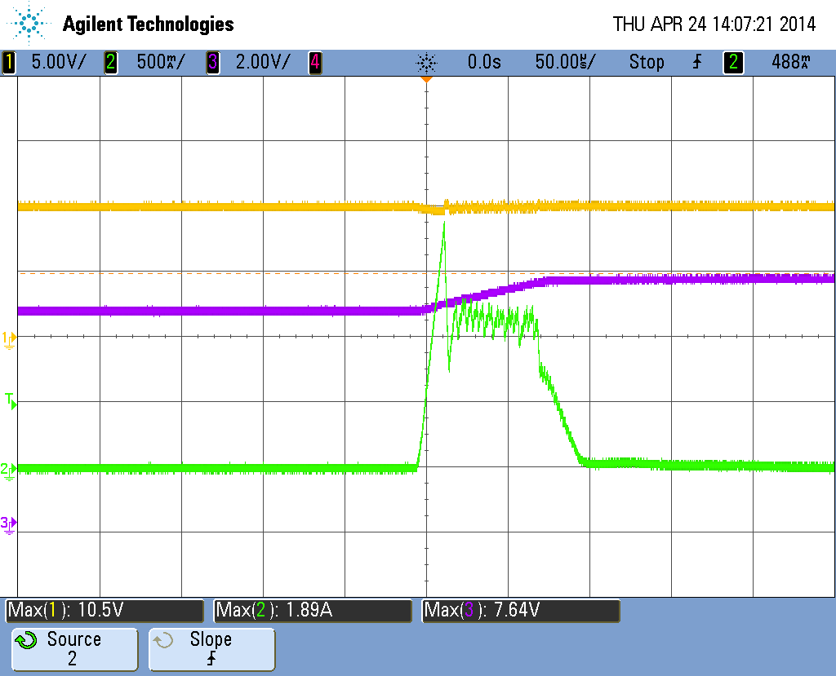
- System Board Test Result

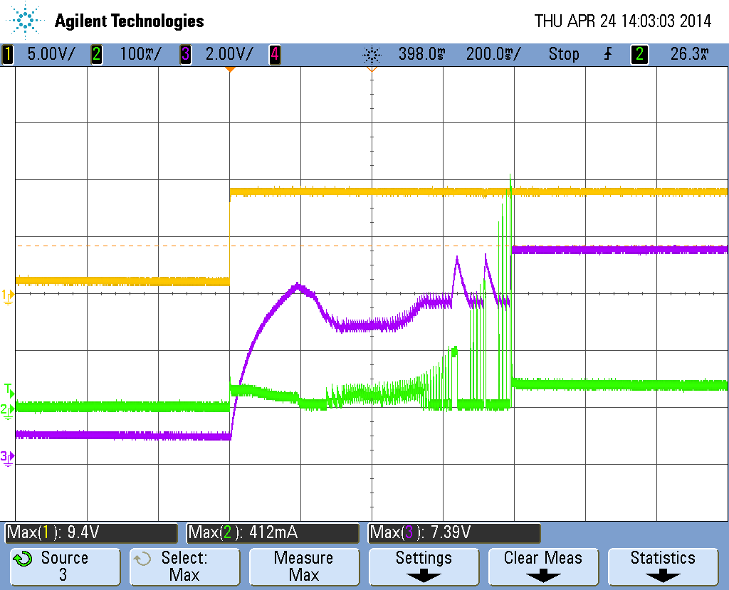
CH1(Orange): Vin : 9V
CH2(Green): current
CH3(Purple): Vout : 7.1V

- Schematic

