**Measurement Result**

**GND voltage: PIN 7**

Comment: around 500 Khz, Vpp=200mV is coupled to GND-PIN7. I think this signal comes from the switching frequency of the PTN7860W module.

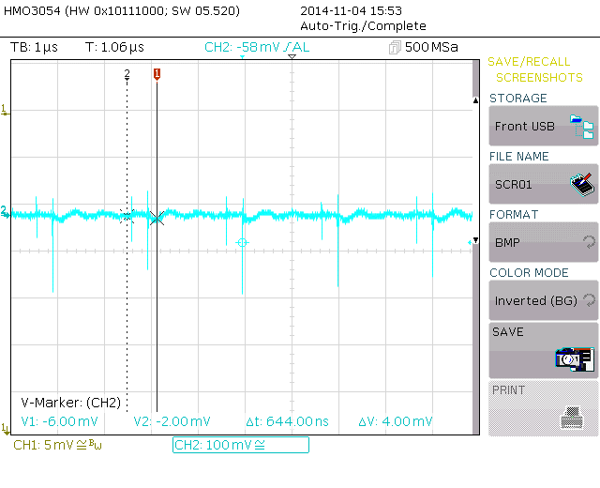

**Adjust Voltage: PIN 4**

Comment: The 500Khz signal disturbs the input of the adjust voltage

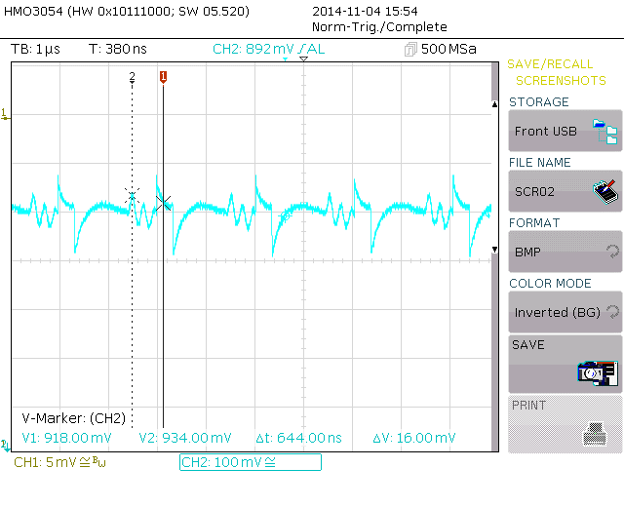

**NEAR GND PIN7; switching frequency signal.**

