- Super-capacitor Overview:
Super-capacitors also known as ultra-capacitors are relatively high energy density storage devices. The amount of energy that can be stored per unit weight is much less than most of the battery technologies that exist today. Thus they are desired in many applications where space and weight are important. Also, their very low internal resistance provides super-capacitors a quick ability to discharge and charge its energy. Consequently, it has high efficiency during charging and discharging process. Moreover, simple charging methods are required. Thus, our bq24650 charger can be used with that purpose by disabling the pre-charge phase.
- bq24650 Description:

The bq24650 is highly integrated switch mode battery charger for solar panels. Its input voltage can vary from 5 to 28Volts. It charges batteries with adjustable voltage from 2.1 to 26Volts with feedback reference set internally to 2.1V. This device charges batteries in three phases based on the state of charge of the battery at any given time as shown in Figure 1.

The first phase is the pre-charge current regulation phase. In this phase, the voltage on the feed back pin should be lower than typical value of 1.55V (VLowv Typical). The purpose of this phase is to revive the deeply discharged cells. The charger applies a pre-charge current, usually very small, that can be set using SRP and SRN pins.

In the fast charge current regulation phase, the feedback voltage should be between 1.55V and 2.1V. The charging current is 10 times higher the current of the pre-charge phase. As the battery charges with time, its terminal voltage of the battery increases. As it reaches the expected regulation voltage level, the fast charge stops phase ends and fast charge voltage regulation starts. In the fast charge voltage regulation phase, the voltage kept constant and the current drops as the battery charges until termination.

In order to use the bq24650 as super-capacitor charger, the pre-charge phase should not be considered. That is because the pre-charge phase is needed only for batteries to revive the deeply discharged cells and avoid damaging them with high current at this condition. Super-capacitors do not have this restriction and can be charged with high current even at very low state of charge. Thus, using bq24650 as a super-capacitor charger requires disabling the pre-charge and that can be done by the following circuitry.
Figure 1: Typical charge profile

- Circuit to Disable the Pre-charge
As described in the previous section, if the battery voltage is below the VLOWV, the charger will enter the pre-charge phase. Super-capacitors voltage can go all the way down to zero voltage at very low state of charge. Charging super-capacitors with a pre-charge current (approximately 1/10 of the full charging current) and with very low state of charge, depends on the capacitance, most likely V_{LOWV} threshold will be not reached within the first 30 minutes of initiating pre-charge. Thus, the bq24650 charger turns off and a FAULT is indicated on the status pins. This scenario is not desired; therefore the circuit in Figure 01 can be used to disable the pre-charge mode partially.

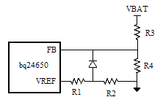

Figure 1: Circuit to disable pre-charge mode

The circuit in Figure 1 clamps the FB pin above the VLOWV. VREF is always constant to 3.3V and R1, R2, R3 and R4 are designed such that:

(V FB REG – V LOWV ) / 2 = V REF R2 / (R1+R2) – VF (1)
VFB REG = VBAT-(Full Charge) R4 / (R3 +R4) (2)

Where:
V FB REG: Feedback regulation voltage
V LOWV: Pre-charge to fast-charge threshold voltage
V REF: Reference voltage
VBAT-(Full Charge): Battery voltage at full charge
V F: Forward diode voltage

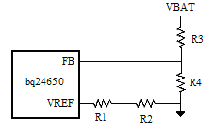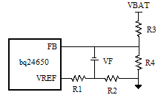
- (b)

Figure 2: Circuit to disable pre-charge mode during pre-charge and fast-charge modes

  - If VBAT R4 / (R3 +R4)> VLOWV, the disable pre-charge mode circuit looks as in Figure 2 (a). During these conditions, the FB pin connected directly to the battery voltage through resistor divider.
  - If VBAT R4 / (R3 +R4)< VLOWV, the diode automatically forward biased as shown in figure 2 (b). The clamp circuit forces the feedback pin voltage to around (V FB REG – V LOWV)/2.

R2 should be at least 10 times smaller than R4 to make the clamper circuit dominant during the pre-charge phase. However, low resistance values on R1 and R2 can cause power loses from the reference pin to the ground. For that reason, A X KΩ range is preferred for R1 and R2. Also the leakage current from the FB is about 100nA, to have a good accuracy in the feed back pin reading, R3 and R4 should be in the XXX KΩ. A design example is illustrated with results in the forthcoming sections.

Result:

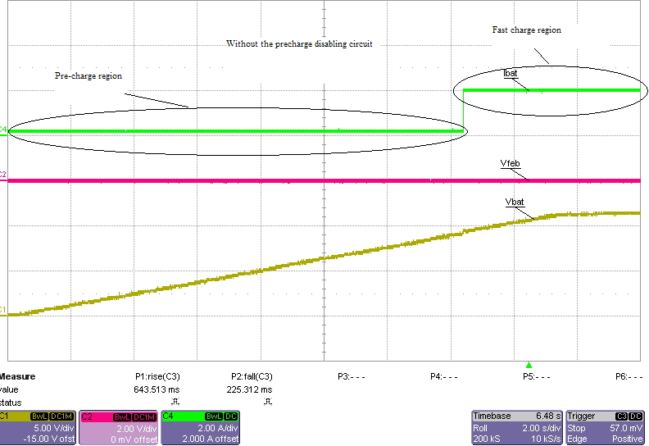
Figure 03: Without pre-charge disabling circuit. The pre-charge region is active.

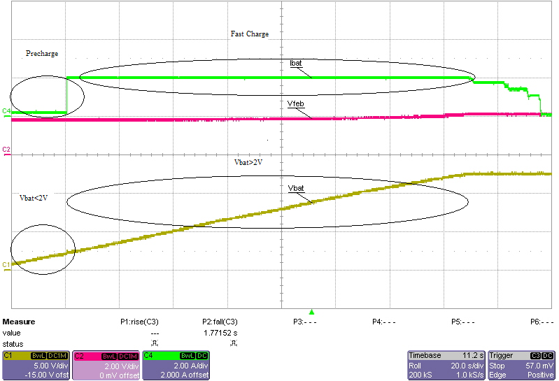
Figure 04: With the pre-charge circuit. The pre-charge region is disabled partially.

