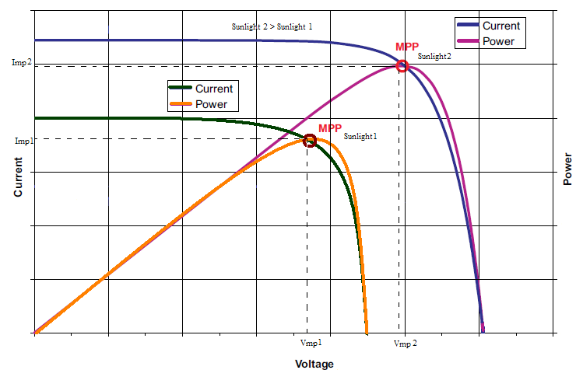

Figure 1: Characteristics of Solar Panel

