DEFAULTS FROM SENC FILE bq20z75_0181_bld_0003.senc

SBS

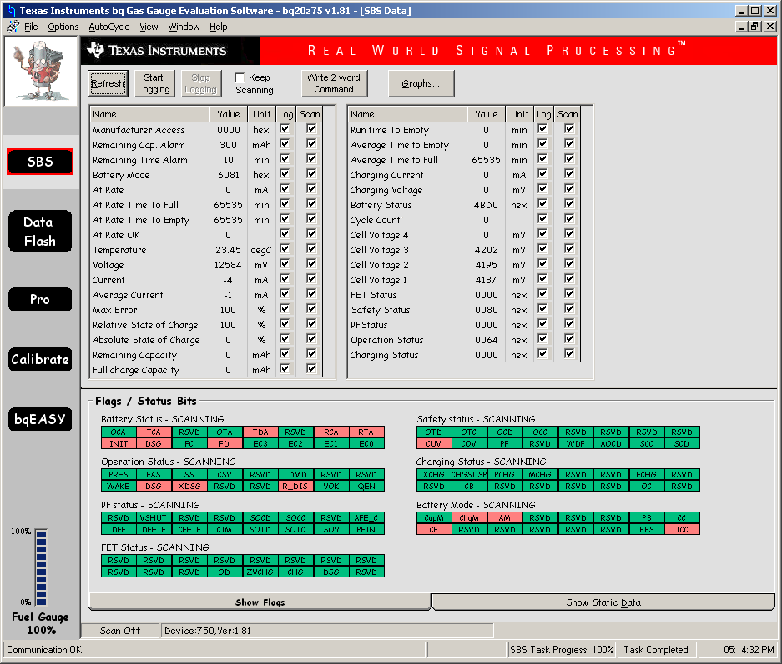

1ST LEVEL

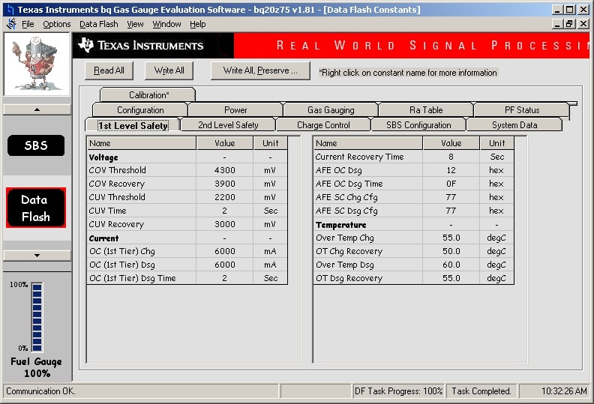

2nd LEVEL

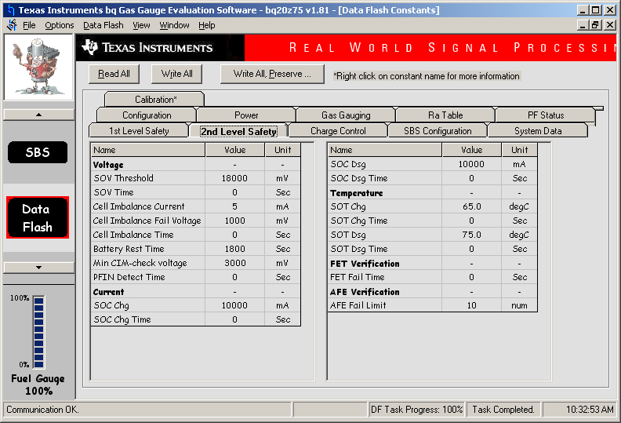

CHARGE CONTROL

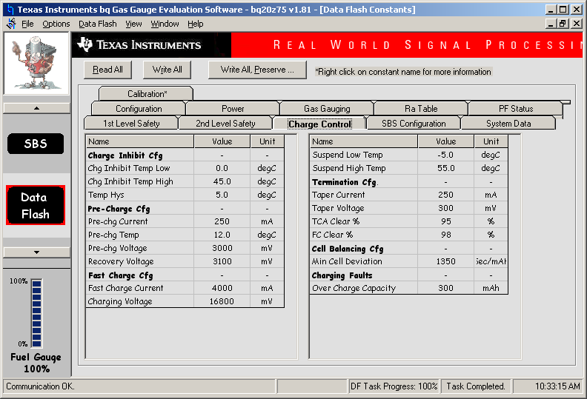

SBS CONFIGURATION

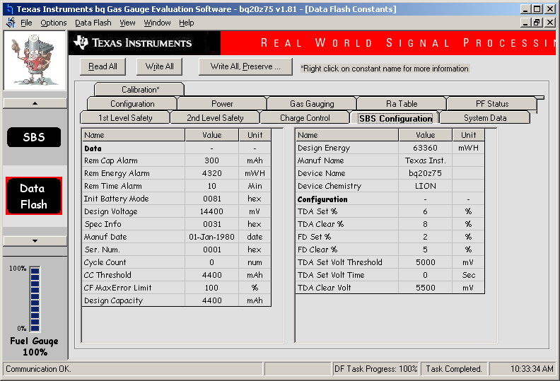

SYSTEM DATA

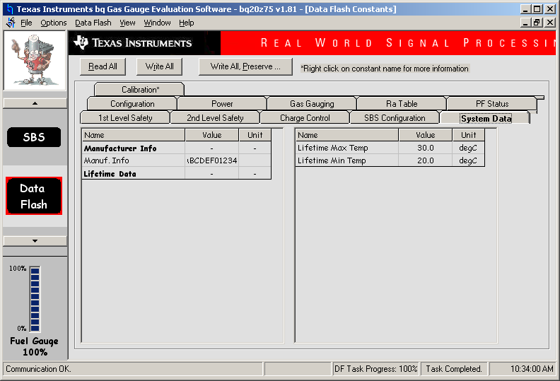

CONFIGURATION

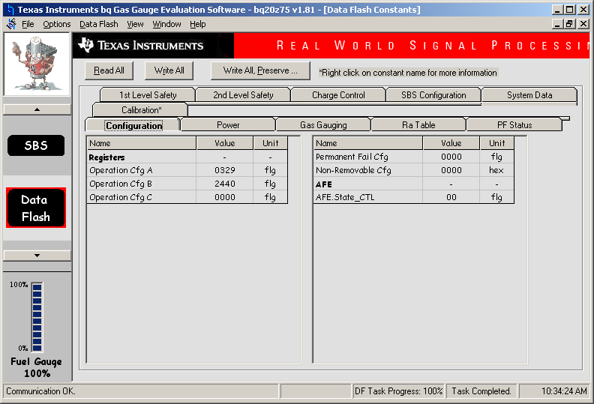

POWER

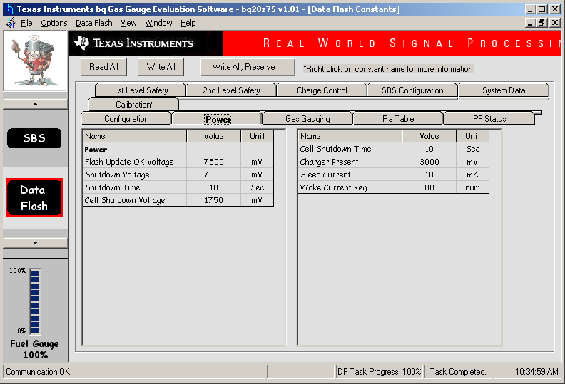

GAS GAUGING

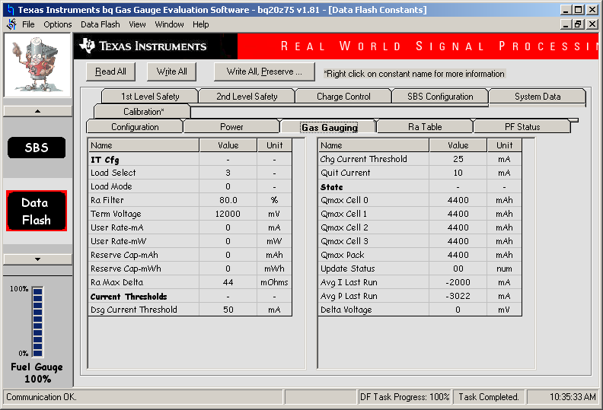

CALIBRATION

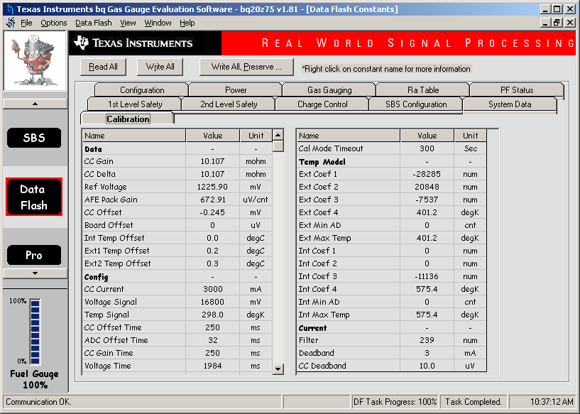

BQEASY SETUP SEPT 10 2012 – NOTE WELL – REMEMBER TO USE THE OK BUTTON AND NOT THE NEXT BUTTON. NEXT WILL NOT WRITE THE DFI

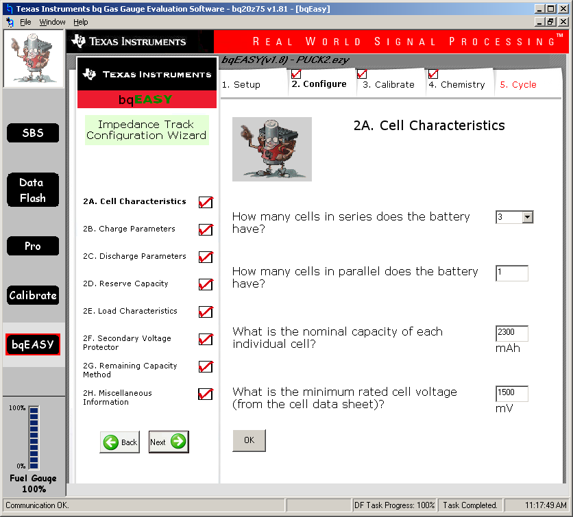

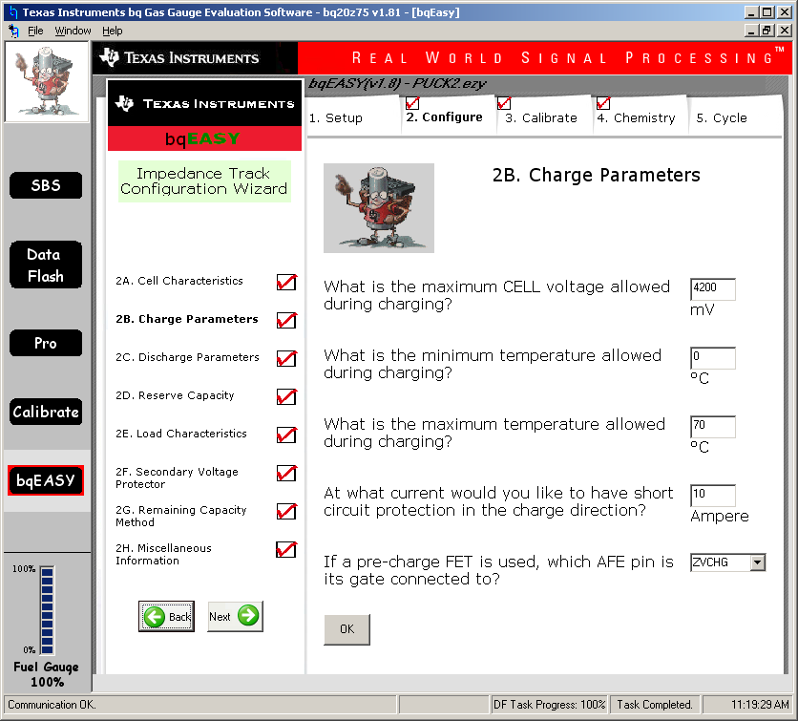

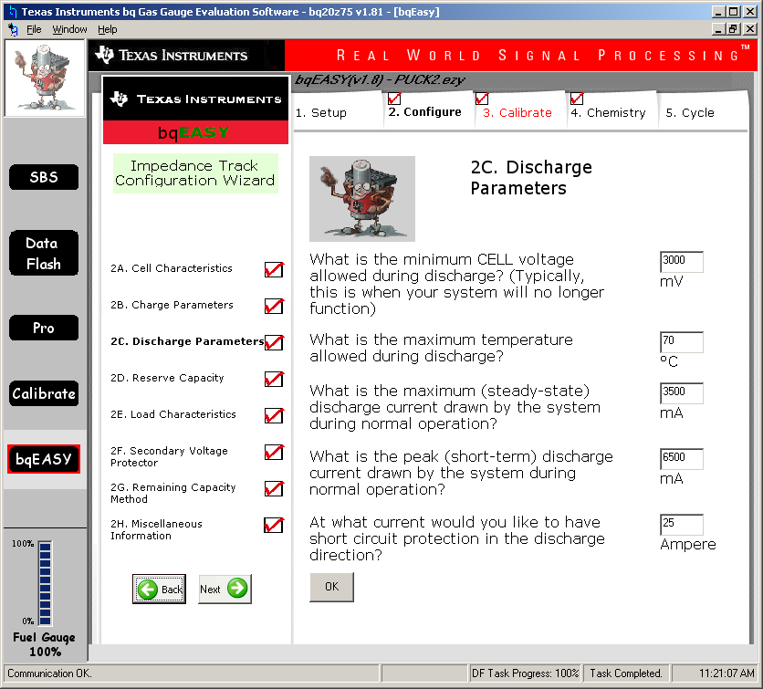

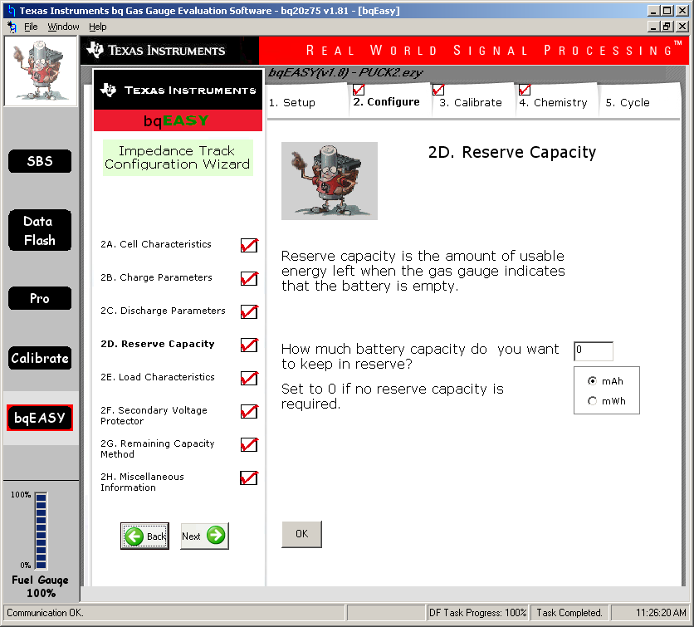

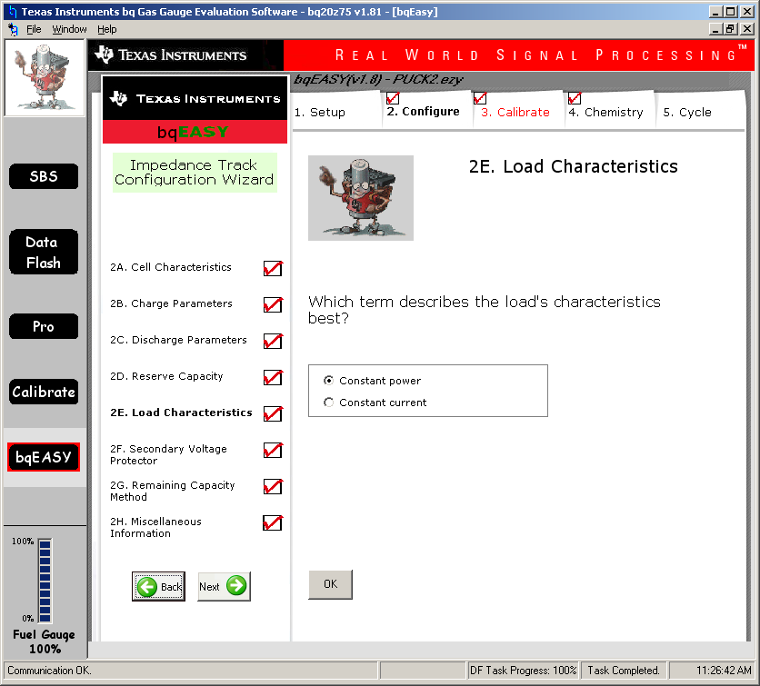

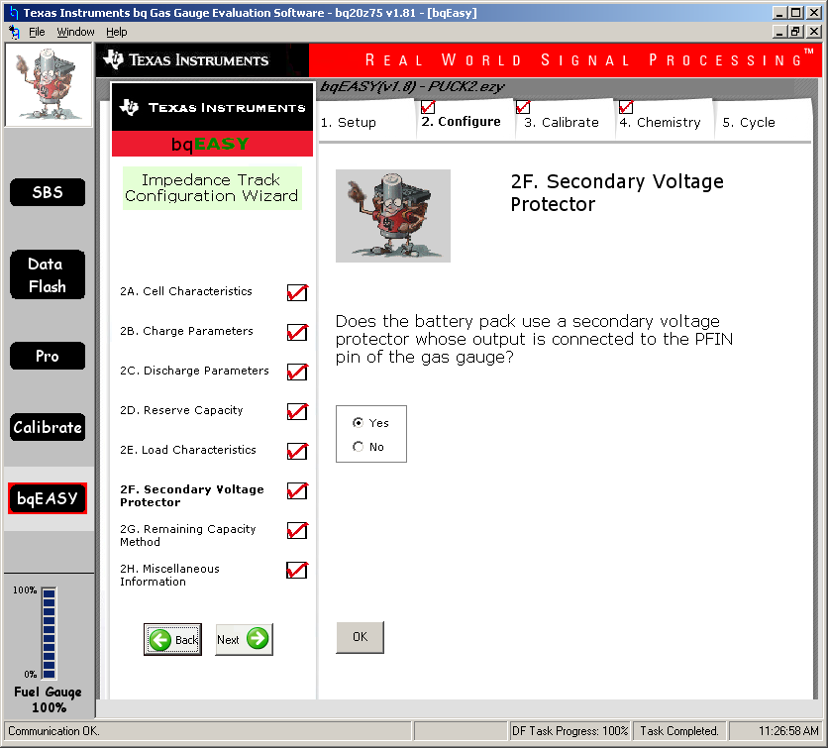

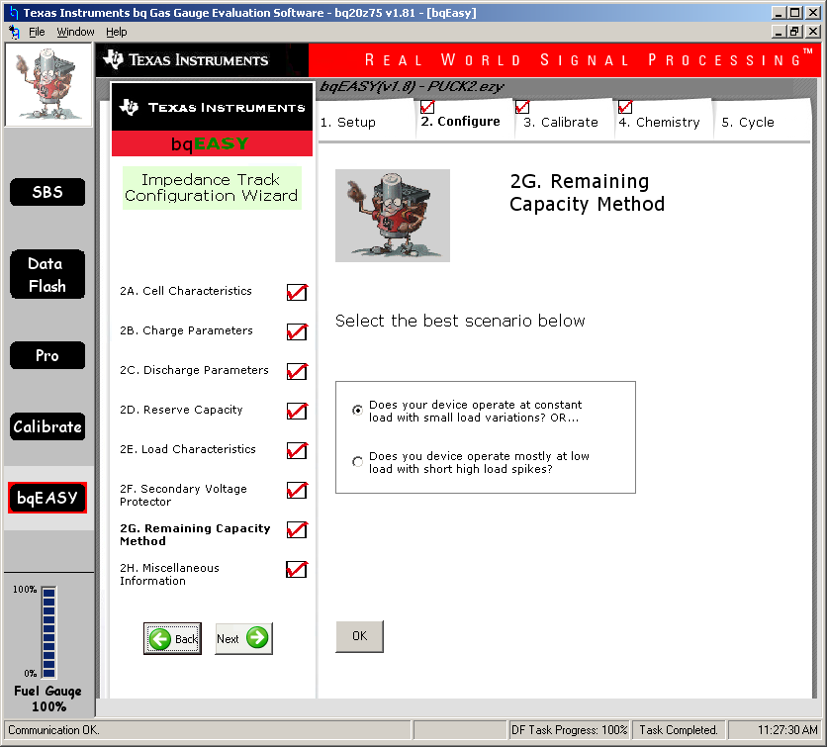

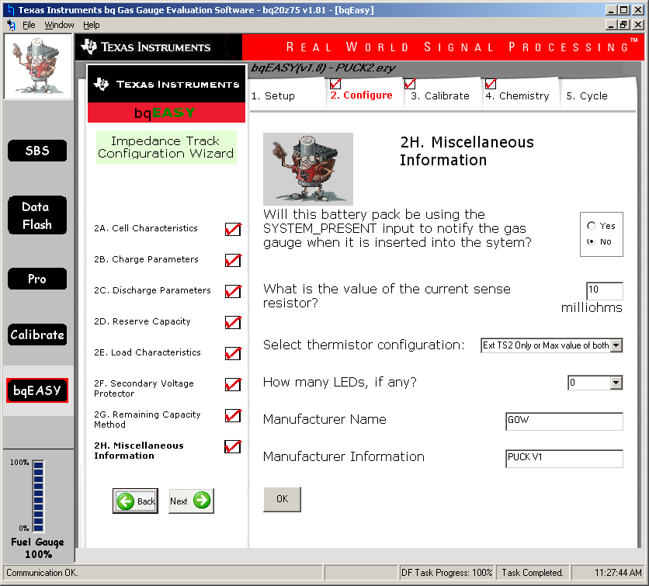

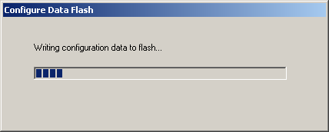

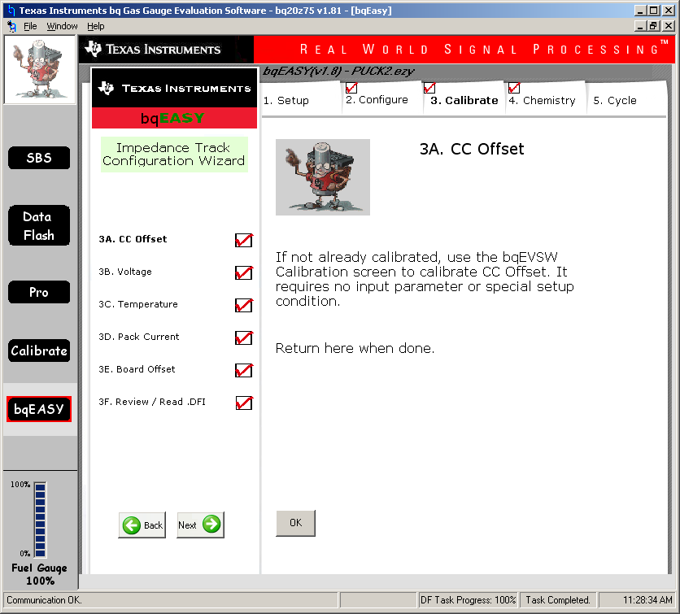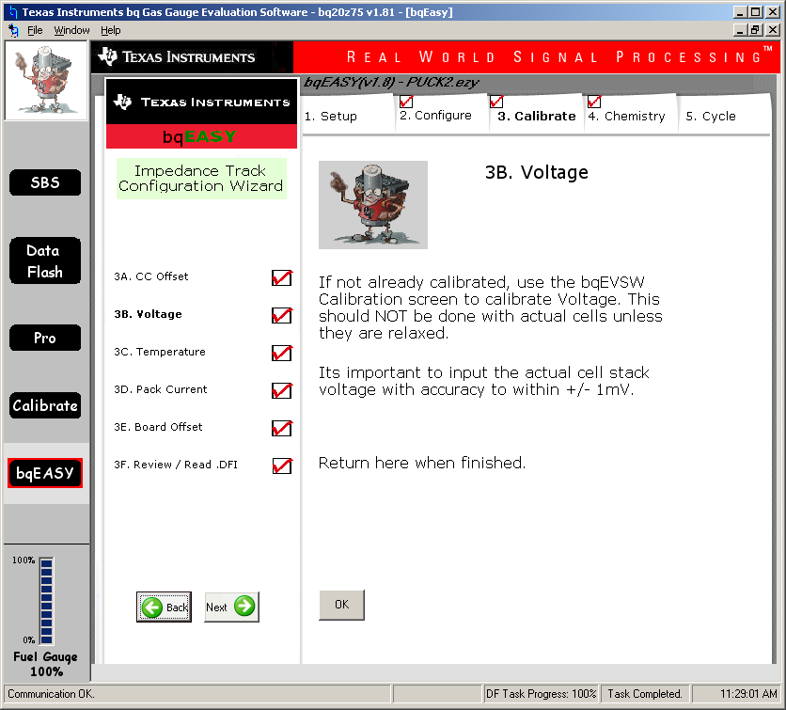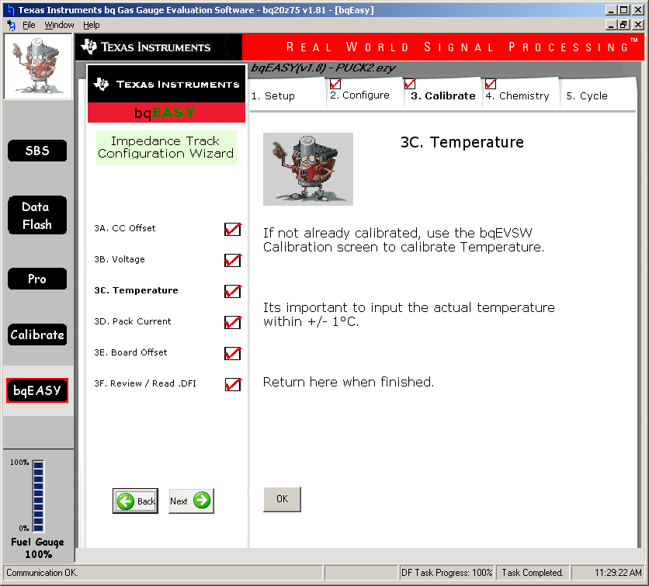

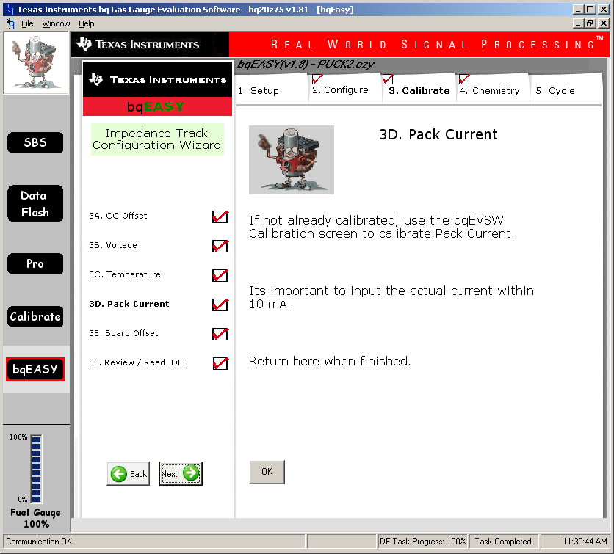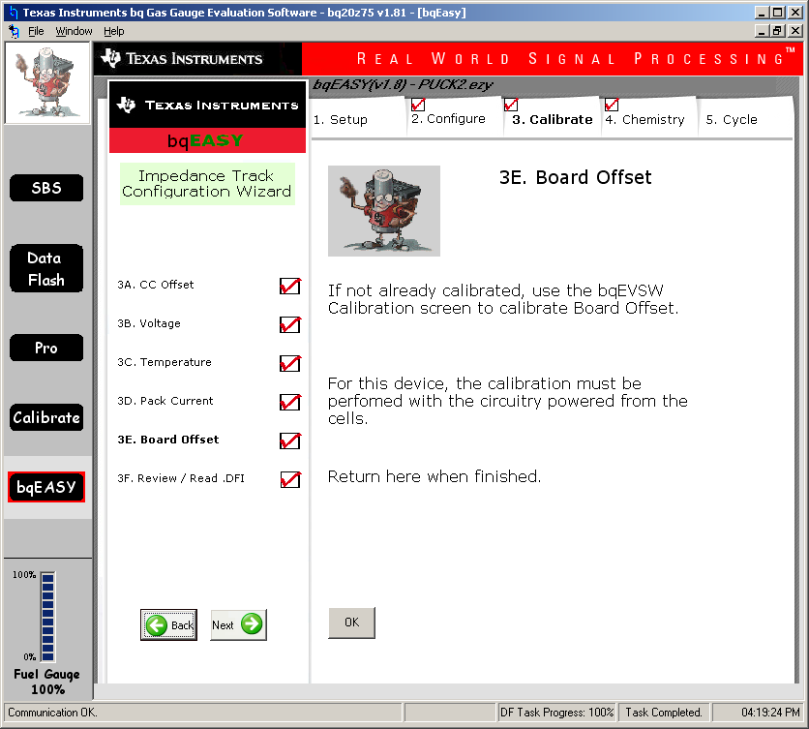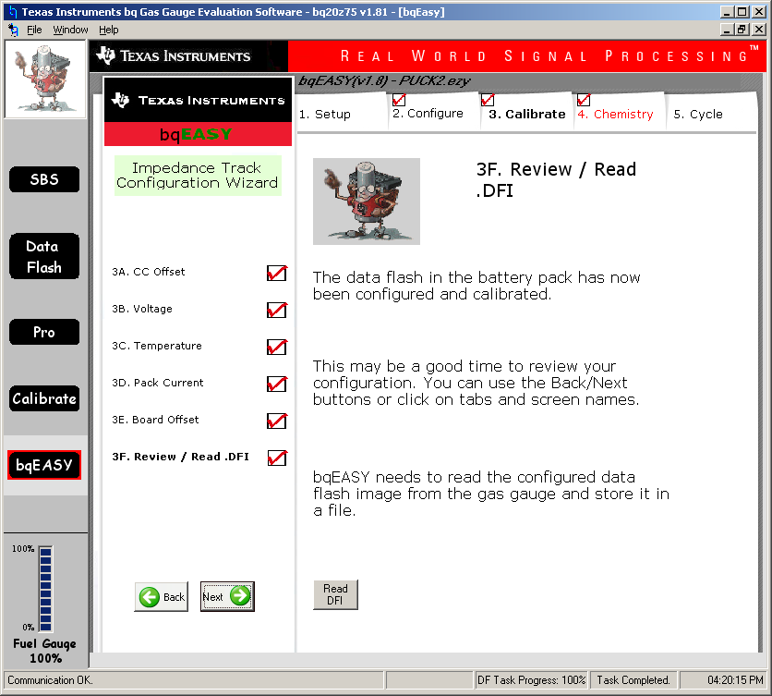

NB Board offset measured with 12VDC bench supply on Batt+/- pins. No voltage on Pack+/-

CALIBRATION SCREEN: NOTE 3 CELL, CURRENT FET CONTROL OFF

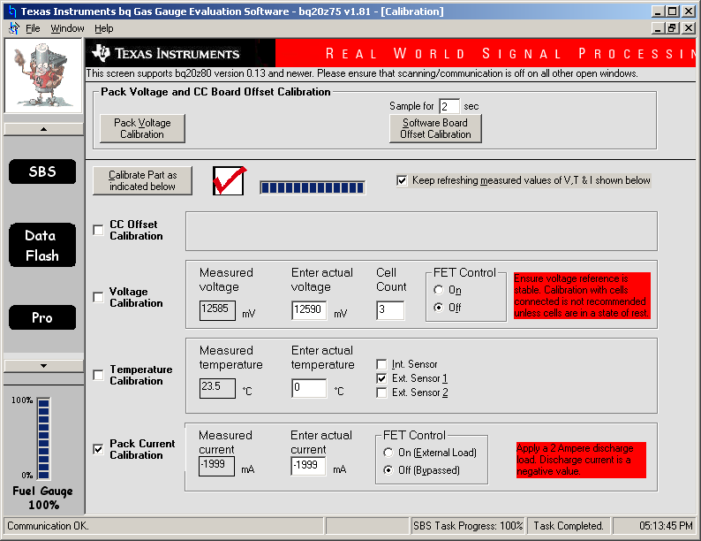

Do in sequence

1. Connect 12.6V bench supply to Batt+/- Pins
2. CC Offset
3. Voltage
4. Temp, Ext1, then Ext2
5. Connect 2A current limit bench supply between 1N Pack- and measure –ve Pack Current. Remove after measurement.
6. Pack Voltage – Connect 12V to Pack+,- . Then remove after measurement.
7. Software Board Offset Calibration.

AFTER BQEASY SETUP FOR 2300mAH

1ST LEVEL

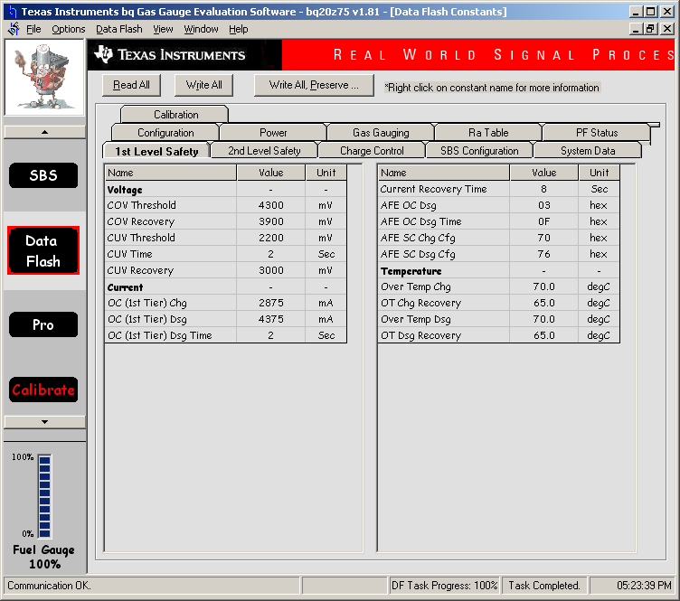

2nd LEVEL

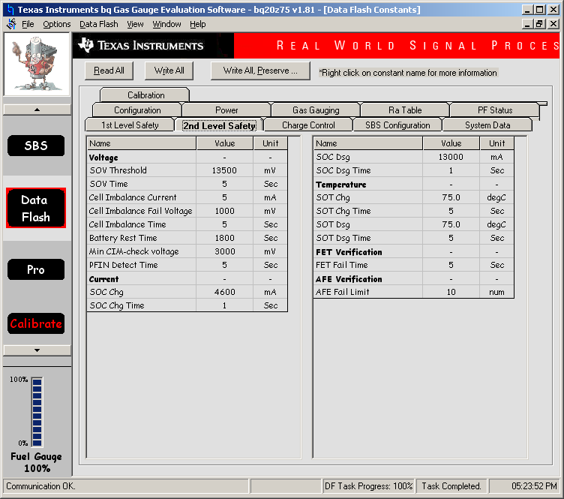

CHARGE CONTROL

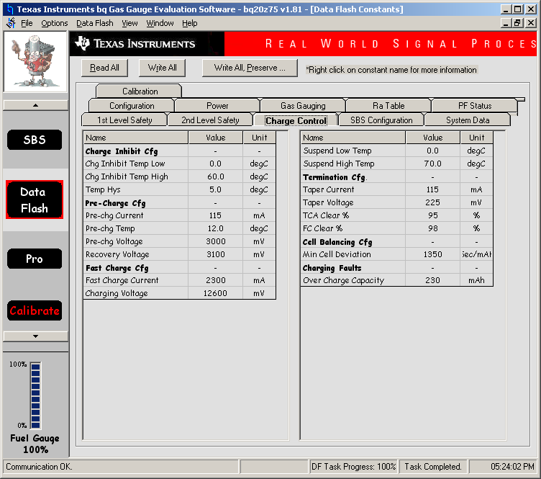

SBS CONFIGURATION

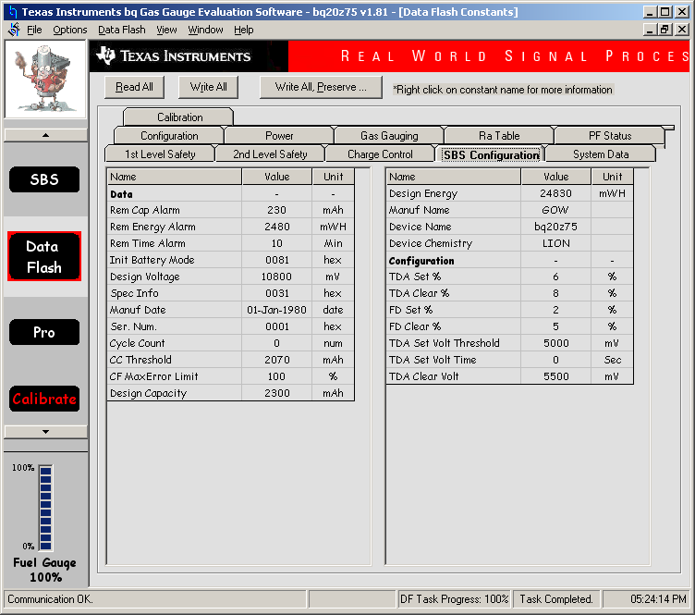

SYSTEM DATA

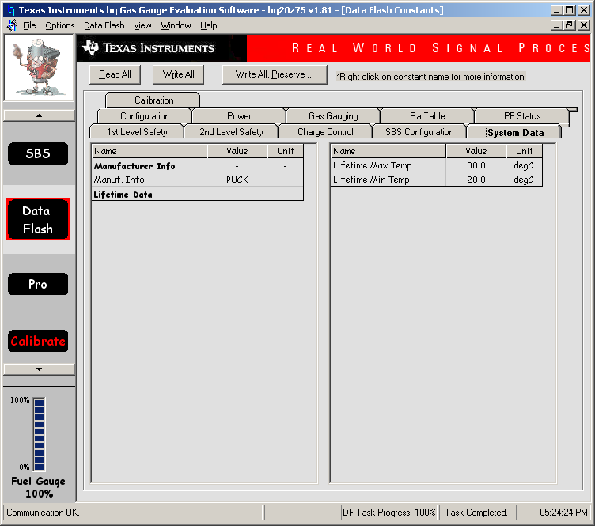

CONFIGURATION

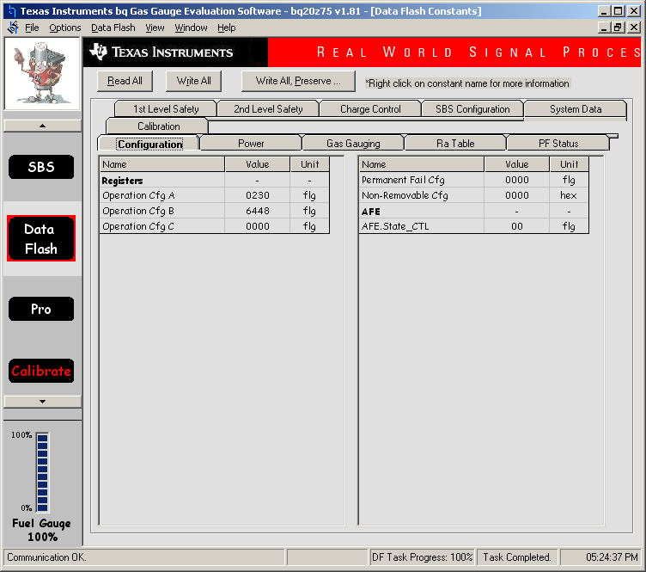

POWER

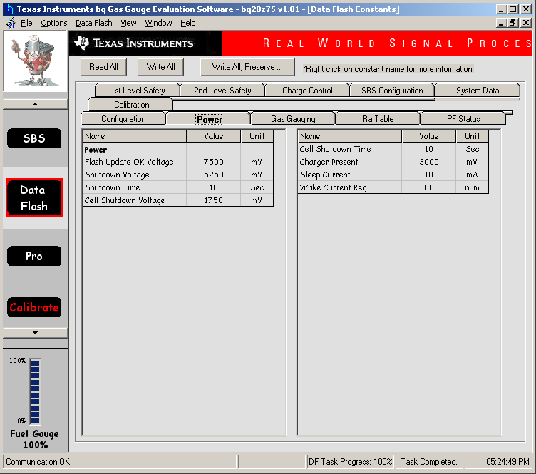

GAS GAUGING

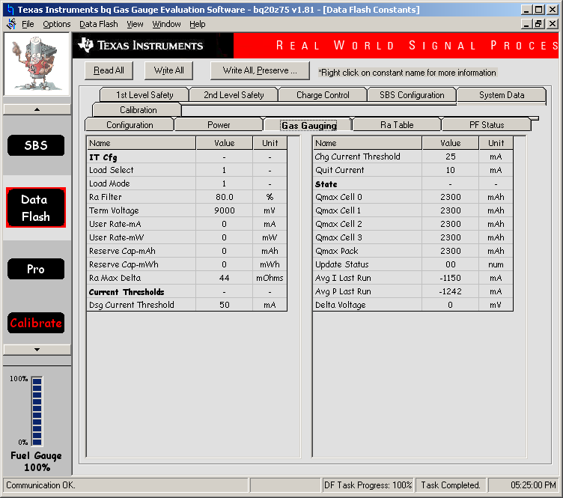

CALIBRATION

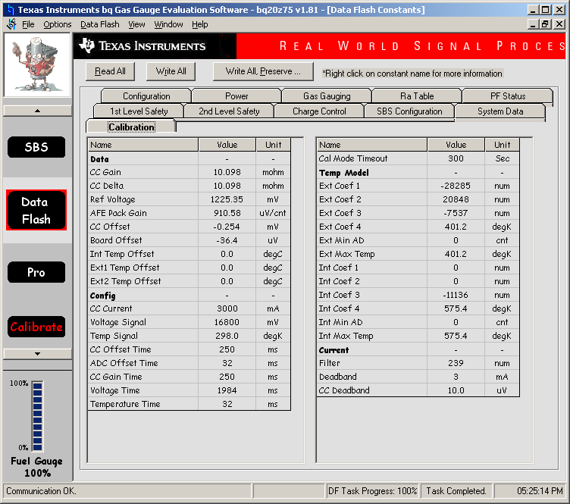

CHARGING DURING GOLDEN FILE 2ND RUN 87% FULL

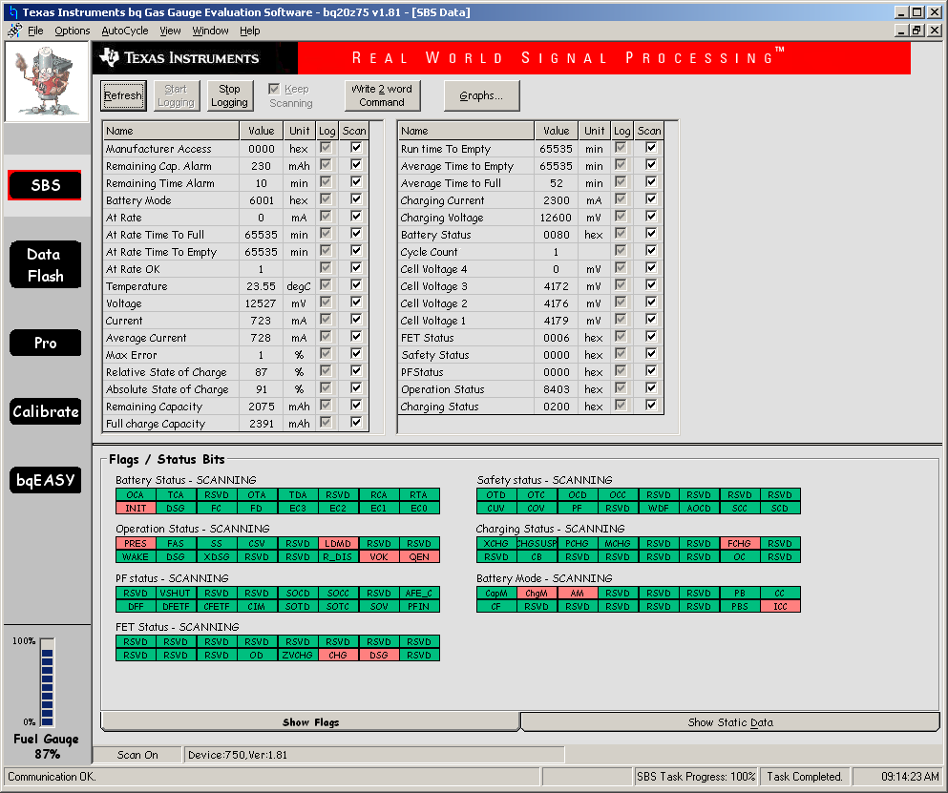

CHARGING DURING GOLDEN FILE 2ND RUN 99% FULL

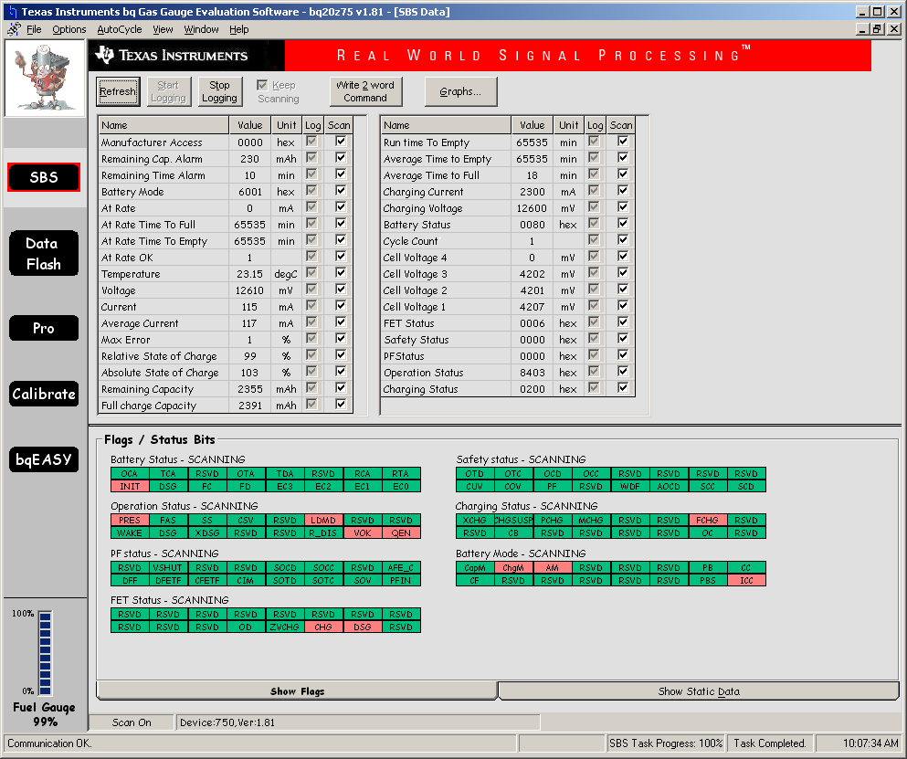

CHARGING DURING GOLDEN FILE 2ND RUN 100% FULL

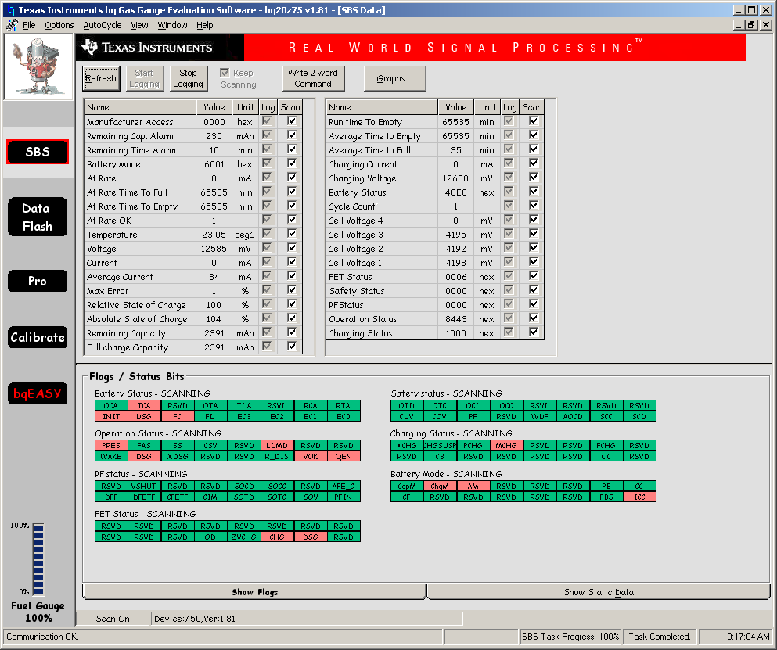

DISCHARGING DURING GOLDEN FILE 2ND RUN C/5 THROUGH MOSFET 25 OHM RESISTOR LOAD

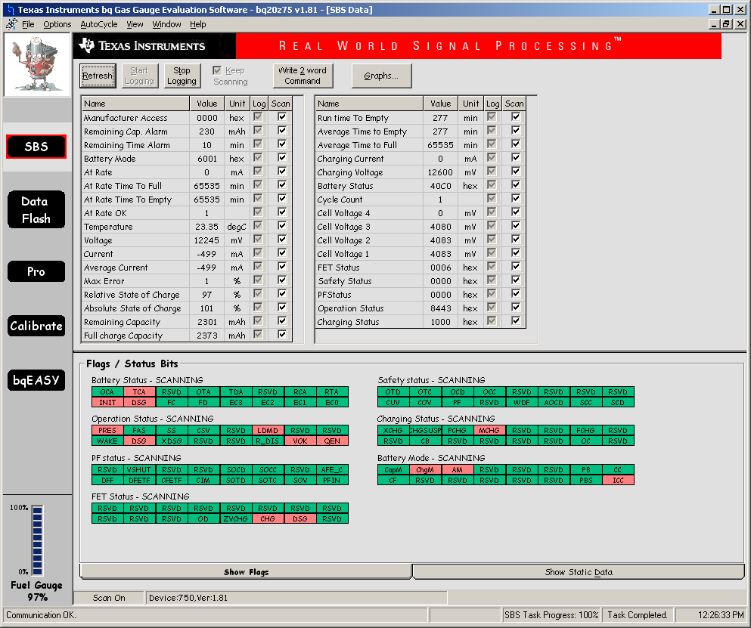

STAGE 2 COMPLETION – UPDATE STATUS = 0E

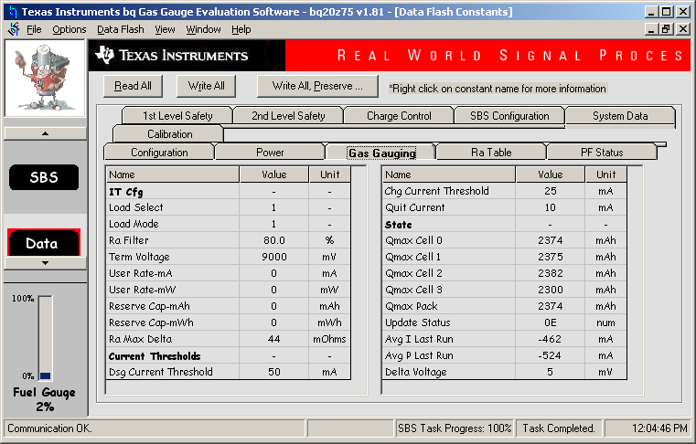

LEARNING CYCLE 2 COMPLETION – NOTE THIS TAKES ABOUT 28 HRS TO GET HERE. 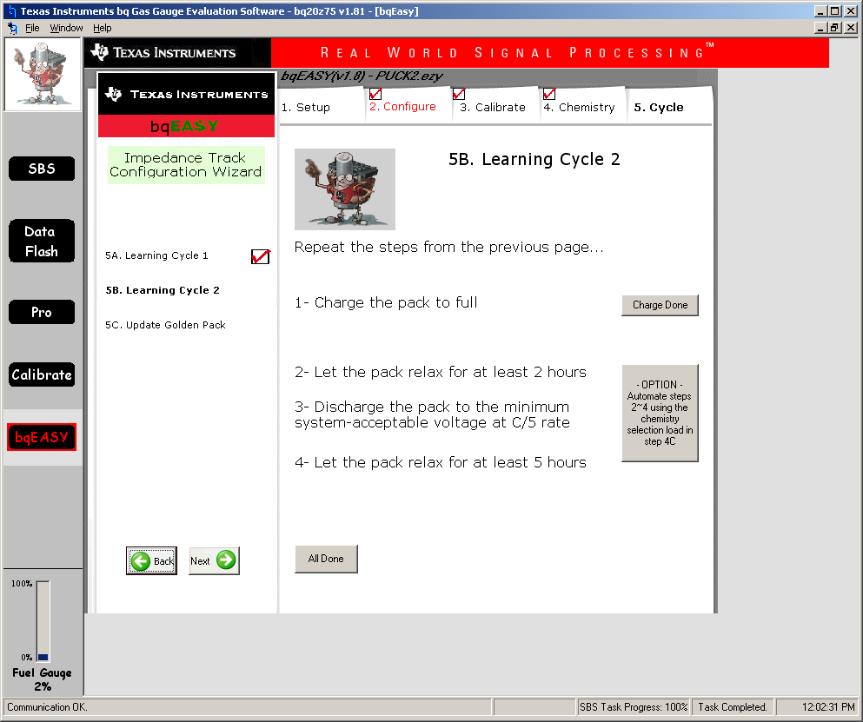

CLICK ON ALL DONE AND GET FOLLOWING ERROR MESSAGE

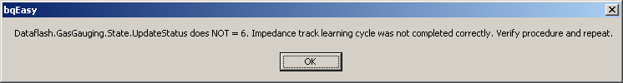

DROPS HERE AND CANNOT UPDATE GOLDEN PACK.

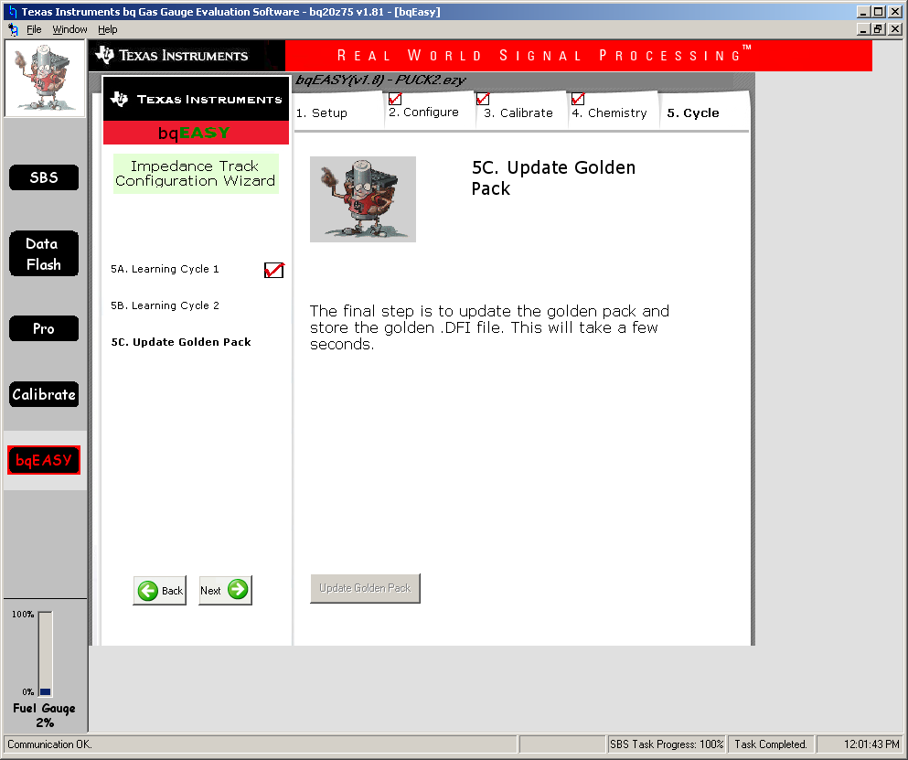

NOTES FROM TI:

1) An Update Status = 0E is a valid value for the bq20z75 v181 FW.. It indicates that a field Qmax update has occurred. I am not sure about your comment that the bqEVSW does not accept the 0E. it works on my system. You should change this value to a 02 before creating the golden image anyway.

The golden image processes that you noted should all yield good results when generating the golden file. As a general rule, you should use the document with the most resent update if you find discrepancies.

2a) The senc file that you noted is the correct version.

2b) The comment is from an older applications note. The newer devices only have one version of the senc file that covers all ChemID's.

3) You need to issue a Reset command (41) to initialize the data in the RAM. The Reset command (41) is fairly well documented in the TRM.

3) After you have reloaded the senc file, gg file, WRITE ALL, and RESET, then you are ready to create the .dfi file. It is a good practice to make sure that your Chemistry file is still selected, so check that in bqEASY. You can then go to the Setup screen on bqEASY and save the dfi or ROM file to use to load into other packs.