AFTER BATTERY CONNECTION AND 41 COMMAND

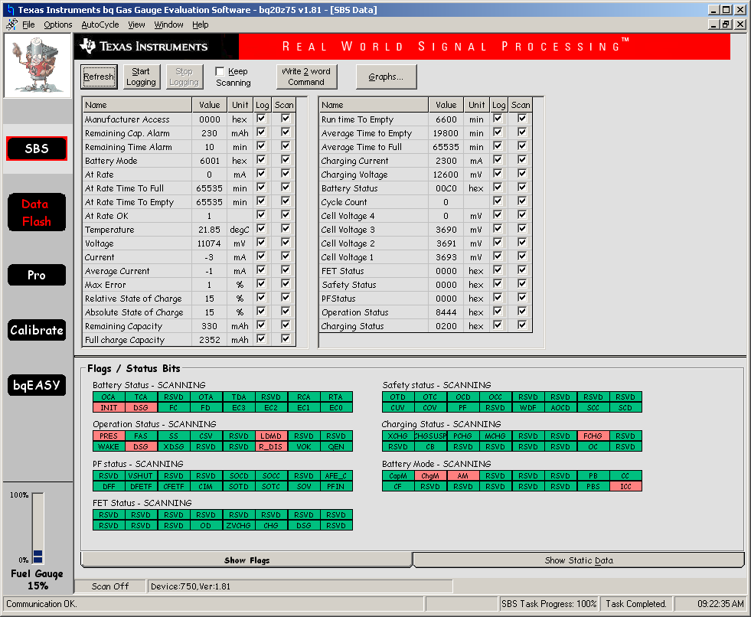

AFTER 20 MINS OF CHARGING, INTERRUPTED CHARGE CYCLE FOR 20 SECS. WAS GAUGING AT START, DID NOT RECOVER AFTER INTERRUPTION.

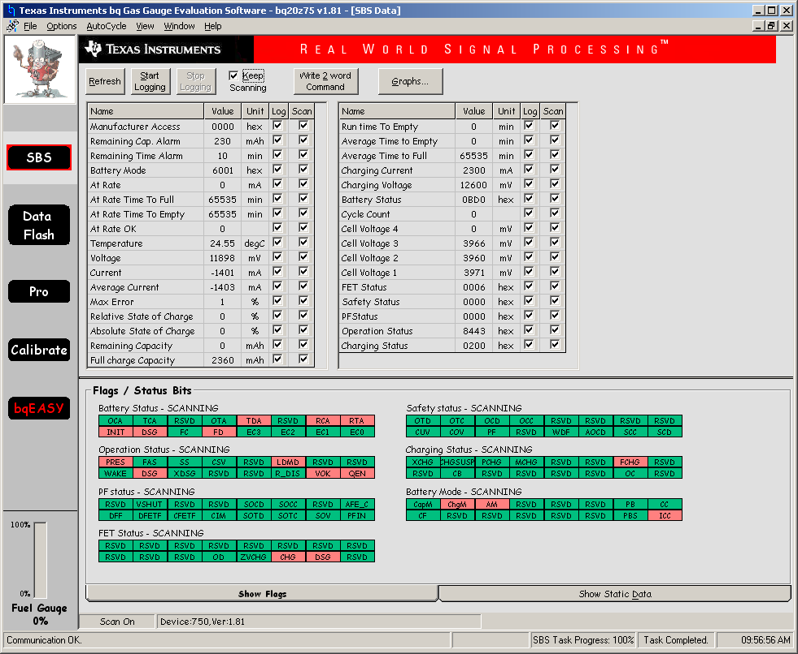

AROUND 60MINS FURTHER CHARGING, CHARGED VOLTAGE INCREASES, GAUGE NOT WORKING.

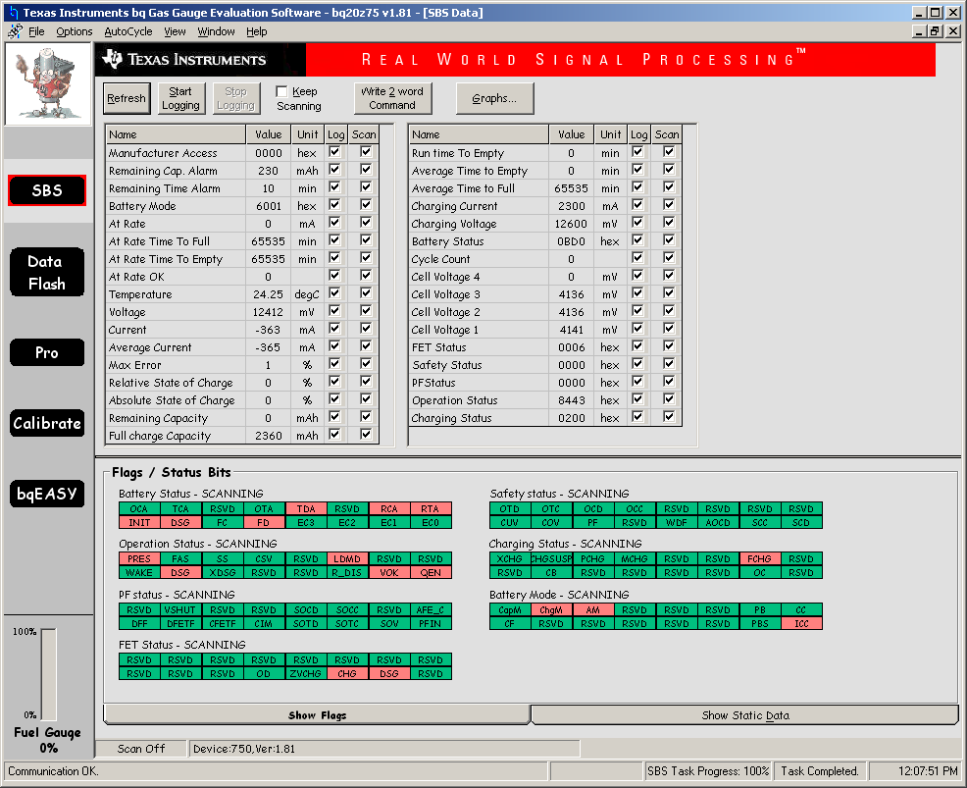

ALMOST FULL, CHARGED VOLTAGE INCREASES, NOTICED INIT BIT STILL SET, ISSUED 0041 IN MANUFACTURER, GG AT 100%  
VOK NOT SET NOW, R_DIS SET.

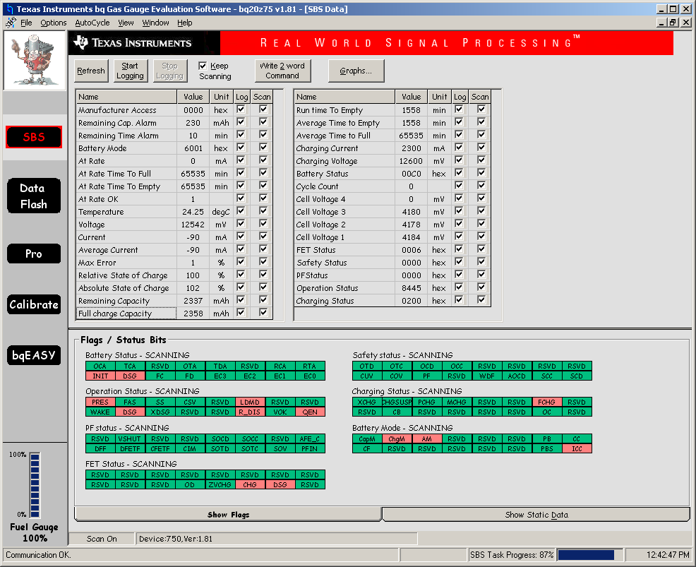

NOT REACHING TERMINATION VOLTAGE, 16mA CURRENT MEASURED, CURRENT POSSIBLY DIVERTED INTO CPU CIRCUIT.  
BUMP UP CHARGE VOLTAGE TO 12.7V, D_DIS CLEARS, VOK SETS. STILL NO FC OR TCA BITS SET.

