|  |  |  |  |
| --- | --- | --- | --- |
| TPS61256 |  |  |  |
| 2.51 Vin | 5.021 Vout | No Load | 34 Hz |
| 2.51 Vin | 5.021 Vout | 10mA | 167kHz |
| 2.51 Vin | 5.021 Vout | 20mA | 378kHz |
| 2.51 Vin | 5.021 Vout | 30mA | 365kHz |
| 2.51 Vin | 5.021 Vout | 40mA | 471kHz |
| 2.51 Vin | 5.021 Vout | 60mA | 485kHz |
| 4.15 Vin | 5.028 Vout | No Load | 88 Hz |
| 4.15 Vin | 5.028 Vout | 10mA | 87.2kHz |
| 4.15 Vin | 5.028 Vout | 30mA | 197.1kHz |
| 4.15 Vin | 5.028 Vout | 60mA | 393.7kHz |

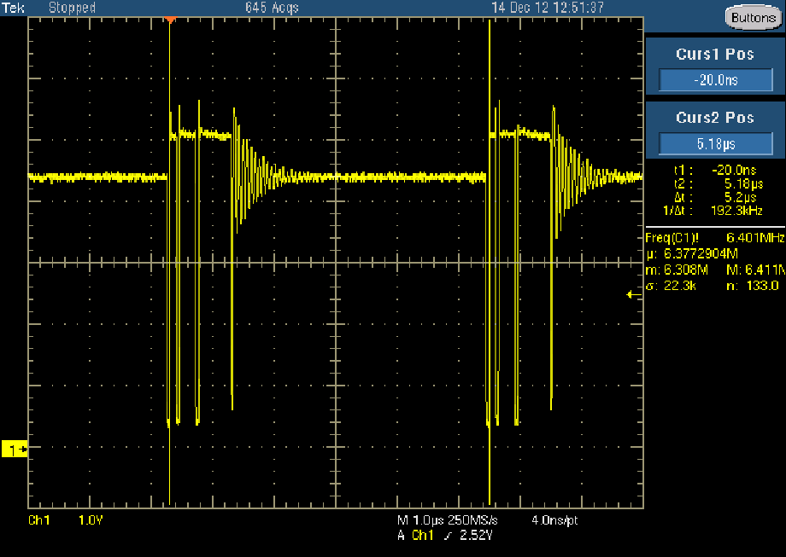

Above TPS61256 4.3Vin, 5.03Vout @ 30mA

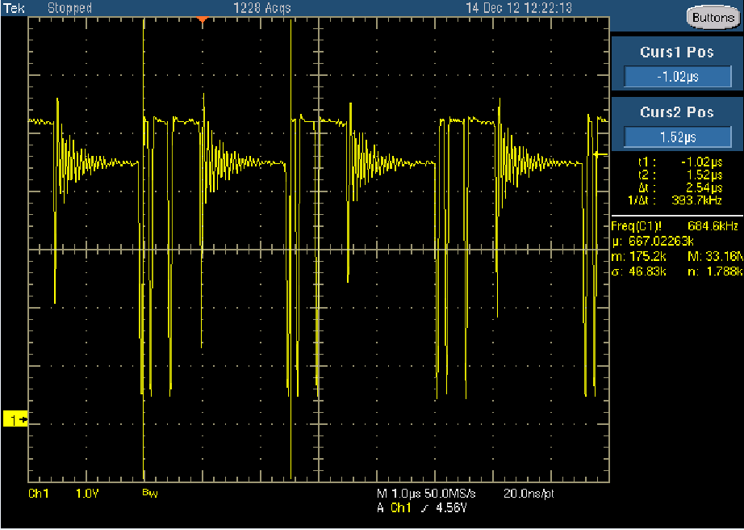

Above TPS61256 4.3Vin, 5.03Vout @ 60mA

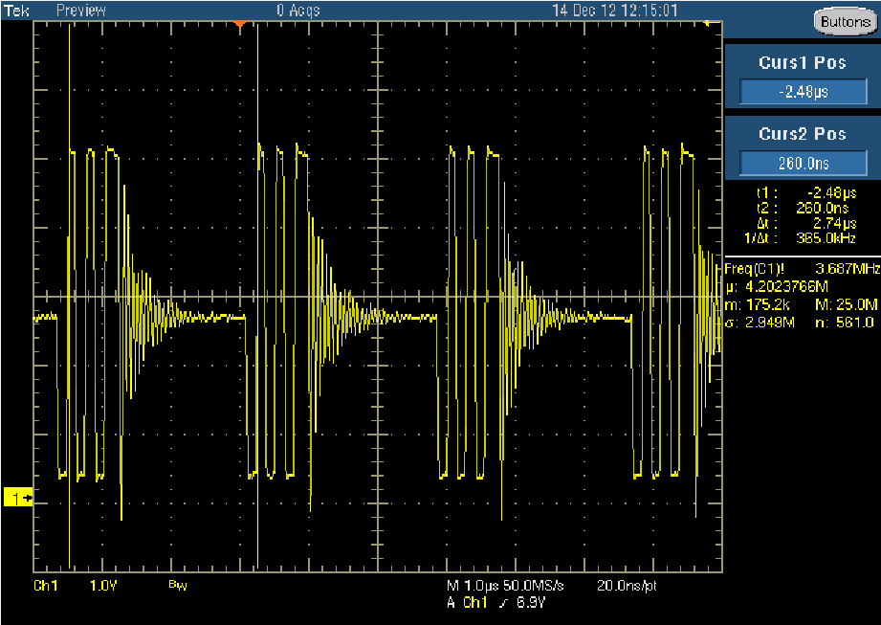

Above TPS61256 2.5Vin, 5.03Vout @ 30mA

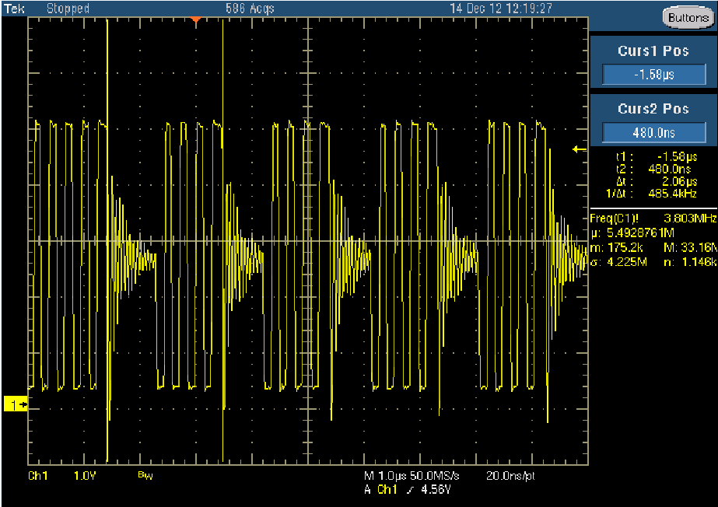

Above TPS61256 2.5Vin, 5.03Vout @ 60mA

Screen captures below for TPS61240

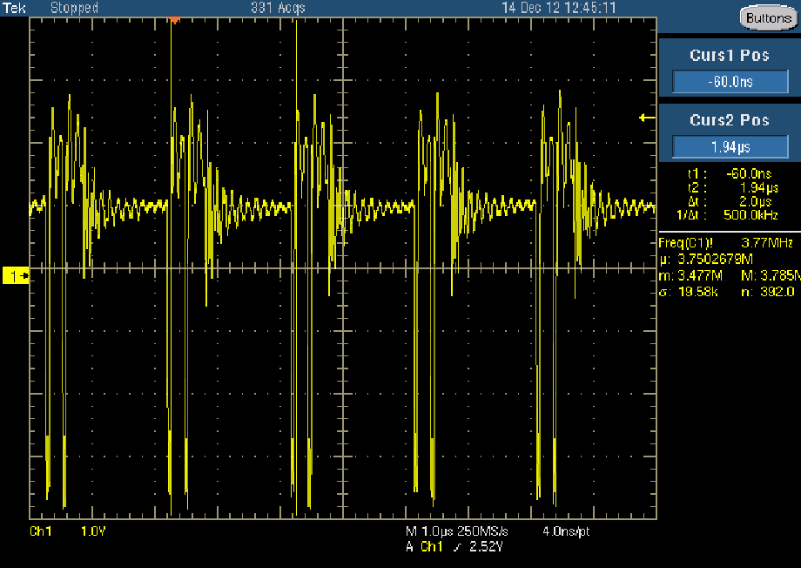

Above TPS61240 4.3Vin, 5.2Vout @ 30mA

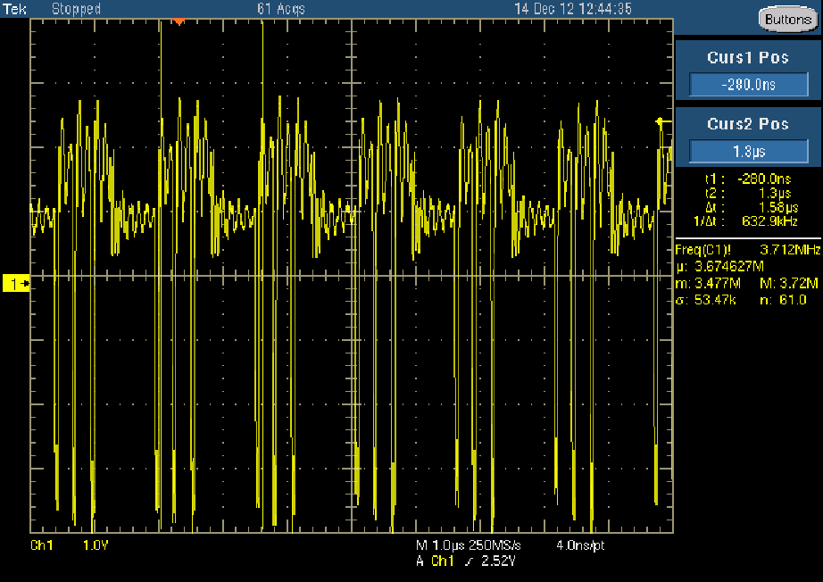

Above TPS61240 4.3Vin, 5.2Vout @ 60mA

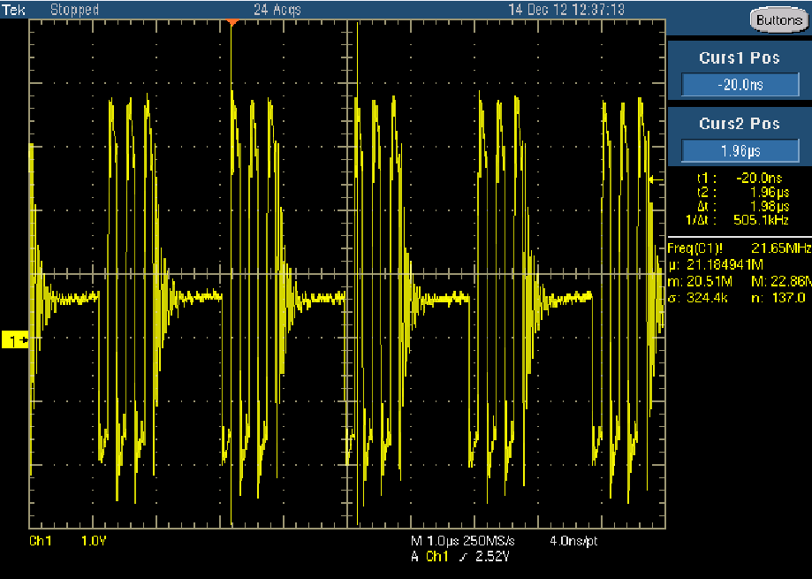

Above TPS61240 2.5Vin, 5.185Vout @ 30mA

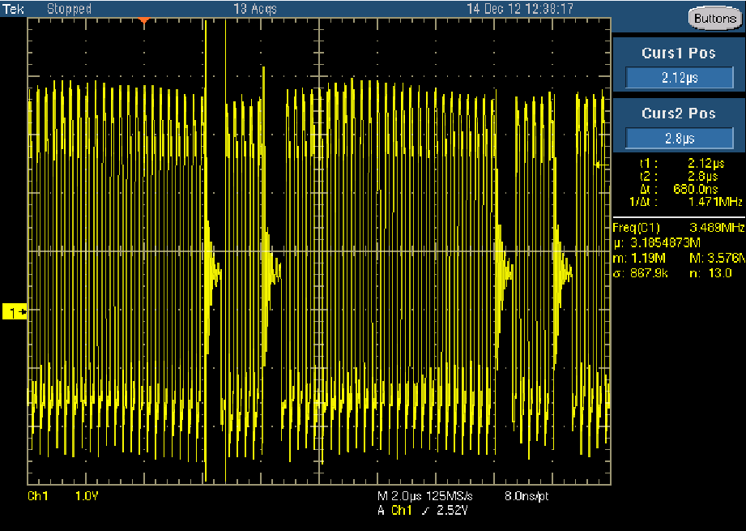

Above TPS61040 2.5Vin, 5.185Vout @ 60mA