FAE Summit 2004 - Interfacing the ADS8361 to the TMS320C6713 DSP
High Performance Analog - Data Acquisition Products Group

Lab Objectives
This lab exercise presents a method for interfacing the ADS8361 16-bit SAR analog- to-digital converter to the TMS320C6713 DSP using McBSP0 and McBSP1 to achieve full speed 2x2 channel, 500KSPS operation of the ADS8361. You will learn how to setup and initialize the McBSP ports, configure the Board Support Library as well as implement probe points and view the graphical display capabilities of Code Composer Studio.
Required Material
TMS320C6713 DSK
ADS8361EVM with “5-6K” Header
5-6K Interface Board
Universal Front End (UFE) Board
Stimulus Board
DAP Power Supply
USB Cable
C6713DSK Lab Introduction
The ADS8361 is a 2+2 channel, 16–bit upgrade for the ADS7861 (12-bit) 2+2 channel analog-to-digital converters. The converter is able to gluelessly interface to the TMS320C6713 digital signal processor (C6713. DSP). This lab uses the TMS320C6713 DSP starter kit (DSK) and ADS8361EVM in conjunction with the 5-6K Interface Board.
- Hardware
The combination of the TMS320C6713 DSK and the 5-6K Interface Board is a convenient way to experiment with interfacing the TMS320C6713 DSP to the ADS8361. The ADS8361EVM plugs onto the 5-6K Interface Board, which then plugs directly into the C6713 DSK through mating connectors compatible with the TMS320 Cross-Platform Daughtercard Interface (SPRA711) connectors found on the DSK platform. Additional hardware is included for the purposes of this lab that eliminate the need to carry lab power supplies and signal generators.
  - TMS320C6713 DSK
The TMS320C6713 DSP starter kit (DSK) not only provides an introduction to C6000. DSP platform technology, but also is powerful enough to use for fast development of networking, communications, imaging and other applications. This lab can also be ported to the 5402, 5416, 5510, 6416 and 6711 platforms.
  - UFE and Stimulus Board
The Universal Front End and Stimulus Boards were designed to accompany the Data Converter Seminar. These boards work together to provided buffered signals to the data converter and offer an effective means to demonstrate hardware without having to carry signal generators and excess lab equipment. These boards are not generally available to customers.
  - DAP PS Board
The DAP PS REV B board is a multi-output power supply that will operate from standard 5VDC wall transformers such as those supplied with the DSK’s. It is important to mention that the voltage applied to the DAP PS board goes directly to the 5V electronics on the various interface and DSK boards this may be used with. DO NOT use a 9V supply with this board! There is no over voltage protection and permanent damage may be inflicted on the hardware.
The DAP Power Supply provides +/-15 V using a PT5062A, -5V using a UCC284 and +3.3/+1.2V using a TPPM0110. The 5V applied to the board is used as the 5V system power as mentioned above.
  - ADS8361EVM
The ADS8361 is a member of the Motor Control Products family of serial ADCs available from Texas Instruments. The EVM provides a platform to demonstrate the functionality of the ADS8361 ADC with various Texas Instruments DSP’s and Micro Controllers, while allowing easy access to all analog and digital signals for customized end-user applications. For more information on the EVM, search for document number SLAU094 from the main page of the Texas Instruments website at http://www.ti.com.
The ADS8361 is a simultaneous sampling converter designed for use in motor control applications, but is also used in non-motor related designs. Any application requiring a fast multi-channel converter can take advantage of the features of this device.
- Hardware Interface
The hardware interface is seamless between the C6713 DSK and the ADS8361 EVM, meaning there is no “glue logic” required between the DSP and the ADC. The 5-6K Interface Board provides direct access to the C6713 DSP McBSP0/1 ports. In order to use both McBSP ports, a simple wire-wrap interface to port 0 is provided. The hardware connections are shown in Figure 1 via the 5-6K Interface Board. The CLOCK, RD(+ CONVST), and SDA pins from the ADS8361 are connected to CLKR1, FSR1, and DRR1 pins of McBSP1 respectively. CLKR0, FSR0 and DRR0 are wire wrapped via the extension header. The chip select (CS) pin is grounded because only one A/D converter is placed on the port. If more than one device is on the bus, then chip select should be controlled by any available GPIO on the C6713DSK.
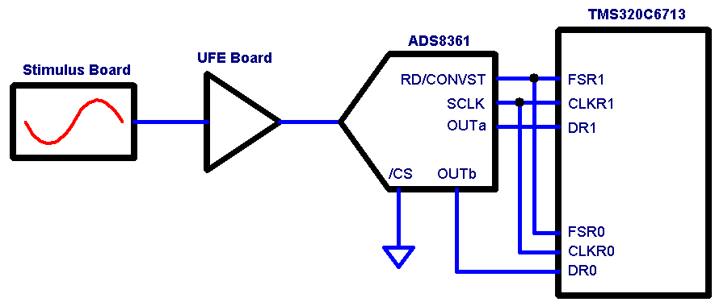
- DSP Interface Block Diagram
  - Applied signals from the Stimulus and UFE Boards
The Stimulus board creates a +/-10V sine, 0-10V square and +/-5V triangle wave. 0-5V DC, 4-20mA transmitter and RTD outputs are also available. The UFE board will scale and level shift these signals to the appropriate range required by the ADS8361 (0-5V).
Channel A0 receives the RTD output. Channel B0 receives the 4-20mA transmitter voltage. Channel A1 receives the sine and triangle waves, which causes the output of the ADC to swing between full scale plus and minus. Channel B1 receives both the square wave and 0-5V DC outputs. Turning the DC knob causes the output of the ADC to swing from Mid to full scale at one extreme, to mid to zero scale at the other. 2.5V in provides a balanced output.
- Software Interface
All of the software was written and compiled using Code Composer Studio version 2.20. The most involved portion of writing the code for this simple interface is programming the multichannel buffered serial port (McBSP) and configuring the ISR to read both McBSP ports.
  - McBSP Settings
The GUI interface of the configuration tool (i.e., CDB file); DSP/BIOS and CSL has made it easier than ever to write programs and set up the multichannel buffered serial port. To see how easy it is to set up the McBSP registers, double click on the .cdb file (in the code example provided, choose the ADS8361.CDB) from within the project window. Browse through the CDB tree, and find the McBSP configuration manger under CSL. Right click on mcbspCfg1 and select properties. This is where the McBSP registers are found as tabs, with individual bit field settings found as pull down options. Feel free to take a minute and review the settings.
McBSP0 is programmed as a serial port with frame sync return (FSR) and serial clock return (CLKR) signals are input pins. McBSP1 is also programmed as a serial port, with FSR and CLKR configured as outputs. Both receivers are set for 20-bit transfers with zero-bit delay on data receive. The frame sync is generated by the sample rate generator and is used for both the RD and CONVST signal on the ADS8361 by jumper W2 on the EVM.

