1.

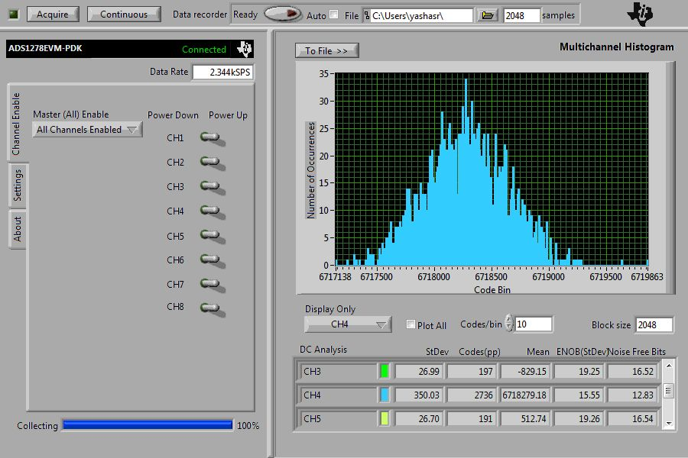

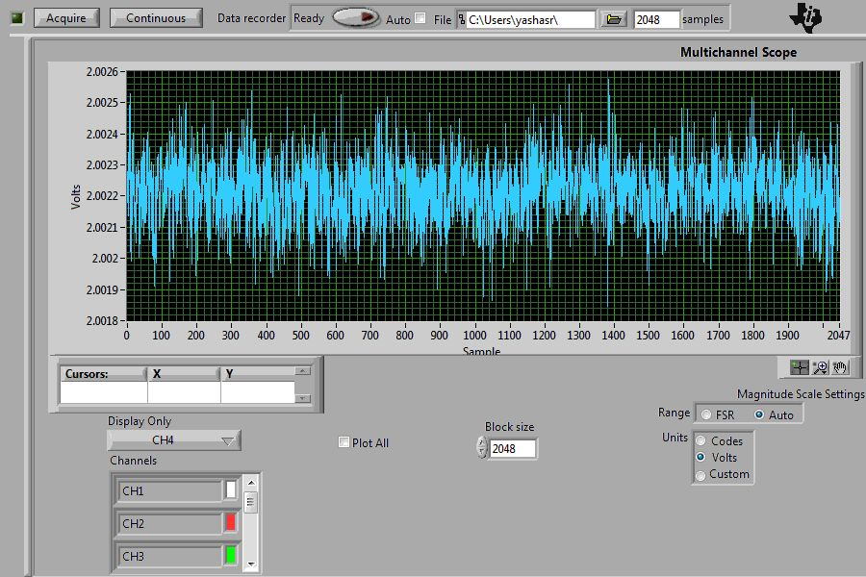

Source – 523

Volts – 2V

ADC – 6MHz PLL, Low Speed Mode, Ch4, **no DMM**

SD – 104.3µV

Mean – 2.002047196V

2.

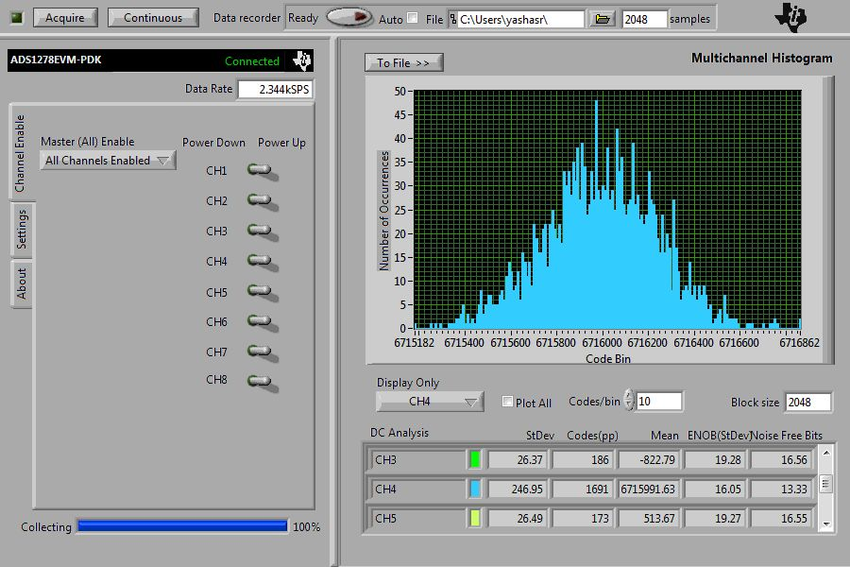

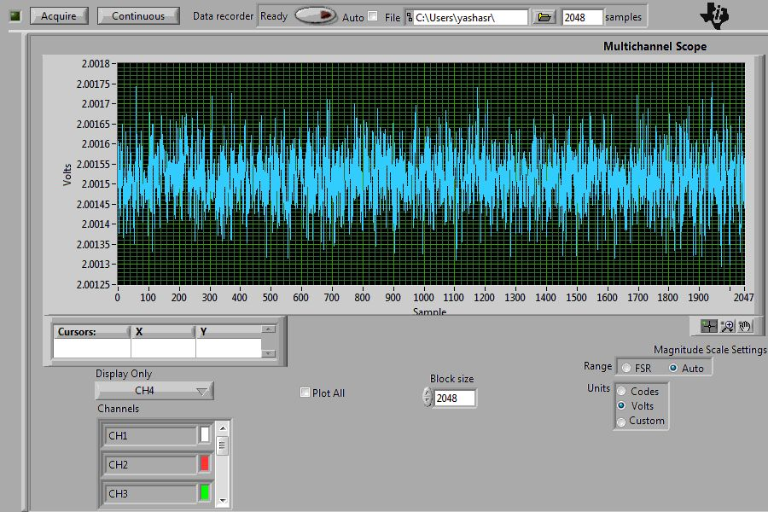

Source – 523

Volts – 2V

ADC – 6MHz PLL, Low Speed Mode, Ch4, **with DMM**

SD – 73.6µV

Mean – 2.001365506V

**Δ = (VDMM)-(VNODMM) = -681.7µV**

3.

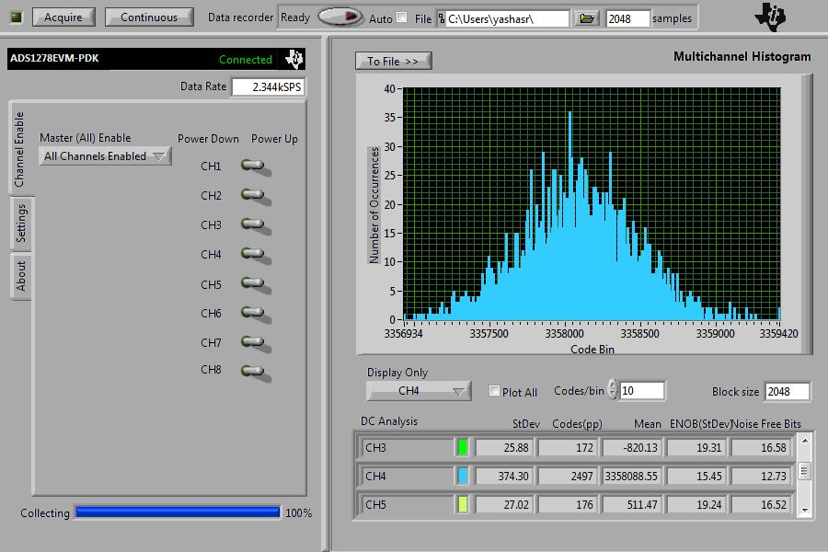

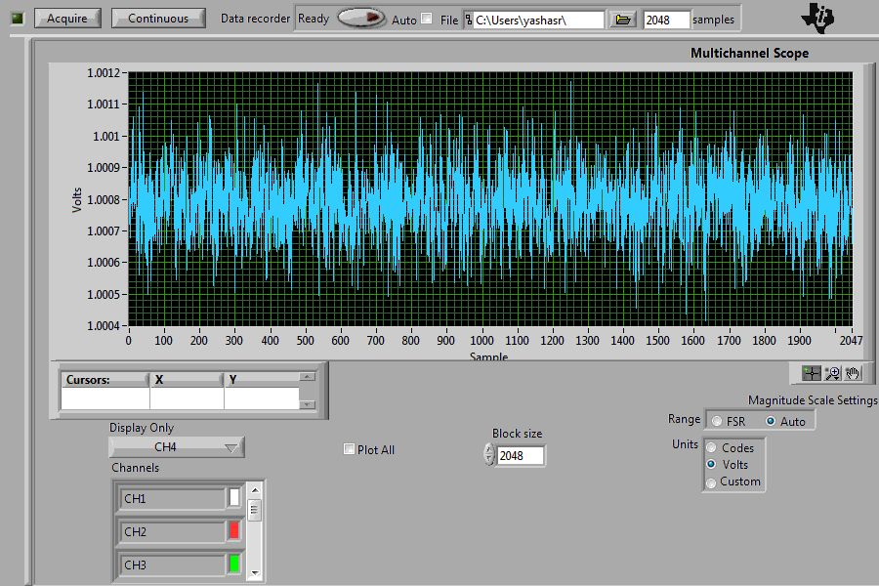

Source – 523

Volts – **1**V

ADC – 6MHz PLL, Low Speed Mode, Ch4, **no DMM**

SD – 111.5µV

Mean – 1.000710388V

4.

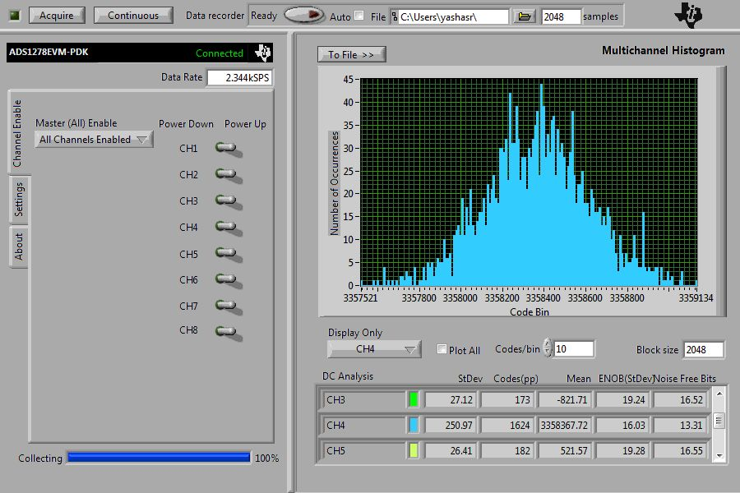

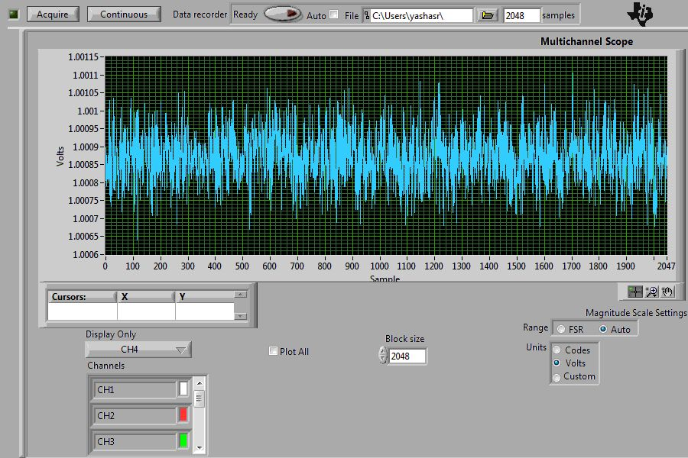

Source – 523

Volts – **1**V

ADC – 6MHz PLL, Low Speed Mode, Ch4, **with DMM**

SD – 74.8µV

Mean – 1.000793581V

**Δ = (VDMM)-(VNODMM) = 83.2µV**

5.

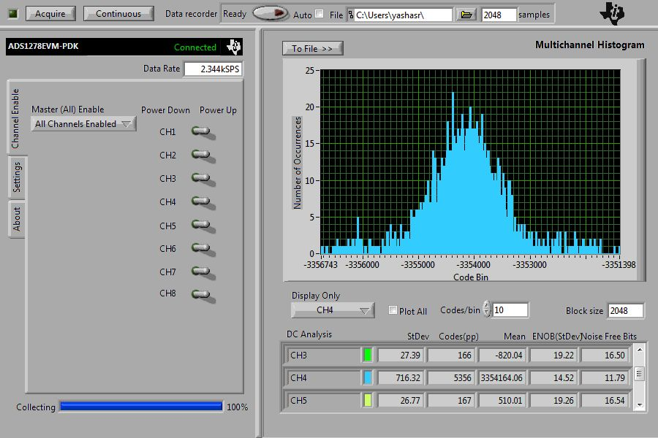

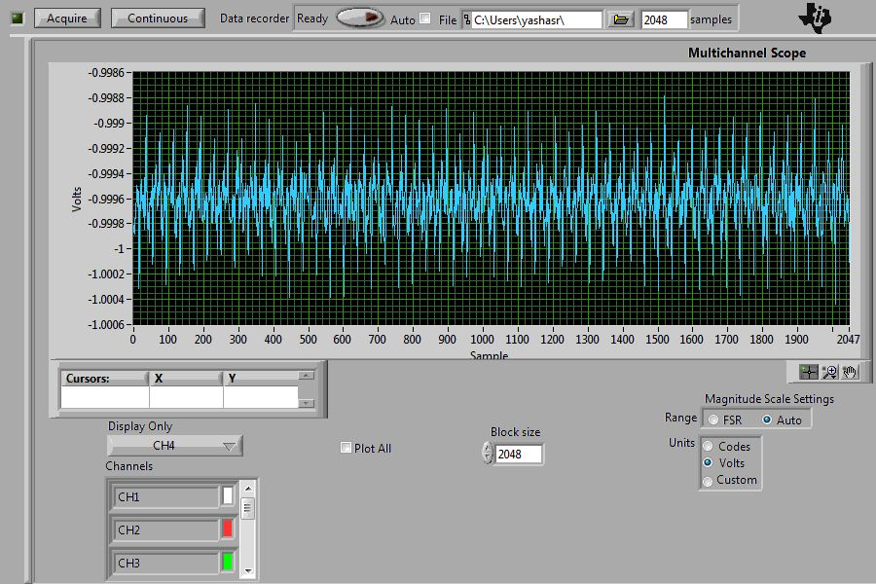

Source – 523

Volts – -**1**V

ADC – 6MHz PLL, Low Speed Mode, Ch4, **no DMM**

SD – 213.5µV

Mean – -0.999540889V

6.

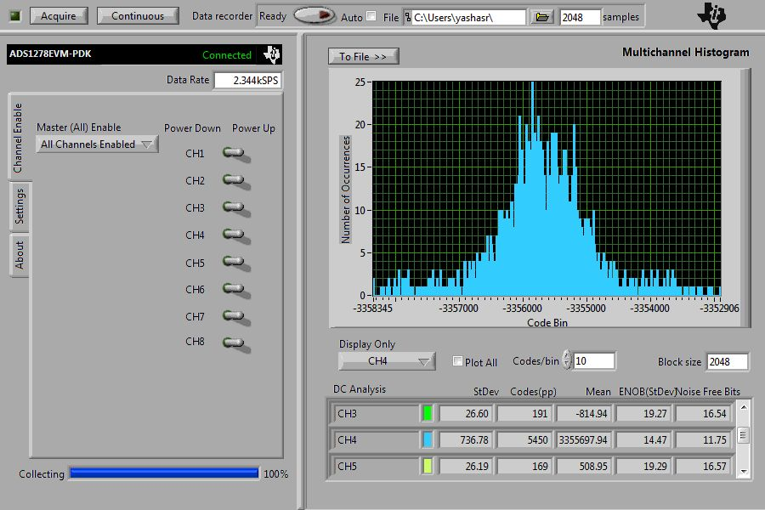

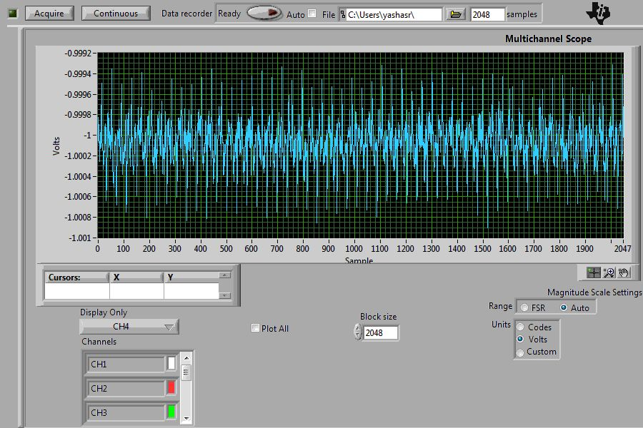

Source – 523

Volts – -**1**V

ADC – 6MHz PLL, Low Speed Mode, Ch4, **with DMM**

SD – 219.6µV

Mean – -0.999778425V

**Δ = (VDMM)-(VNODMM) = -237.5µV**

7.

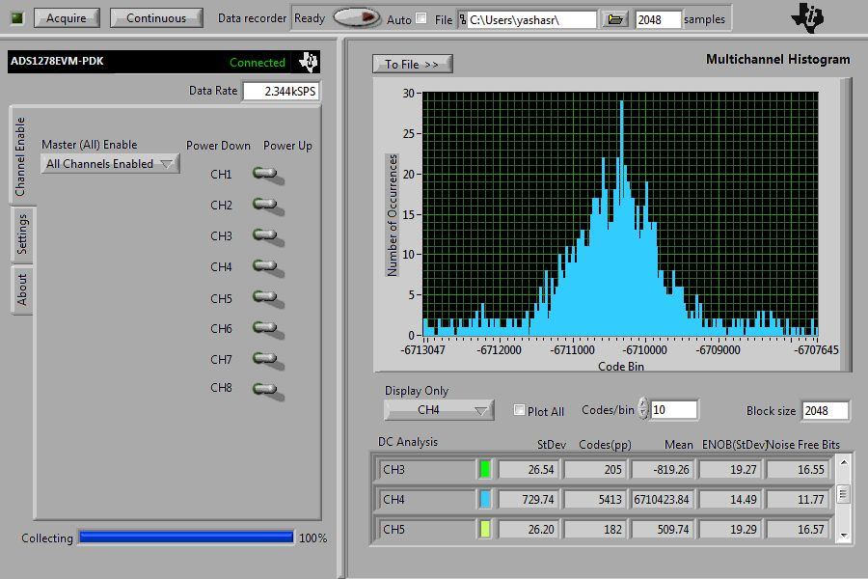

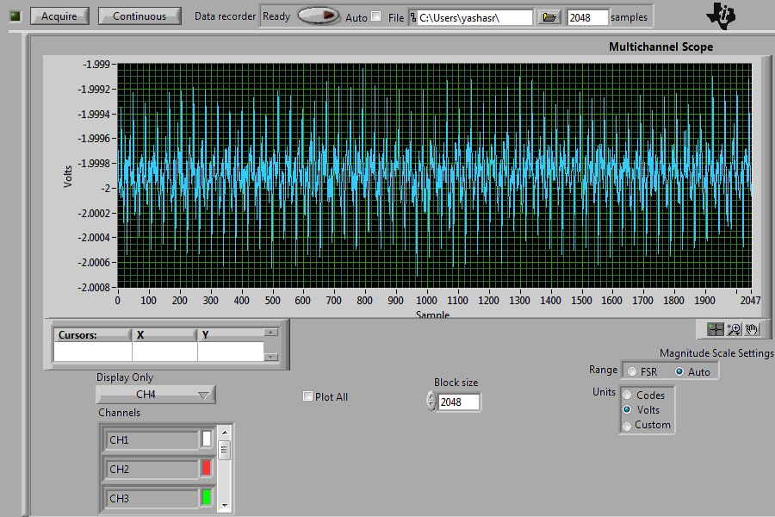

Source – 523

Volts – -**2**V

ADC – 6MHz PLL, Low Speed Mode, Ch4, **no DMM**

SD – 217.5µV

Mean – -1.999706304V

8.

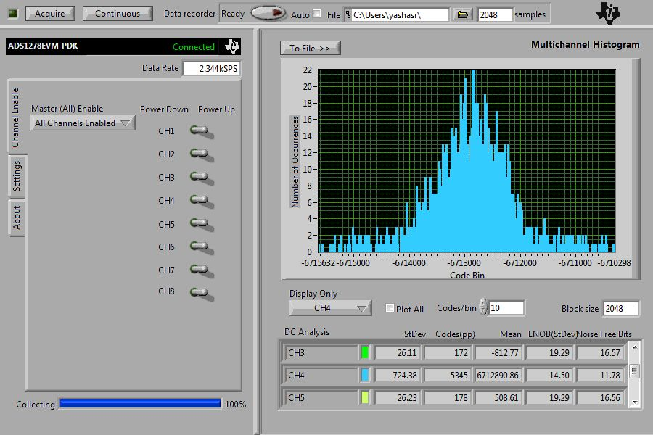

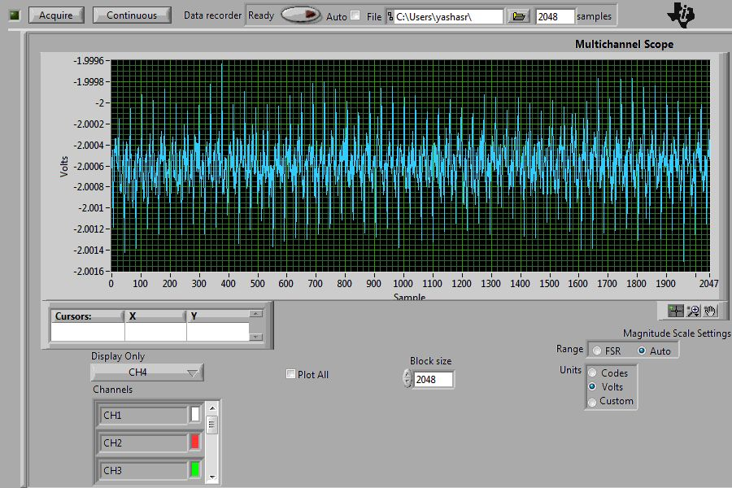

Source – 523

Volts – -**2**V

ADC – 6MHz PLL, Low Speed Mode, Ch4, **with DMM**

SD – 215.9µV

Mean – -2.000441476V

**Δ = (VDMM)-(VNODMM) = -735.2µV**