Hi ,

We design a model, It reference pandaboardES B3, It doesn't change in principle, It is reduce the TI PandaboardES to layout PCB area.

But we use CCS5.5 and XDS560v2 to connect plate, it is always reported to the error message, error no. 241.

But we use CCS "Test Connection" function Test Connection plate no problem.

Please check the attachment.

**Error Message:**

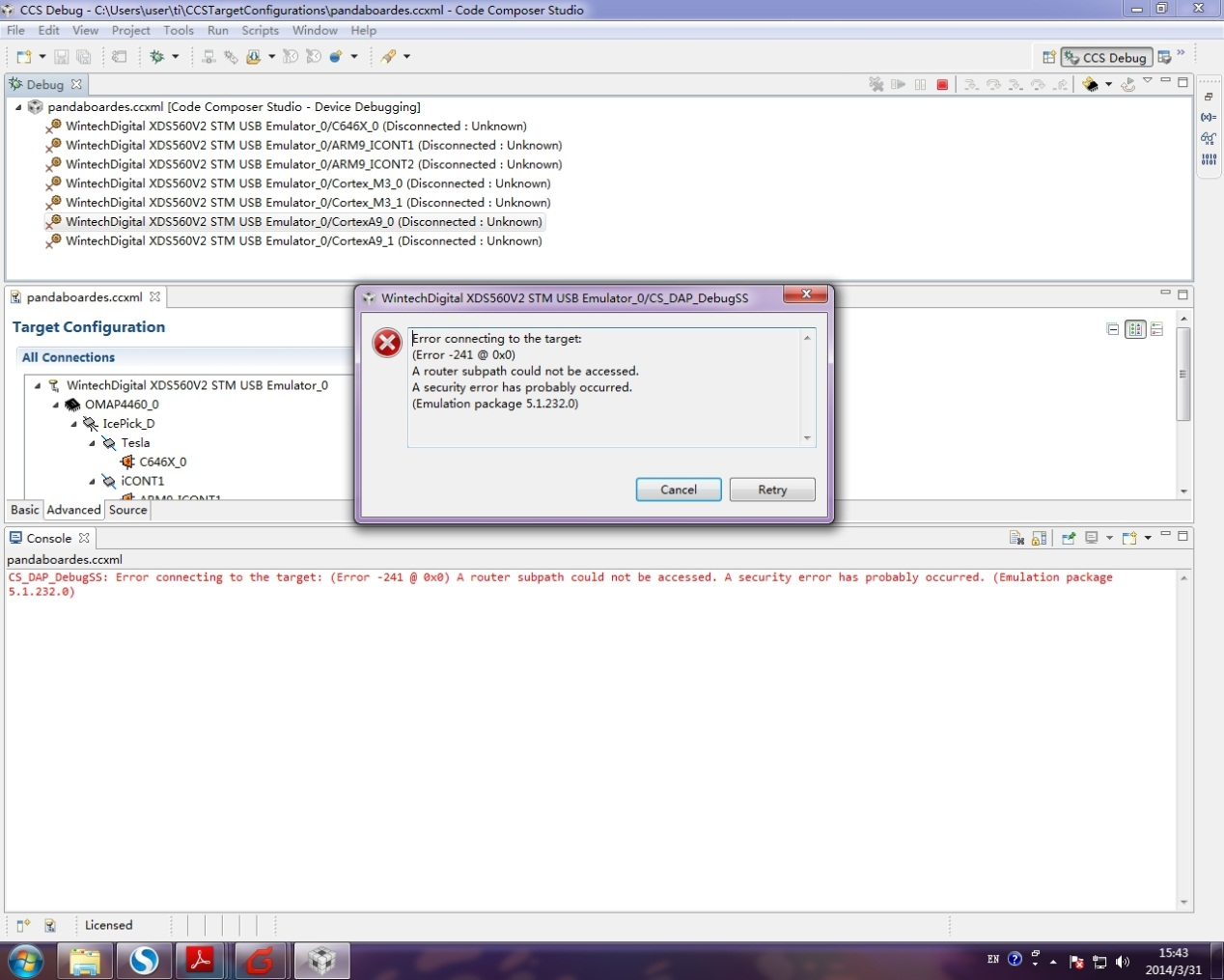

**Test Connection Message:**

[Start]

Execute the command:

%ccs_base%/common/uscif/dbgjtag.exe -f %boarddatafile% -rv -F inform,logfile=yes -S pathlength -S integrity

[Result]

-----[Print the board config pathname(s)]------------------------------------

C:\Users\user\AppData\Local\.TI\1504740867\

    0\0\BrdDat\testBoard.dat

-----[Print the reset-command software log-file]-----------------------------

This utility has selected a 560/2xx-class product.

This utility will load the program 'sd560v2u.out'.

Loaded FPGA Image: D:\Program Files\CCS\ccsv5\ccs_base\common\uscif\dtc_top.jbc

The library build date was 'Aug 19 2013'.

The library build time was '22:41:20'.

The library package version is '5.1.229.0'.

The library component version is '35.34.40.0'.

The controller does not use a programmable FPGA.

The controller has a version number of '5' (0x00000005).

The controller has an insertion length of '0' (0x00000000).

The cable+pod has a version number of '8' (0x00000008).

The cable+pod has a capability number of '7423' (0x00001cff).

This utility will attempt to reset the controller.

This utility has successfully reset the controller.

-----[Print the reset-command hardware log-file]-----------------------------

The scan-path will be reset by toggling the JTAG TRST signal.

The controller is the Nano-TBC VHDL.

The link is a 560-class second-generation-560 cable.

The software is configured for Nano-TBC VHDL features.

The controller will be software reset via its registers.

The controller has a logic ONE on its EMU[0] input pin.

The controller has a logic ONE on its EMU[1] input pin.

The controller will use falling-edge timing on output pins.

The controller cannot control the timing on input pins.

The scan-path link-delay has been set to exactly '2' (0x0002).

The utility logic has not previously detected a power-loss.

The utility logic is not currently detecting a power-loss.

Loaded FPGA Image: D:\Program Files\CCS\ccsv5\ccs_base\common\uscif\dtc_top.jbc

-----[The log-file for the JTAG TCLK output generated from the PLL]----------

  Test  Size   Coord      MHz    Flag  Result       Description

  ~~~~  ~~~~  ~~~~~~~  ~~~~~~~~  ~~~~  ~~~~~~~~~~~  ~~~~~~~~~~~~~~~~~~~

    1   none  - 01 00  500.0kHz   -    similar      isit internal clock

    2   none  - 01 09  570.3kHz   -    similar      isit internal clock

    3    512  - 01 00  500.0kHz   O    good value   measure path length

    4    128  - 01 00  500.0kHz   O    good value   auto step initial

    5    128  - 01 0D  601.6kHz   O    good value   auto step delta

    6    128  - 01 1C  718.8kHz   O    good value   auto step delta

    7    128  - 01 2E  859.4kHz   O    good value   auto step delta

    8    128  + 00 02  1.031MHz   O    good value   auto step delta

    9    128  + 00 0F  1.234MHz   O    good value   auto step delta

   10    128  + 00 1F  1.484MHz   O    good value   auto step delta

   11    128  + 00 32  1.781MHz   O    good value   auto step delta

   12    128  + 01 04  2.125MHz   O    good value   auto step delta

   13    128  + 01 11  2.531MHz   O    good value   auto step delta

   14    128  + 01 21  3.031MHz   O    good value   auto step delta

   15    128  + 01 34  3.625MHz   O    good value   auto step delta

   16    128  + 02 05  4.313MHz   O    good value   auto step delta

   17    128  + 02 13  5.188MHz   O    good value   auto step delta

   18    128  + 02 23  6.188MHz   O    good value   auto step delta

   19    128  + 02 37  7.438MHz   O    good value   auto step delta

   20    128  + 03 07  8.875MHz   O    good value   auto step delta

   21    128  + 03 15  10.63MHz   O    good value   auto step delta

   22    128  + 03 1E  11.75MHz  {O}   good value   auto step delta

   23    512  + 02 3E  7.875MHz   O    good value   auto power initial

   24    512  + 03 0E  9.750MHz   O    good value   auto power delta

   25    512  + 03 16  10.75MHz   O    good value   auto power delta

   26    512  + 03 1A  11.25MHz   O    good value   auto power delta

   27    512  + 03 1C  11.50MHz   O    good value   auto power delta

   28    512  + 03 1D  11.63MHz   O    good value   auto power delta

   29    512  + 03 1D  11.63MHz   O    good value   auto power delta

   30    512  + 03 13  10.38MHz  {O}   good value   auto margin initial

The first internal/external clock test resuts are:

The expect frequency was 500000Hz.

The actual frequency was 499872Hz.

The delta frequency was 128Hz.

The second internal/external clock test resuts are:

The expect frequency was 570312Hz.

The actual frequency was 569976Hz.

The delta frequency was 336Hz.

In the scan-path tests:

The test length was 16384 bits.

The JTAG IR length was 6 bits.

The JTAG DR length was 1 bits.

The IR/DR scan-path tests used 30 frequencies.

The IR/DR scan-path tests used 500.0kHz as the initial frequency.

The IR/DR scan-path tests used 11.75MHz as the highest frequency.

The IR/DR scan-path tests used 10.38MHz as the final frequency.

-----[Measure the source and frequency of the final JTAG TCLKR input]--------

The frequency of the JTAG TCLKR input is measured as 10.37MHz.

The frequency of the JTAG TCLKR input and TCLKO output signals are similar.

The target system likely uses the TCLKO output from the emulator PLL.

-----[Perform the standard path-length test on the JTAG IR and DR]-----------

This path-length test uses blocks of 512 32-bit words.

|| // -- \\  The test for the JTAG IR instruction path-length succeeded.

The JTAG IR instruction path-length is 6 bits.

The test for the JTAG DR bypass path-length succeeded.

The JTAG DR bypass path-length is 1 bits.

-----[Perform the Integrity scan-test on the JTAG IR]------------------------

This test will use blocks of 512 32-bit words.

This test will be applied just once.

Do a test using 0xFFFFFFFF.

Scan tests: 1, skipped: 0, failed: 0

Do a test using 0x00000000.

Scan tests: 2, skipped: 0, failed: 0

Do a test using 0xFE03E0E2.

Scan tests: 3, skipped: 0, failed: 0

Do a test using 0x01FC1F1D.

Scan tests: 4, skipped: 0, failed: 0

Do a test using 0x5533CCAA.

Scan tests: 5, skipped: 0, failed: 0

Do a test using 0xAACC3355.

Scan tests: 6, skipped: 0, failed: 0

All of the values were scanned correctly.

The JTAG IR Integrity scan-test has succeeded.

-----[Perform the Integrity scan-test on the JTAG DR]------------------------

This test will use blocks of 512 32-bit words.

This test will be applied just once.

Do a test using 0xFFFFFFFF.

Scan tests: 1, skipped: 0, failed: 0

Do a test using 0x00000000.

Scan tests: 2, skipped: 0, failed: 0

Do a test using 0xFE03E0E2.

Scan tests: 3, skipped: 0, failed: 0

Do a test using 0x01FC1F1D.

Scan tests: 4, skipped: 0, failed: 0

Do a test using 0x5533CCAA.

Scan tests: 5, skipped: 0, failed: 0

Do a test using 0xAACC3355.

Scan tests: 6, skipped: 0, failed: 0

All of the values were scanned correctly.

The JTAG DR Integrity scan-test has succeeded.

[End]