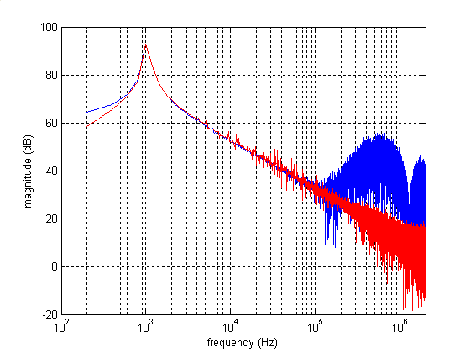

blue trace: FFT of sinewave generated by AIC3106

red trace: FFT of sinewave generated by AIC3106 passed through first order CR low pass filter

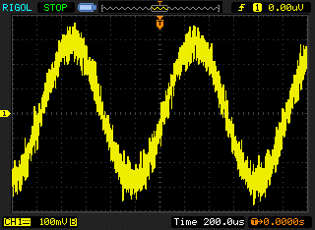

sinewave generated by AIC3106

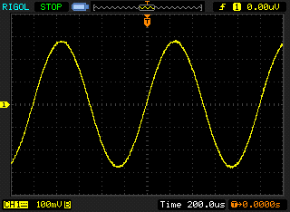

sinewave generated by AIC3106 passed through first order CR low pass filter