Diagrams Related To The Issues.

Stack Overflow

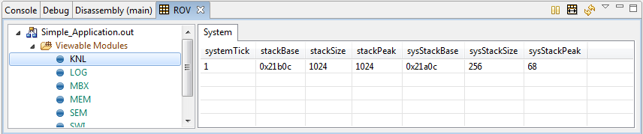

Execution Halts

Disassembly Window view:

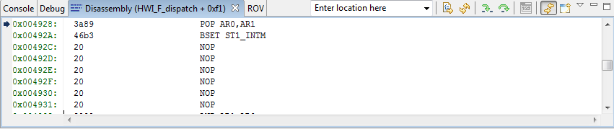

Debug Window View:

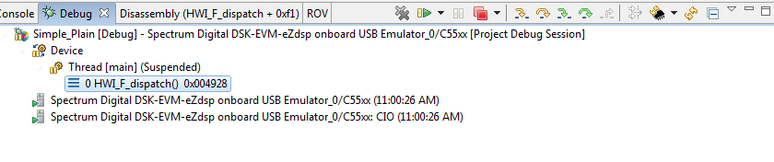

Symbol Not available

Debug Window view:

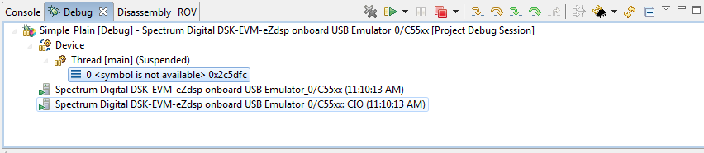

Disassembly Window View:

