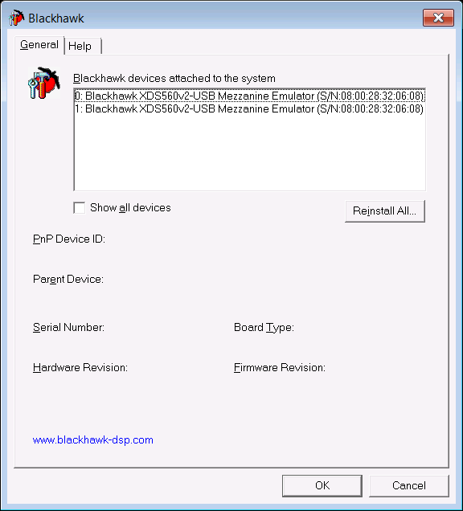

Renamed:

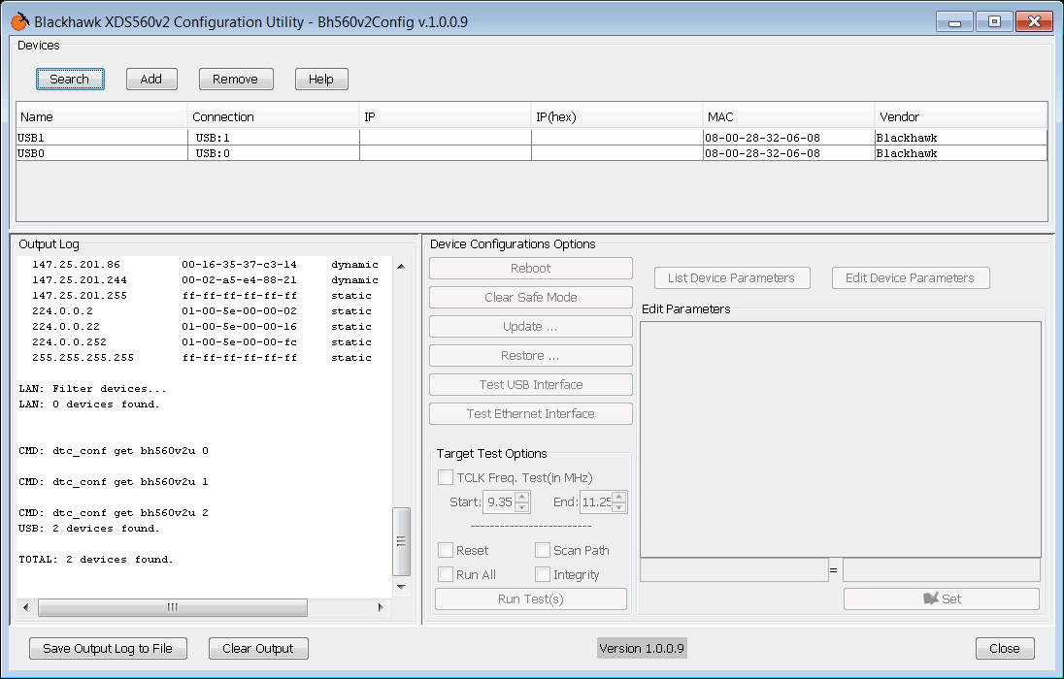

Swapped cables:

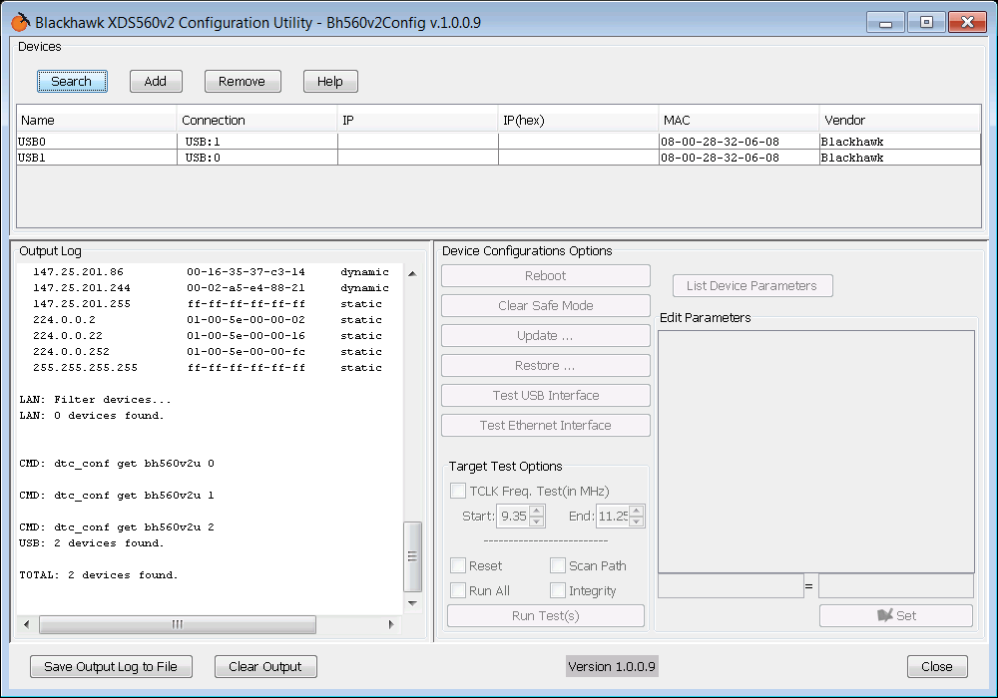

Only Emulator on Port 0 connected

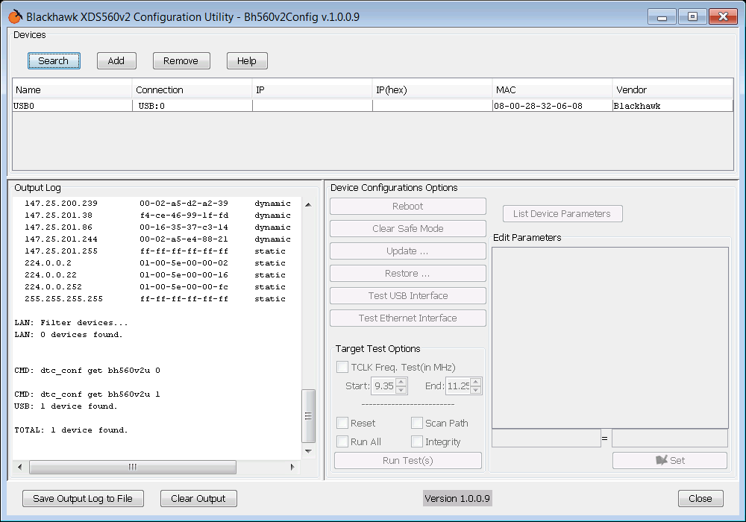

Target on port 0

This is my target tree. The first connection is on port 0, the second on port 1

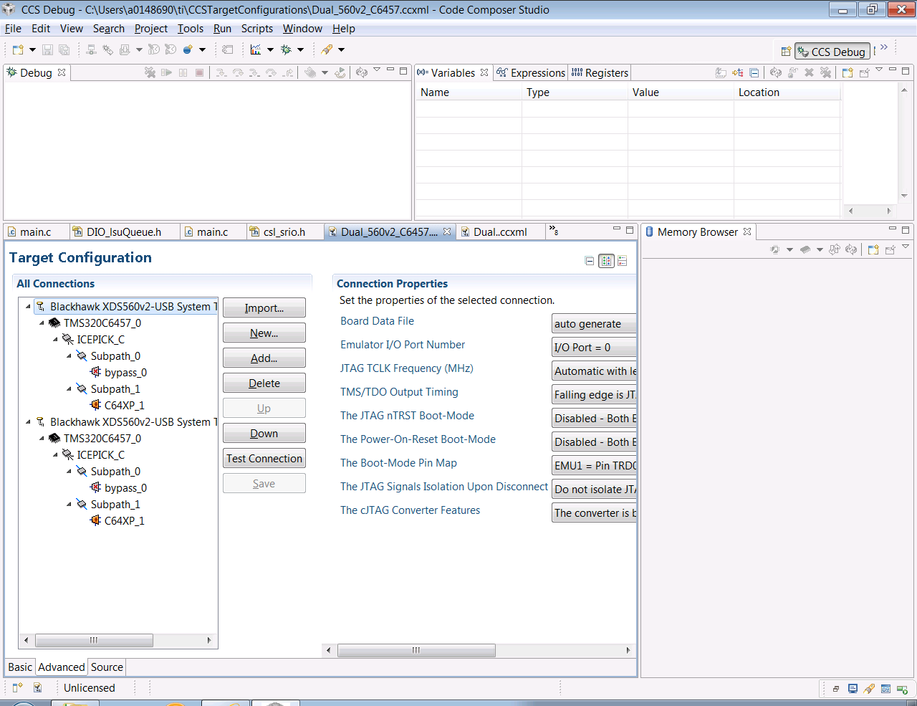

All attempts to connect using the second Target fail when using a second instance of Code composer