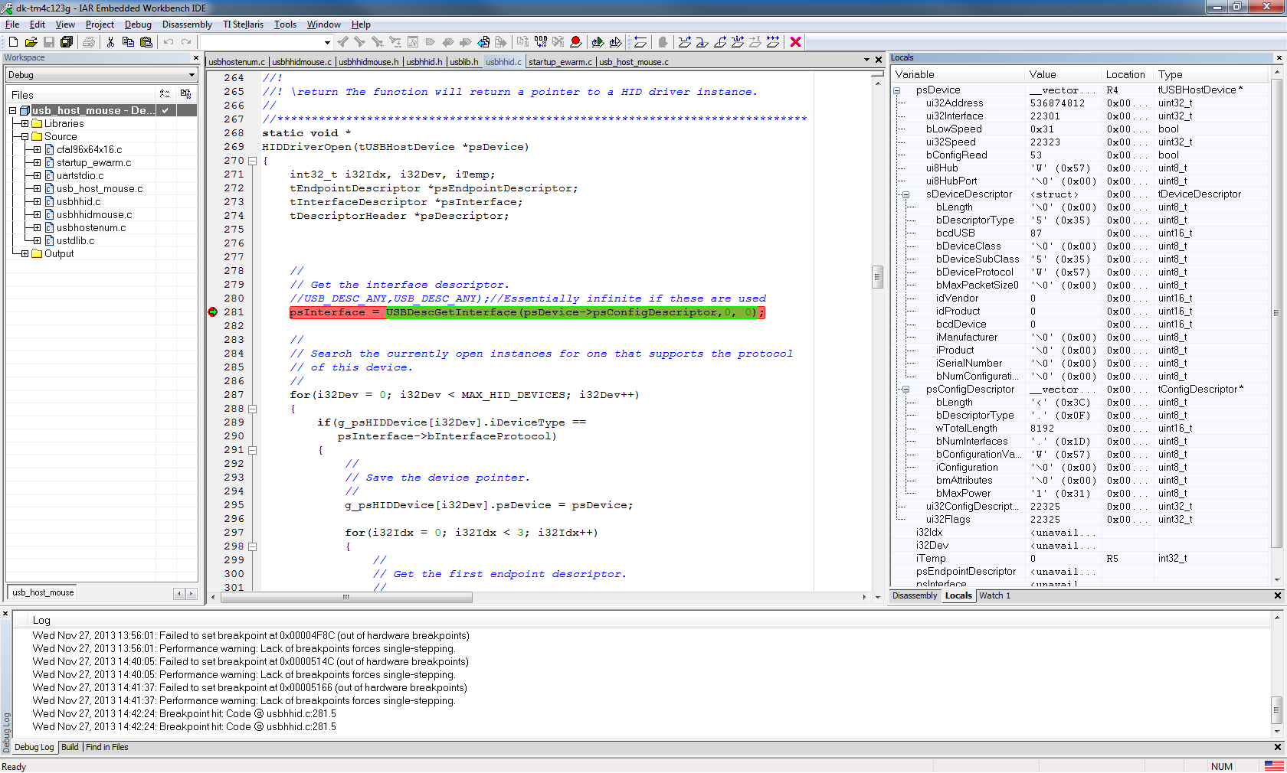
Compare Local variables for psDevice with the report from USBlyzer; the descriptors appear to be garbage for psDevice.
USB Input Device
Connection Status | Device connected
Current Configuration | 1
Speed | Full (12 Mbit/s)
Device Address | 1
Number Of Open Pipes | 2
Device Descriptor PenMount USB
Offset | Field | Size | Value | Description
0 | bLength | 1 | 12h
1 | bDescriptorType | 1 | 01h | Device
2 | bcdUSB | 2 | 0110h | USB Spec 1.1
4 | bDeviceClass | 1 | 00h | Class info in Ifc Descriptors
5 | bDeviceSubClass | 1 | 00h
6 | bDeviceProtocol | 1 | 00h
7 | bMaxPacketSize0 | 1 | 40h | 64 bytes
8 | idVendor | 2 | 14E1h
10 | idProduct | 2 | 6000h
12 | bcdDevice | 2 | A4B4h | ?4.?4
14 | iManufacturer | 1 | 01h | "DIALOGUE INC"
15 | iProduct | 1 | 02h | "PenMount USB"
16 | iSerialNumber | 1 | 00h
17 | bNumConfigurations | 1 | 01h
Configuration Descriptor 1 Bus Powered, 500 mA
Offset | Field | Size | Value | Description
0 | bLength | 1 | 09h
1 | bDescriptorType | 1 | 02h | Configuration
2 | wTotalLength | 2 | 0029h
4 | bNumInterfaces | 1 | 01h
5 | bConfigurationValue | 1 | 01h
6 | iConfiguration | 1 | 04h | "full speed"
7 | bmAttributes | 1 | A0h | Bus Powered, Remote Wakeup
 | 4..0: Reserved |  | ...00000
 | 5: Remote Wakeup |  | ..1..... | Yes
 | 6: Self Powered |  | .0...... | No, Bus Powered
 | 7: Reserved (set to one)  (bus-powered for 1.0) |  | 1.......
8 | bMaxPower | 1 | FAh | 500 mA
Interface Descriptor 0/0 HID, 2 Endpoints
Offset | Field | Size | Value | Description
0 | bLength | 1 | 09h
1 | bDescriptorType | 1 | 04h | Interface
2 | bInterfaceNumber | 1 | 00h
3 | bAlternateSetting | 1 | 00h
4 | bNumEndpoints | 1 | 02h
5 | bInterfaceClass | 1 | 03h | HID
6 | bInterfaceSubClass | 1 | 00h
7 | bInterfaceProtocol | 1 | 00h
8 | iInterface | 1 | 03h | "EndPoint1 Interrupt Pipe"
HID Descriptor
Offset | Field | Size | Value | Description
0 | bLength | 1 | 09h
1 | bDescriptorType | 1 | 21h | HID
2 | bcdHID | 2 | 0101h | 1.01
4 | bCountryCode | 1 | 00h
5 | bNumDescriptors | 1 | 01h
6 | bDescriptorType | 1 | 22h | Report
7 | wDescriptorLength | 2 | 004Ch | 76 bytes
Endpoint Descriptor 81 1 In, Interrupt, 1 ms
Offset | Field | Size | Value | Description
0 | bLength | 1 | 07h
1 | bDescriptorType | 1 | 05h | Endpoint
2 | bEndpointAddress | 1 | 81h | 1 In
3 | bmAttributes | 1 | 03h | Interrupt
 | 1..0: Transfer Type |  | ......11 | Interrupt
 | 7..2: Reserved |  | 000000..
4 | wMaxPacketSize | 2 | 0005h | 5 bytes
6 | bInterval | 1 | 01h | 1 ms
Endpoint Descriptor 02 2 Out, Interrupt, 1 ms
Offset | Field | Size | Value | Description
0 | bLength | 1 | 07h
1 | bDescriptorType | 1 | 05h | Endpoint
2 | bEndpointAddress | 1 | 02h | 2 Out
3 | bmAttributes | 1 | 03h | Interrupt
 | 1..0: Transfer Type |  | ......11 | Interrupt
 | 7..2: Reserved |  | 000000..
4 | wMaxPacketSize | 2 | 0005h | 5 bytes
6 | bInterval | 1 | 01h | 1 ms
Interface 0 HID Report Descriptor Mouse
Item Tag (Value) | Raw Data
Usage Page (Generic Desktop) | 05 01
Usage (Mouse) | 09 02
Collection (Application) | A1 01
Usage (Pointer) | 09 01
Collection (Physical) | A1 00
Usage (Undefined) | 09 00
Logical Minimum (0) | 15 00
Logical Maximum (1) | 25 01
Report Count (6) | 95 06
Report Size (1) | 75 01
Input (Cnst,Ary,Abs) | 81 01
Usage Page (Button) | 05 09
Usage Minimum (Button 1) | 19 01
Usage Maximum (Button 3) | 29 03
Logical Minimum (0) | 15 00
Logical Maximum (1) | 25 01
Report Count (2) | 95 02
Report Size (1) | 75 01
Input (Data,Var,Abs,NWrp,Lin,Pref,NNul,Bit) | 81 02
Usage Page (Generic Desktop) | 05 01
Usage (X) | 09 30
Usage (Y) | 09 31
Logical Minimum (0) | 15 00
Logical Maximum (1023) | 26 FF 03
Physical Minimum (128) | 36 80 00
Physical Maximum (32767) | 46 FF 7F
Report Size (16) | 75 10
Report Count (2) | 95 02
Input (Data,Var,Abs,NWrp,Lin,Pref,NNul,Bit) | 81 02
Usage (Undefined) | 09 00
Logical Minimum (0) | 15 00
Logical Maximum (255) | 26 FF 00
Report Size (8) | 75 08
Report Count (5) | 95 05
Feature (Data,Var,Abs,NWrp,Lin,Pref,NNul,NVol,Bit) | B1 02
End Collection | C0
End Collection | C0
This report was generated by USBlyzer

